ANSI/ABTG – FS 200.1 – XXXX (pending)

Standard for Use of Foam Plastic Insulating Sheathing (FPIS) in Building Envelopes: Above-grade Walls

COMMITTEE BALLOT DRAFT
(Clean Version – Entire Document)

October 21, 2021

Table of Contents

Acknowledgements (TBD)……………………………………………………………....…………….i
FS200 Project Committee & Advisory Council (TBD)………..…………………………………….ii
Foreword (TBD)…………………………………………………………………………………..……iii
Table of Contents 2
Chapter 1 – GENERAL 4
1.1. Purpose 4
1.2 Scope 4
1.3 FPIS Labeling 5
1.4 FPIS Quality Assurance 6
Chapter 2 - DEFINITIONS 7
Chapter 3 – FPIS for Use in Above Grade Walls 10
3.1 General 10
3.2 Water-Resistive Barrier 11
3.3 Air Barrier System 12
3.4 Water Vapor Control for Frame Wall Assemblies 13
3.5 Water Vapor Control for Reservoir Claddings 18
3.6 Fenestration Installation in Walls with FPIS 20
Chapter 4 - Connections Through FPIS 26
4.1 General. 26
4.2 Specification Requirements 26
4.3 Installation Requirements. 37
4.4 Qualification, Quality Assurance, and Labeling Requirements. 37
Chapter 5 – Reference Documents 38
Mandatory Appendix A – Quality Assurance 40
A.1. General. 40
A.2. Quality Assurance Testing 40
A.3. Process Control 40
A.4. Alternate to Full-Scale Testing. 41
A.5. Requalification. 41
MANDATORY APPENDIX B – Standard Practice for Evaluation of Water-Resistive Barrier Application of FPIS 42
B.1 General 42
B.2. Evaluation of Materials for a FPIS WRB System 42
B.3. Evaluation of FPIS WRB System 44
Mandatory Appendix C - Standard Practice for Evaluation of Building Component Shear Connections through FPIS 49
C.1 General 49
C.2 Specimen construction. 49
C.3 Test set-up and Conditions. 50
C.4 Test procedure (short term loading) 50
C.5 Test procedure (long term loading) 51
C.6 Criteria for shear allowable design values. 51
C.7 Material Properties 51
C.8 Reporting Requirements 51
COMMENTARY 52
Commentary Chapter 1 – General 52
Commentary Chapter 2 – Definitions 61
Commentary Chapter 3 – FPIS for Use in Above Grade Walls 61
Commentary Chapter 4 – Connections through FPIS 67
Commentary for Mandatory Appendix A 70
Commentary for Mandatory Appendix B 70
Commentary for Mandatory Appendix C 75
COMMENTARY & USER NOTE REFERENCES 76

Chapter 1 – GENERAL

1.1. Purpose

1.1.1 This standard establishes minimum requirements for applications of Foam Plastic Insulating Sheathing (FPIS) in the design and construction of building envelopes: specifically, above-grade walls.
User Note: The content of this standard addresses two major user groups: (1) Designers, specifiers, builders, and code officials, and (2) FPIS manufacturers and third party agencies conducting quality assurance services. To the extent possible, information is organized to facilitate easy access to relevant information for each user group. For example, applications of FPIS are generally organized by general requirements, specification requirements, installation requirements, and then quality assurance requirements. Mandatory appendices contain detailed testing and quality assurance information that support quality assurance, labeling, and material qualification requirements.

1.2 Scope

1.2.1 This standard addresses FPIS materials that comply with ASTM C578 or ASTM C1289 as indicated in Table 1 for use on above-grade walls. This standard supplements the locally applicable building code and energy conservation code requirements, including flame spread and smoke developed index as well as thermal barrier requirements.
TABLE 1
FPIS Material Standards
FPIS Material | Applicable Material Standard
Expanded polystyrene (EPS) | ASTM C578
Extruded polystyrene (XPS) | ASTM C578
Polyisocyanurate (Polyiso) | ASTM C1289

1.2.2 The requirements in this standard shall govern in all matters pertaining to design and construction using FPIS, except where it is in conflict with requirements in the locally applicable building code or energy conservation code.

1.2.3 This standard shall govern in all matters pertaining to design, construction, and material properties where there is conflict with requirements contained in other standards referenced in this standard.

1.2.4 Where there is a conflict between a general requirement and a specific requirement within this standard, the specific requirement shall be applicable. Where, in any specific case, different sections of this standard specify different materials, methods of construction or other requirements, the more restrictive shall govern.

1.2.5 This standard does not address assembly fire performance, safety and protective requirements for use of FPIS in above-grade walls. The use and qualification of FPIS in above-grade walls shall comply with the relevant fire safety provisions of the locally applicable building code.
User Note: Specific requirements for FPIS are contained in the International Building Code (IBC) Chapter 26 and the International Residential Code Section R316, as applicable. For fire performance and building code compliance data, refer to the FPIS manufacturer.

1.2.6 This standard addresses above-grade wall applications where FPIS materials are protected against damage from abrasion, impact, long-term U/V exposure, and exposure to incompatible elements during service.
Exception: Applications where exposure to damage is inconsequential or acceptable for the intended use.
User Note: FPIS materials are generally intended for limited exposure during construction only and must be permanently concealed within the construction (e.g., located underneath cladding or within assemblies). For additional information, refer to the FPIS manufacturer’s data.

1.2.7 The FPIS materials shall have no defects that will adversely affect their service qualities. Where damaged during construction, materials shall be repaired or replaced.

1.2.8 This standard does not address exterior insulation finish systems (EIFS), structural insulated panels (SIP), and insulating concrete forms (ICF).

1.2.9 The provisions of this standard are not intended to prevent the installation of any material or to prohibit any design or method of construction not specifically prescribed by this standard or the locally applicable building code. Approval of an alternative material, design, or method of construction shall be in accordance with the alternative means and methods provisions of the locally applicable building code.

1.3 FPIS Labeling

1.3.1 Certification. FPIS products, packages, or containers represented as conforming to this standard shall bear the label of an approved agency or agencies which evaluated the manufacturer for conformance to this standard.

1.3.2 Product marking. FPIS products represented as conforming to this standard shall be identified with a mark or certificate issued by an approved agency. The product marking shall meet the following minimum requirements.
- Manufacturer Name or Identification (such as name or logo),
- Manufacturing date or equivalent traceable marking,
- Each approved Agency identification (such as name or logo),
- Each approved Agency listing or report number,
- ASTM C578 Type or ASTM C1289 Type and Class

1.3.3 Approved Agency Listing. The Approved Agency listing or report shall provide confirmation of product qualification to ASTM C578 or ASTM C1289 per Section 1.2.1. Approved Agency listings or reports also shall provide details of FPIS product or assemblies evaluated to the following sections of FS-200.1, only as applicable to each intended use:
- Wind Pressure Resistance established per Section 3.1.1;
- Water Resistive Barrier resistance established per Section 3.2 and Appendix B;
- Air Barrier (Material or Assembly) resistance established per Section 3.3;
- Water Vapor Control for Frame Wall Assemblies: Minimum water vapor permeance at declared thickness established per Section 3.4;
- Water Vapor Control for Reservoir Claddings: Drainage efficiency per Section 3.5;
- Fenestration Installation in Walls with FPIS: Compressive resistance and thickness per Section 3.6;
- Window installation details when qualified in accordance with Section 3.6.2.1(2); and
- Cladding connection fastening requirements established per Chapter 4 and Appendix C.
The Approved Agency listings or reports shall include a statement of compliance to ANSI/ABTG FS200.1 for each applicable attribute (example, “Complies with ANSI/ABTG FS200.1, Section 3.2 for Water Resistive Barrier”). The approved agency listing or report shall include installation instructions consistent with the manner in which the assembly was tested.

1.4 FPIS Quality Assurance

1.4.1 Quality Control. FPIS material physical properties shall comply with the inspection and qualification requirements of ASTM C578 or ASTM C1289. Where required to be qualified for specific above-grade wall applications or functions in accordance with this standard, FPIS products and related accessories or components shall comply with the quality assurance requirements of Mandatory Appendix A.
User Note: ASTM C578 and ASTM C1289 identify FPIS material physical properties requiring inspection or qualification in accordance with the sampling and acceptance requirements of ASTM C390. Generally, inspection requirements include dimensional tolerances, workmanship, finish, and appearance. Qualification requirements include thermal resistance, compressive resistance, dimensional stability, flexural strength, tensile strength, water absorption, and water vapor permeance. Other properties may require qualification depending on the FPIS material type.
The quality assurance requirements of Mandatory Appendix A are intended to supplement the above-described inspection and qualification requirements which focus on conformance with the material physical property requirements of ASTM C578 and ASTM C1289. An overarching requirement of this standard in Section 1.2.1 is that FPIS materials must comply with ASTM C578 and ASTM C1289. However, these ASTM standards do not address specific building envelope applications that can involve specialized qualification requirements to provide assurance that the necessary performance characteristics for a given application are achieved. Applications of FPIS materials in this standard where additional qualification and quality assurance requirements apply are addressed in Section 1.3.3 in relation to labeling.

Chapter 2 - DEFINITIONS
Air barrier assembly: A building construction, such as a wall, roof, or floor, that is able to provide a continuous barrier to air movement through the assembly, including interfaces at windows, doors, and other components penetrating the assembly.
Air barrier material: A building material with low air permeance, including membranes, panels, sealants, and tapes, used to construct air barrier assemblies and to form a continuous air barrier system for the entire building envelope.
Air barrier system: A combination of air barrier materials and assemblies used to construct a building envelope that is resistant to air leakage and that is continuous across foundations, walls, floors, and roofs and their associated components.
Locally Applicable Building [Energy] Code: The building code (or energy code) adopted by the governmental unit having jurisdiction over a building construction project.
Approved: Acceptable to the building official.
Approved Agency: An agency, approved by the building official or otherwise independently certified, that conducts tests, provides inspection services, or furnishes product certification.
Building Envelope: Building assemblies and components (walls, roofs, foundation, floors, windows, doors, etc.) separating the interior environment of the building from the exterior (outdoors or ground).
Continuous Insulation: Insulation installed continuously on the interior or exterior surface of or integral to an opaque building envelope assembly without compression or disruption by thermal bridges other than fasteners and service penetrations such as access hatches, pipes, ducts or vents, electric boxes, etc.
Expanded Polystyrene (EPS) Thermal Insulation: A cellular plastic product, with or without facings, manufactured from polystyrene expanded and molded resulting in a product that is rigid with a closed cellular structure. Refer to ASTM C578 for additional information.
Exterior Wall Covering: An assembly of materials applied to the exterior side of an exterior wall for the purpose of providing weather resistance, including cladding, continuous insulation, water-resistive barrier, air barrier, and other materials such as trim, attachments, and flashing.
Extruded Polystyrene (XPS) Thermal Insulation: A cellular plastic product, with or without facings, manufactured in a one-stage process by extrusion and expansion of the base polymer resulting in a product that is rigid with a closed cellular structure. Refer to ASTM C578 for additional information.
Facer: An integral material applied to the face of one or both surfaces of the FPIS product evaluated in accordance with this standard.
Flashing: Flashing is a material or assembly used to integrate components such as window flanges, mechanical flashing, water resistive barriers, air barriers, and other components to prevent intrusion of liquid water beyond a continuous WRB layer or surface using one or more of the following methods:
Mechanical Flashing – Generally a rigid, pre-formed or formable, corrosion-resistant and water-resistant material shaped to direct water away from joints or around components, mechanically fastened to a suitable substrate, and installed in an overlapping fashion to shed liquid water and prevent intrusion by gravity. Laps are of a sufficient length to prevent liquid water intrusion due to capillary action or pressure differential.
Self-Adhering Flashing – Flexible, water-resistant facing materials coated completely or partially on at least one side with an adhesive material and which do not depend on mechanical fasteners for permanent attachment; also known as flashing tape.
Liquid-Applied Flashing – A type of flashing material that is a fluid or paste at the time of application and is applied by trowel, roller, spray, or other suitable method to provide a durable water-resistant coating or seal over compatible substrates and joints or interfaces between materials to prevent liquid water intrusion.
Foam Plastic Insulating Sheathing (FPIS): For the purpose of this standard, foam plastic insulating sheathing is a rigid panel or board consisting of foam plastic material complying with ASTM C578 or ASTM C1289, including facers as applicable, with a minimum thermal resistance of R-2 (ft²-ºF-h/Btu) at 75°F mean temperature.
FPIS WRB System: A water-resistive barrier composed of a qualified FPIS product, joint-sealing method(s), and accessories to form a continuous plane of water-resistance.
Insulation Ratio (IR): FPIS exterior continuous insulation R-value (Re) divided by the interior cavity insulation R-value (Ri) such that IR = Re/Ri. This ratio, together with presence or absence of an interior vapor retarder, provides a means to control water vapor and risk of condensation.
Joint Methods: Mechanical edge conditions or shapes such as tongue-and-groove or ship-lap edges.
Joint-sealing Treatments: Tapes, caulks, sealants, joint reinforcing, and other materials used to seal joints that occur between abutting edges of FPIS.
Labeled: A product or product packaging to which a label has been applied to identify the product and manufacturer, conformity to applicable code requirements and reference standards, the approved agency certifying conformity, and other manufacturer data.
Over-sheathing: The application of FPIS over a separate sheathing layer or solid wall surface that is independently capable of resisting the full design wind load.
Polyisocyanurate (Polyiso) Thermal Insulation: A faced cellular plastic product formed through the reaction of an isocyanate with a polyol and the reaction of an isocyanate with itself. Refer to ASTM C1289 for additional information.
Registered Design Professional: An individual licensed to practice design in accordance with professional registration laws of the state in which the project is located.
Reservoir Cladding: Claddings that absorb and retain rain water, increasing the potential for inward moisture movement. Examples include Portland cement stucco, adhered masonry veneer, anchored masonry veneer, cement siding panels, and other similar claddings.
Responsive Vapor Retarder: A Class I or II Vapor retarder as measured by the desiccant method (Procedure A, dry cup) of ASTM E96 which has a permeance of greater than 1 perm as measured by the water method (Procedure B, wet cup) of ASTM E96. One example is coated Kraft paper laminated to fiberglass batt insulation.
Sample: A set of specimens analyzed as a group.
Sealant: A water-resistant caulk, foam, or other material capable of bonding to compatible materials and creating a bridge at joints between components or filler in gaps between components resulting in a durable and water-tight interface.
Specimen: The individual test piece or assembly.
Under-sheathing: The application of FPIS underneath a separate sheathing layer that is independently capable of resisting the full design wind load.
Vapor Retarder Class: Used to categorize the water vapor resistance of vapor retarders typically used on the interior side of building envelope assemblies on the basis of water vapor permeance (perms) as measured by the desiccant method (Procedure A, dry cup) of ASTM E96. Vapor retarder classes are as follows:

Class I: less than or equal to 0.1 perm
Class II: greater than 0.1 perm and less than or equal to 1 perm
Class III: greater than 1 perm and not more than 10 perm

Water-resistive barrier (WRB): A continuous surface or material layer installed behind the cladding material to provide a plane of protection against water that has penetrated behind the cladding; also referred to as a drainage plane and weather-resistive barrier.

Chapter 3 – FPIS for Use in Above Grade Walls

3.1 General. Above-grade wall applications of foam plastic insulating sheathing (FPIS) shall comply with this Chapter, the general requirements of Chapter 1, and the requirements of the locally applicable building and energy conservation codes.
User Note: Continuous insulation is the primary application of FPIS on above grade walls as a means to compy with the locally applicable energy conservation code and to minimize thermal bridging through building envelopes at framing members and other thermal bridging conditions. For this application, the primary material property to specify for compliance with the locally applicable energy conservation code is the thermal resistance (i.e., R-value as addressed in Chapter 1). However, Chapter 3 addresses various other applications and functions for FPIS on exterior wall assemblies. Fire resistance properties and protective requirements also are very important for applications of FPIS; refer to Section 1.2.5.

3.1.1 Wind Resistance. The wind resistance of exterior walls of buildings shall comply with the locally applicable building code. Where an FPIS product is proposed for use as a wind resisting element in an exterior wall covering assembly, the wind pressure resistance of FPIS shall comply with ANSI/ABTG FS 100. The design wind load shall be determined in accordance with ASCE 7 or the locally applicable building code.
User Note: Where installed directly to studs (open framing) and not installed over or under structural sheathing or to the surface of a solid wall such as masonry or concrete, FPIS is required to be tested and labeled for wind pressure resistance in accordance with ANSI/ABTG FS 100 (formerly ANSI/SBCA FS 100). The labeled design wind pressure resistance and the wind load requirements of the locally applicable building code provide the basis for code-compliant specification where wind pressure resistance is required. Where not separately and permanently secured by furring and cladding materials, the ANSI/ABTG FS 100 standard also provides means to qualify the permanent attachment of FPIS for design wind load resistance. Typical manufacturer installation instructions provide for attachment for temporary conditions during construction and rely on cladding elements for permanent securement for design wind load resistance. For additional information, refer to the FPIS manufacturer’s data.

3.1.2 Wall Bracing. FPIS shall be integrated with wall bracing materials and methods complying with the locally applicable building and energy conservation codes.

3.1.3 Cladding. Where cladding is installed over FPIS, the installation shall comply with Chapter 4. The wind-pressure resistance of the cladding materials and fastening shall comply with the locally applicable building code and the cladding manufacturer’s installation instructions. For vinyl siding installed over FPIS, its wind load design pressure rating shall comply with ASTM D3679, the locally applicable building code, and the vinyl siding manufacturer’s installation instructions.
Exception: Where FPIS is installed over open stud framing and is attached to studs to resist only temporary construction exposure to wind, the wind load design pressure rating of vinyl siding installed over FPIS shall comply with one of the following:
1. Table 3.1.3, or
2. The vinyl siding manufacturer’s wind load design pressure rating and installation instructions where specifically approved for installation over FPIS that is not used as over-sheathing or under-sheathing.

TABLE 3.1.3
Required Minimum Wind Load Design Pressure Rating for Vinyl Siding
Installed over FPIS not used as Over-sheathing or Under-sheathing^{a,b}
Basic Design Wind Speed (MPH) | Minimum ASD Wind Pressure Rating for Vinyl Siding (PSF)
Basic Design Wind Speed (MPH) | Case 1: With interior gypsum board^{c} |  |  | Case2: Without interior gypsum board^{c}
Basic Design Wind Speed (MPH) | Wind Exposure |  |  | Wind Exposure
Basic Design Wind Speed (MPH) | B | C | D | B | C | D
95 | -30.0 | -33.2 | -39.4 | -33.9 | -47.4 | -56.2
100 | -30.0 | -36.8 | -43.6 | -37.2 | -52.5 | -62.2
105 | -30.0 | -40.5 | -48.1 | -41.4 | -57.9 | -68.6
110 | -31.8 | -44.5 | -52.8 | -45.4 | -63.5 | -75.3
115 | -35.5 | -49.7 | -59.0 | -50.7 | -71.0 | -84.2
120 | -37.4 | -52.4 | -62.1 | -53.4 | -74.8 | -88.6
130 | -44.9 | -62.8 | -74.5 | -64.1 | -89.7 | -106
> 130 | See footnote d
a. Linear interpolation is permitted.
b. Table values are based on a maximum 30-foot mean roof height, effective wind area of 10 ft², Wall Zone 5 (corner), and the allowable stress design (ASD) component and cladding wind pressure determined in accordance with ASCE 7 with the following adjustment factors applied: 1.87 (Case 1) and 2.67 (Case 2).
c. Gypsum wallboard, gypsum panel product or equivalent.
d. For the indicated wind speed condition and where foam sheathing is the only sheathing on the exterior of a frame wall with vinyl siding, the wall assembly shall be capable of resisting an impact without puncture at least equivalent to a wood frame wall with minimum 7/16-inch OSB sheathing as tested in accordance with ASTM E1886. The vinyl siding shall comply with an adjusted design wind pressure requirement as determined in accordance with footnote b, using an adjustment factor of 2.67.

User Note: Table 3.1.3 is based on the IRC (ICC, 2021b), Section R703.11.2 As in the 2021 IRC, adjustments to determine design wind pressure ratings for vinyl siding are made to convert to a PEF of 0.7 (Case 1) and 1.0 (Case 2) and to a safety factor of 2.0 from 1.5 as used in ASTM D3679. Thus, the adjustments to the ASCE 7 ASD wind loads to determine required minimum vinyl siding wind pressure ratings are determined as follows: (0.7/0.5)x(2.0/1.5) = 1.87 (Case 1) and (1.0/0.5)x(2.0/1.5) = 2.67. The use of a greater PEF factor and safety factor accounts for use of the vinyl siding as a means for permanent securement of the FPIS when not installed as over- or under-sheathing. The minimum design wind pressure is set at -30 psf to correspond with the scope of prescriptive wall covering requirements in IRC Section R703.3.2 (ICC, 2021b).

3.2 Water-Resistive Barrier

3.2.1 General. A water-resistive barrier (WRB) shall be provided on exterior walls of buildings in accordance with the locally applicable building code. Where an FPIS WRB system is proposed for use as the water-resistive barrier, the FPIS product, joint-sealing methods, and accessories shall be specified in accordance with Section 3.2.2 and installed in accordance with Section 3.2.3. The FPIS product manufacturer shall comply with Section 3.2.4 with regard to qualification testing, quality assurance, and product labeling requirements.

3.2.2 Specification Requirements. The FPIS WRB system specified for use as a water-resistive barrier shall be qualified and labeled in accordance with Section 3.2.4.

3.2.3 Installation Requirements. The specified FPIS WRB system shall be installed in accordance with the FPIS product manufacturer’s installation instructions. Such instructions shall be consistent with the materials and methods of construction used for qualification in accordance with Section 3.2.4.

3.2.4 Qualification, Quality Assurance, and Labeling Requirements. The FPIS WRB system shall be qualified in accordance with Mandatory Appendix B. Quality assurance and labeling shall comply with Chapter 1.

3.3 Air Barrier System

3.3.1 General. Control of whole-building air leakage shall be provided by installation of an air barrier system in accordance with the locally applicable energy conservation code. Where FPIS is used as an air barrier material or as a component in an air barrier assembly which comprises a building’s air barrier system, the requirements of this section shall apply.

3.3.2 Specification Requirements. FPIS specified for use as an air barrier material or as part of an air barrier assembly shall be qualified and labeled in accordance with Section 3.3.4.

3.3.3 Installation Requirements. FPIS used as an air barrier material or as part of an air barrier assembly shall be installed in accordance with the FPIS manufacturer’s installation instructions and the locally applicable energy conservation code. The air barrier system as installed shall be continuous (a) across junctions between different building assemblies and components, (b) across construction, control, and expansion joints, and (c) around penetrations through building assemblies.

3.3.4 Qualification, Quality Assurance, and Labeling Requirements. FPIS intended for use as an air barrier material or as part of an air barrier assembly shall be qualified in accordance with Section 3.3.4.1 or 3.3.4.2, respectively. Quality assurance and labeling shall comply with Chapter 1.

3.3.4.1 Air Barrier Material. FPIS shall be qualified as an air barrier material where tested in accordance with ASTM E 2178 and determined to have an air permeance not exceeding 0.02 L/s-m² (0.004 cfm/ft²) at a 75 Pa (1.57 psf) pressure difference.

Exception: FPIS materials recognized as an air barrier material in the locally applicable energy conservation code.
3.3.4.2 Air-Barrier Assembly. FPIS shall be qualified as part of an air barrier assembly where the assembly is tested in accordance with ASTM E2357, ASTM E1677, or ASTM E283 and determined to have an air leakage rate not greater than 0.2 L/s-m² (0.04 cfm/ft²) at a 75 Pa (1.57 psf) pressure difference.

3.4 Water Vapor Control for Frame Wall Assemblies

3.4.1 General. Where FPIS is installed as continuous insulation on the exterior side of frame walls as illustrated in Figure 3.4.1, the specification of water vapor retarders and FPIS shall comply with Section 3.4.2 and installation shall comply with Section 3.4.3. Alternatively, wall assemblies shall be designed using accepted engineering practice for hygrothermal analysis to provide at least equivalent performance. The FPIS qualification, quality assurance, and labeling requirements shall comply with Section 3.4.4.
User Note: The provisions of this section are intended to apply specifically to framed walls with FPIS exterior continuous insulation. U.S. Model building codes provide generalized requirements for use of vapor retarders on frame wall assemblies and recognize the use of an approved design by accepted engineering practice for hygrothermal analysis; refer to Section 1404.3 and R702.7 of the 2021 editions of the International Building Code and International Residential Code, respectively (ICC, 2021a; ICC, 2021b). Accepted engineering practices for hygrothermal analysis generally follow methods of analysis such as described in ASTM C755 (ASTM, 2020) or ASHRAE 160 (ASHRAE, 2016) and the ASHRAE Handbook of Fundamentals (ASHRAE, 2017) and involve appropriate use of assumptions and engineering judgment regarding boundary conditions, material properties, and interpretation of analysis results relative to experience with similar assemblies, materials, and use conditions; see Commentary for additional resources related to the basis of these provisions.

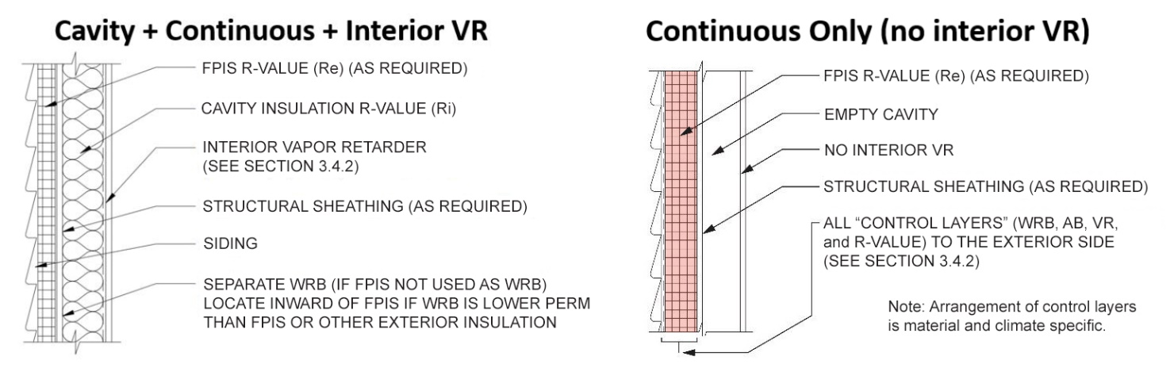

(a) FPIS Continuous Insulation on the Exterior Side and Vapor Permeable Cavity Insulation
(b) FPIS Continuous Insulation on Exterior Side and No Cavity Insulation

Figure 3.4.1 Illustration of FPIS as Continuous Insulation
on the Exterior Side of Frame Walls

3.4.2 Specification Requirements. Specification of water-vapor control materials and methods shall comply with Section 3.4.2.1 or Section 3.4.2.2. The applicable climate zone shall be determined in accordance with Figure 3.4.2 or the locally applicable energy conservation code.
User Note: These requirements are based on normal use and occupancy conditions with regard to indoor moisture loads and indoor relative humidity levels. In addition, these provisions are based on appropriate application of air-barriers, water-resistive barriers, and flashing to prevent or minimize risk of moist air or rain water intrusion into assemblies. Where high indoor moisture generation activities occur (such as a sauna or indoor swimming pool), an enhanced design should be considered (e.g., careful air-leakage sealing on the interior side of the building envelope and use of lower perm interior vapor retarder, a greater insulation ratio, mechanical ventilation, mold-resistant interior finishes, or a combination of all of these practices). For example, increasing the insulation ratio will enhance water-vapor control for a wall assembly.

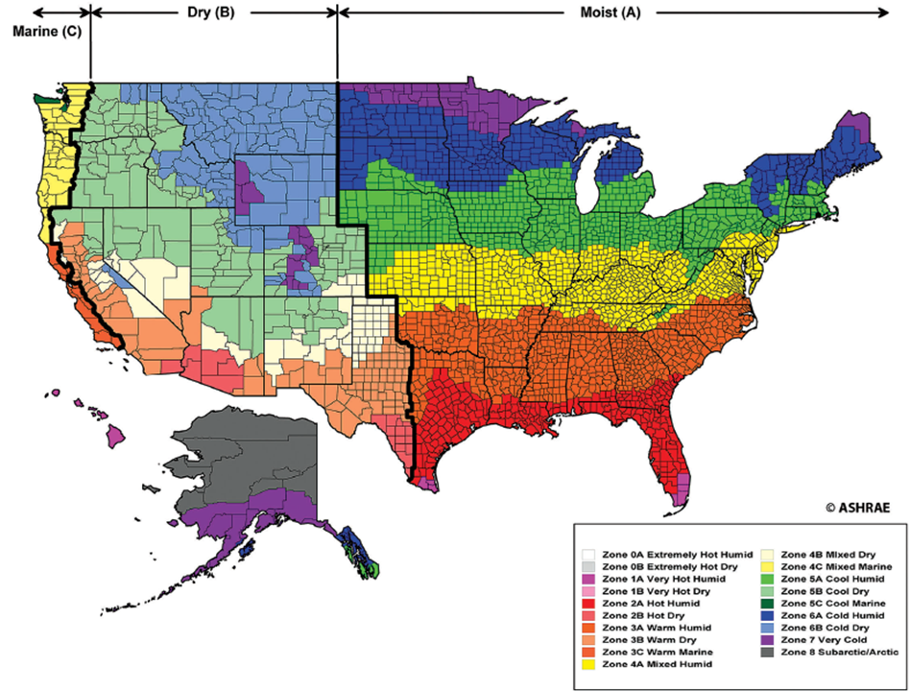
Figure 3.4.2. U.S. Climate Zone Map
(Source: ©ASHRAE www.ashrae.org Standard 169, 2013)

3.4.2.1 Performance Specification. The water vapor retarder class on the interior side of frame walls and insulation ratio of the frame wall assembly with FPIS installed as continuous insulation on the exterior side shall comply with Table 3.4.2.1.

TABLE 3.4.2.1
MINIMUM INSULATION RATIO (IR) OR CONTINUOUS INSULATION R-VALUE
FOR LIGHT-FRAME WALLS WHERE EXTERIOR CONTINUOUS INSULATION (ci) IS USED ^{a,b,c,d}
Climate Zone  (Fig. 3.4.2) | Maximum Heating Degree Days (65F basis) | Interior Vapor Retarder (VR) Class
Climate Zone  (Fig. 3.4.2) | Maximum Heating Degree Days (65F basis) | Class Ie | Class IIe | Class III | No Interior VR^{f}  & CI only
1-2 | N/A | NP | NP | R-2ci minimum | R-2ci minimum
3 | 3,600 | NP | R-2ci minimum | R-2ci minimum | 0.4
4 | 5,400 | NP | 0.2 | 0.2 | 0.9
5 | 7,200 | 0.2 | 0.2 | 0.35 | 1.3
6 | 9,000 | 0.2 | 0.2 | 0.5 | 1.7
7 | 12,600 | 0.35 | 0.35 | 0.7 | 2.3
8^{g} | 16,200 | 0.5 | 0.5 | 0.9 | 2.8
For SI: 1 heating degree day (65°F basis) = 0.56 heating degree days (18°C basis)
NP = indicated vapor retarder class is not permitted in the indicated Climate Zone.
- Insulation ratio (IR) is the exterior continuous insulation R-value (Re) divided by the cavity insulation R-value (Ri). For example, a wall with R20 cavity insulation and R5 continuous insulation (e.g., R20+5ci) has an insulation ratio of IR = Re/Ri = 5/20 = 0.25. The R-2ci minimum applies where there is no minimum insulation ratio required and is intended to ensure a minimum level of performance as required by the definition for FPIS. The R-value of building materials other than insulation shall be permitted to be included in determining IR provided all applicable materials are included in the determination of both Re and Ri where Ri is for all building and insulation materials located in the framing cavity (excluding cavity insulation complying with footnote d which is included in Re) and to the interior face of the wall including air-spaces and an interior air film (R-0.68); Re shall include all materials to the exterior side of the wall framing except vented or ventilated cladding materials and air-spaces shall not have an R-value exceeding R-0.7; an exterior air film R-value (i.e., R-0.17) shall not be included.
- Interpolation of insulation ratios using a site-specific annual average heating degree day value shall be permitted.
- For light-frame cold-form steel wall construction, the tabulated minimum insulation ratio shall be increased by adding 0.1.
- In addition to the interior vapor retarder, where required, spray foam with a maximum permeance of 1.5 perms at the installed thickness, applied to the interior cavity side of the exterior sheathing shall comply with minimum R-value for continuous insulation determined using the tabulated insulation ratio. For compliance with the moisture control purpose of minimum insulation ratios in this table, the spray foam R-value shall be permitted to be added to the R-value of FPIS continuous insulation to determine Re used to determine IR in accordance with footnote ‘a’. This addition of spray foam cavity insulation and continuous insulation R-values is not permitted for compliance with the locally applicable energy conservation code R-value requirements and the R-value of cavity and continuous insulation components shall be separately considered for compliance. Alternatively, the U-factor of the assembly shall be determined in accordance with accepted testing or calculation procedures as a basis for energy code compliance.
- A responsive vapor retarder shall be permitted to be used in any climate zone. Where used with FPIS exterior continuous insulation, the Class I or II interior vapor retarder shall be a responsive vapor retarder.
- “No interior VR” refers to the case where there is no interior vapor retarder and water vapor control relies entirely on the amount of exterior insulation as a means to control temperature, humidity, and condensation conditions within the assembly. Where there is no cavity insulation, the R-value of any material layers, air-space, and air-film to the interior side of the exterior continuous insulation shall be used to determine the insulation ratio in accordance with footnote ‘a’. In no case shall the value of Ri be taken as less than R-5 in determining the insulation ratio (Re/Ri) for the “No interior VR” case. The water vapor permeance of at least one of the following shall not exceed 1 perm (ASTM E 96, Procedure A) in Climate Zones 4-8: (1) the exterior continuous insulation, (2) a facer on the interior face of the continuous insulation, or (3) another material layer located adjacent to the interior side of the exterior continuous insulation.
- The insulation ratio requirement for Climate Zone 8 is based on a maximum 16,200 heating degree days (65ºF basis) [9,000 heating degree days (18ºC basis)]. Where this heating degree day limit is exceeded, a design shall be required to determine the minimum insulation ratio.

User Note (Table 3.4.2.1): The minimum FPIS continuous insulation requirements in Table 3.4.2.1 are intended for water vapor control purposes only. If additional insulation is needed for energy code compliance (beyond that required above for moisture control purposes), there are two options: (1) increase the FPIS continuous insulation R-value (which will improve moisture performance) or (2) increase both cavity insulation and continuous insulation R-values in proportion such that the insulation ratio of the wall assembly is not reduced below that required by Table 3.4.2.1.

3.4.2.2 Prescriptive Specification. FPIS R-value and an interior vapor retarder shall be provided in accordance with Table 3.4.2.2(A) for wood frame walls and Table 3.4.2.2(B) for cold-formed steel frame walls, including compliance with all applicable footnotes.

TABLE 3.4.2.2(A)
MINIMUM REQUIRED R-VALUE FOR FPIS USED AS CONTINUOUS INSULATION (ci)
ON THE EXTERIOR SIDE OF WOOD-FRAMED WALL ASSEMBLIESª
CLIMATE ZONE  (Figure 3.4.2) | Interior Vapor Retarder (VR) Class
CLIMATE ZONE  (Figure 3.4.2) | Class I^{b} | Class II^{b} | Class III | No interior VR^{c}  & ci only
1-2 | Not Permitted | Not Permitted | FPIS ci R-value ≥ 2 | FPIS Ci R-value ≥ 2
3 | Not Permitted | FPIS Ci R-value ≥ 2 | FPIS ci R-value ≥ 2 | FPIS ci R-value ≥ 3
4 | Not Permitted | FPIS ci R-value ≥3 over 2x4 wall  FPIS ci R-value ≥5 over 2x6 wall | FPIS ci R-value ≥ 2.5 over 2x4 wall  FPIS ci R-value ≥ 3.75 over 2x6 wall | FPIS ci R-value ≥ 4.5
5 | FPIS ci R-value ≥3 over 2x4 wall  FPIS ci R-value ≥5 over 2x6 wall |  | FPIS ci R-value ≥ 5 over 2x4 wall  FPIS ci R-value ≥ 7.5 over 2x6 wall | FPIS ci R-value ≥ 6.5
6 |  |  | FPIS ci R-value ≥ 7.5 over 2x4 wall  FPIS ci R-value ≥ 11.25 over 2x6 wall | FPIS ci R-value ≥ 8.5
7 | FPIS ci R-value ≥5 over 2x4 wall  FPIS ci R-value ≥7.5 over 2x6 wall |  | FPIS ci R-value ≥ 10 over 2x4 wall  FPIS ci R-value ≥ 15 over 2x6 wall | FPIS ci R-value ≥ 11.5
8 | FPIS ci R-value ≥7.5 over 2x4 wall  FPIS ci R-value ≥10 over 2x6 wall |  | FPIS ci R-value ≥ 12.5 over 2x4 wall  FPIS ci R-value ≥ 20 over 2x6 wall | FPIS ci R-value ≥ 14
- The continuous insulation minimum R-values for use with 2x4 and 2x6 wall construction where indicated for Class I, II, and III interior vapor retarder conditions, is based on a maximum cavity insulation component R-value of R-15 for 2x4 walls and R-23 for 2x6 walls. The minimum continuous insulation amounts for the “no interior vapor retarder” condition are based on a maximum R-value of 5 for the wall assembly components and materials to the interior side of the continuous insulation (including cavity air-space or insulation if any, exterior sheathing underlying the continuous insulation, and interior finishes). For other conditions of use, refer to Table 3.4.2.1.
- A responsive vapor retarder shall be permitted to be used in any climate zone. Where used with FPIS exterior continuous insulation, the Class I or II interior vapor retarder shall be a responsive vapor retarder.
- In Climate Zones 4 through 8, a water vapor control material layer of less than 1 perm per ASTM E96, Procedure A, is required, but is placed on the exterior side of the wall and to the interior side of the exterior insulation. The exterior insulation shall be permitted to serve as the vapor control layer where the FPIS material at installed thickness or facer on the interior side of the FPIS is a Class I or II vapor retarder.

TABLE 3.4.2.2(B)
MINIMUM REQUIRED R-VALUE FOR FPIS USED AS CONTINUOUS INSULATION (ci)
ON THE EXTERIOR SIDE OF COLD FORMED STEEL FRAME WALL ASSEMBLIESª
CLIMATE ZONE  (Figure 3.4.2) | Interior Vapor Retarder Class
CLIMATE ZONE  (Figure 3.4.2) | Class I^{b} | Class II^{b} | Class III | No interior VR^{c}  & ci only
1-2 | Not Permitted | Not Permitted | FPIS ci R-value ≥ 2 | FPIS ci R-value ≥ 2
3 | Not Permitted | FPIS ci R-value ≥ 2 | FPIS ci R-value ≥ 2.5 | FPIS ci R-value ≥ 3
4 | Not Permitted | FPIS ci R-value ≥ 4.5 over 4” stud wall  FPIS ci R-value ≥ 6.9 over 6” stud wall | FPIS ci R-value ≥ 4.5 over 4” stud wall  FPIS ci R-value ≥ 6.9 over 6” stud wall | FPIS ci R-value ≥ 5
5 | FPIS ci R-value ≥ 4.5 over 4” stud wall  FPIS ci R-value ≥ 6.9 over 6” stud wall |  | FPIS ci R-value ≥ 6.8 over 4” stud wall  FPIS ci R-value ≥ 10.4 over 6” stud wall | FPIS ci R-value ≥ 7
6 |  |  | FPIS ci R-value ≥ 9.0 over 4” stud wall  FPIS ci R-value ≥ 13.8 over 6” wall | FPIS ci R-value ≥ 9
7 | FPIS ci R-value ≥ 6.8 over 4” stud wall  FPIS ci R-value ≥ 10.4 over 6” stud wall |  | FPIS ci R-value ≥ 13.5 over 4” stud wall  FPIS ci R-value ≥ 20.7 over 6” stud wall | FPIS ci R-value ≥ 12
8 | FPIS ci R-value ≥ 9.0 over 4” stud wall  FPIS ci R-value ≥ 13.8 over 6” stud wall |  | FPIS ci R-value ≥ 18.0 over 4” stud wall  FPIS ci R-value ≥ 27.6 over 6” stud wall | FPIS ci R-value ≥ 15

- Refer to Note ‘a’ of Table 3.4.2.2(A).
- Refer to Note ‘b’ of Table 3.4.2.2(A).
- Refer to Note ‘c’ of Table 3.4.2.2(A).

User Note (Tables 3.4.2.2(A) and (B)): The minimum FPIS continuous insulation requirements in Tables 3.4.2.2(A) and (B) are intended for water vapor control purposes only. If additional insulation is needed for energy code compliance (beyond that required above for moisture control purposes), there are two options: (1) increase the FPIS continuous insulation R-value (which will improve moisture performance) or (2) increase both cavity insulation and continuous insulation R-values in proportion such that the minimum insulation ratio (see Table 3.4.2.1) used to derive the continuous insulation amounts in the Tables 3.4.2.2(A) and (B) are satisfied to increase thermal performance without decreasing moisture control performance.

3.4.3 Installation Requirements. Vapor retarders and FPIS shall be installed in accordance with the manufacturer’s installation instructions. Where the vapor retarder is intended to function as an air barrier, it shall meet all the requirements for air barrier materials and installation.
User Note: There are no special installation requirements for FPIS when used for water vapor control in accordance with Section 3.4.2. As with any water vapor control strategy, however, it is important to ensure air-leakage into the assembly is controlled by adequate use of air-barriers and air leakage sealing strategies as generally required by the locally applicable energy conservation code (refer to Section 3.3 for use of FPIS as an air barrier). These provisions also assume appropriate use of water-resistive barriers and flashing to prevent or minimize the risk of rain water intrusion; refer to Section 3.2 for use of FPIS as a WRB system and to Commentary for additional resources for moisture-resistant design and installation detailing best practices.

3.4.4 Qualification, Quality Assurance, and Labeling Requirements. The FPIS material properties, quality assurance, and labeling shall comply with Chapter 1.

3.5 Water Vapor Control for Reservoir Claddings

3.5.1 General. Where FPIS is used behind a reservoir cladding as a means to insulate and protect wood-based sheathing or other moisture-sensitive wall materials from inward water vapor movement, it shall be specified in accordance with Section 3.5.2. The assembly also shall comply with Section 3.4 for water vapor control and Chapter 4 for connection of the reservoir cladding through FPIS to the wall structure. In addition to these requirements, reservoir claddings shall be installed in accordance with the locally applicable building code and the cladding manufacturer’s installation instructions.
User Note: FPIS materials have a sufficiently low water vapor permeability to retard the inward driven water vapor from reservoir claddings that are wetted from rain and subsequently exposed to radiation from the sun. The provisions of this section employ FPIS as a means to control this inward vapor movement to protect moisture-sensitive materials within a wall assembly. When used in this manner, the FPIS may serve as the WRB system (Section 3.5.2.1) or be provided as an intervening non-water-absorbing layer (Section 3.5.2.2). It also provides additional requirements for appropriate drainage in moist or marine climate regions (Section 3.5.2.3). In all cases the FPIS and interior vapor retarder specified must also comply with the water vapor control requirements of Section 3.4 based on Climate Zone.

3.5.2 Specification Requirements. The FPIS application shall comply with Section 3.5.2.1 or Section 3.5.2.2, and the additional requirements of Section 3.5.2.3 for moist (A) or marine (C) climate regions as identified in Figure 3.4.2 or the locally applicable energy conservation code.

3.5.2.1 FPIS WRB system. Where FPIS is used as a water-resistive barrier behind a reservoir cladding, the FPIS WRB system shall comply with Section 3.2 and an intervening bond-break material layer or air space shall be provided between the FPIS WRB system and the reservoir cladding. The bond-break material layer shall be moisture-resistant and prevent the reservoir cladding from bonding to the surface of the FPIS WRB system. Materials complying with the water-resistance requirements of ASTM E2556, Type 1, such as No.15 felt, Grade D paper, or polymeric sheet materials shall be considered a suitable bond-break material.

3.5.2.2 FPIS intervening layer. Where FPIS is used as an intervening non-water-absorbing layer, it shall be located immediately behind the reservoir cladding and installed over an approved water-resistive barrier with water resistance equal to or greater than a water-resistive barrier complying with ASTM E2556, Type II or 60-minute Grade D paper.

3.5.2.3 Moist or marine climate regions. Where located in a moist (A) or marine (C) climate region in accordance with Figure 3.4.2, one of the following shall be added to the exterior side of the water-resistive barrier required in Section 3.5.2.1 and Section 3.5.2.2:
1. a minimum 3/16” drainage space, or
2. a means of drainage with minimum 90% drainage efficiency as measured in accordance with ASTM E2273 or Annex A2 of ASTM E2925.

3.5.3 Installation Requirements. FPIS materials shall be installed in accordance with the manufacturers’ installation instructions.
User Note: There are no special installation requirements for FPIS when used in accordance with Section 3.5.2 for control of inward vapor drives from reservoir claddings. Where the weight of cladding is supported by fastening through the FPIS, refer to Chapter 4 for fastening requirements. The fastening requirements do not apply to separately supported reservoir claddings such as anchored brick veneer where attachments through the FPIS for ties are only to transfer lateral (out-of-plane) loads.

3.5.4 Qualification, Quality Assurance, and Labeling Requirements. The FPIS material properties, quality assurance, and labeling shall comply with Chapter 1.

3.6 Fenestration Installation in Walls with FPIS

3.6.1 General. Fenestration interface with above-grade exterior walls with FPIS used as continuous insulation shall be in accordance with the locally applicable building code and the requirements of this section.
User Note: The provisions of Section 3.6 are based on research including a review of building code requirements, industry accepted installation practices developed over the past 50 years, installation guidelines, and various sources of test data evaluating the structural, water-resistance, and durability performance of fenestration installed on walls with FPIS materials of various types and thicknesses (ABTG, 2021). Refer to the commentary for additional information.

3.6.2 Specification Requirements. A fenestration product’s interface with a wall assembly including FPIS on the exterior side shall comply with Section 3.6.2.1 and Section 3.6.2.2. Installations complying with Section 3.6.3 shall be permitted as an alternative.

3.6.2.1 Flashing. Flashing of the fenestration product’s interface with the wall assembly shall comply with one or more of the following as applicable:
1. The fenestration manufacturer’s installation instructions;
2. The FPIS WRB system manufacturer’s installation instructions complying with Section 3.2.3;
3. The flashing method of FMA/AAMA/WDMA 500 where FPIS is used with a separate membrane-type WRB;
4. The flashing manufacturer’s installation instructions;
5. The design of a registered design professional; or
6. Testing in accordance with the durability conditioning and water-resistance testing requirements of AAMA TIR-504.

3.6.2.2 Anchorage and Support. Fenestration shall be anchored and supported in accordance with the fenestration manufacturer’s installation instructions. For anchorage and support conditions not addressed in the fenestration manufacturer’s installation instructions, the installation shall comply with one or more of the following as applicable:
1. The design of a registered design professional, or
2. Testing in accordance with the design pressure and structural test pressure requirements of AAMA TIR-504.

User Note: The flashing and structural support and anchorage requirements, while addressing separate specification and performance requirements, should be considered in a coordinated fashion and a registered design professional or testing laboratory should be consulted as needed or for unique conditions. Where the fenestration manufacturer provides installation instructions for integration with FPIS, the fenestration manufacturer’s instructions should be preferred. The specifications in the Sections 3.6.2 are intended to be generally applicable except as noted.
3.6.3 Installation Requirements. Fenestration, FPIS, and related components shall be installed in accordance with installation procedures specified in accordance with Section 3.6.2. Alternatively, fenestration shall be permitted to be installed in accordance with Section 3.6.3.1, Section 3.6.3.2, Section 3.6.3.3, Section 3.6.3.4, or Section 3.6.3.5 as applicable.
User Note: The alternative prescriptive installation requirements of Section 3.6.3 are intended for flanged and block-frame windows and door units installed into “punched openings” in framed wall assemblies. They do not apply to fenestration applications such as curtain window walls. They also are not exhaustive of all acceptable installation procedures and may not be appropriate for all installation conditions. However, for the conditions represented in Section 3.6.3, the alternative prescriptive installation procedures are considered to be representative of best practices and are not intended to establish a minimum accepted practice or supplant other suitable methods of installation complying with Section 3.6.2.

3.6.3.1 Standard Installation Method. Windows with perimeter mounting flanges bearing directly on an FPIS WRB system shall be installed with flashing in accordance with Figures 3.6.3.1(1) and (2). The standard installation method shall comply with the fenestration manufacturer’s installation instructions for anchorage and support including the following limitations and requirements:

1. Fenestration flange fasteners shall be increased in length equal to the thickness of the FPIS substrate to maintain required embedment in underlying framing materials.

2. Fenestration through-frame fasteners, where required, shall engage structural framing materials maintaining required penetration and edge distances.

3. The FPIS material shall comply with ASTM C578 or ASTM C1289 and have a minimum 15 psi compressive resistance.

4. The FPIS material thickness shall not exceed a nominal 1-1/2 inches.

5. The allowable stress design wind pressure for the building site and installed location on the building wall shall not exceed +/- 35 psf.

6. The width of a single or mulled fenestration unit shall not exceed 6 feet.

User Note: FPIS WRB systems are required to be qualified, including testing with a window penetration and flashing detail, in accordance with Section 3.2. Thus, specific flashing materials and methods of installation used to comply with Section 3.6.3.1 or Section 3.6.3.2 must also comply with the FPIS WRB system manufacturer’s installation instructions developed in accordance with Section 3.2.3.
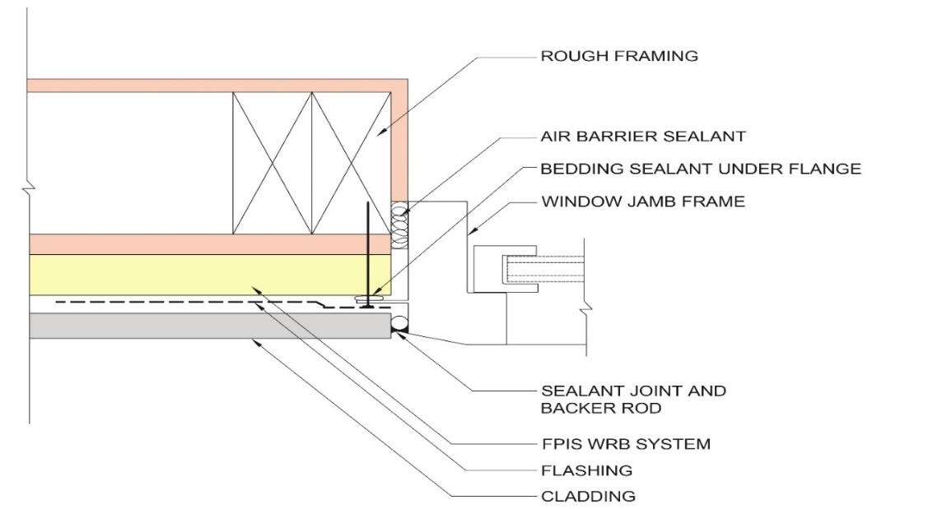

Figure 3.6.3.1(1): Interface of Integral Flange Window with FPIS WRB System

User Note (Figure 3.6.3.1(1)): While recommended, not all window manufacturers’ installation instructions or methods require bedding sealant under the flange as shown in Figure 3.6.3.1(1). Where used, bedding sealant is applied discontinuously at sill flange/pan flashing interface to allow for sill pan drainage.

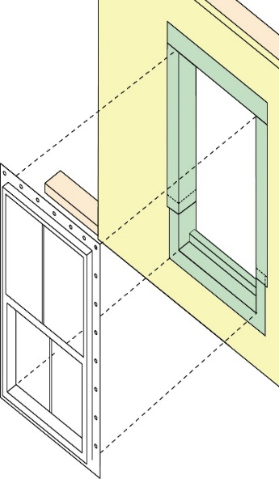  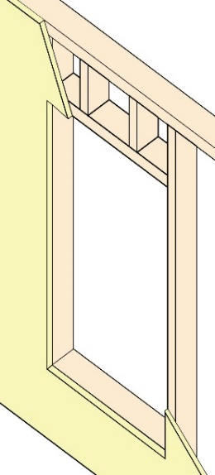  STEP 1: Install FPIS WRB System | 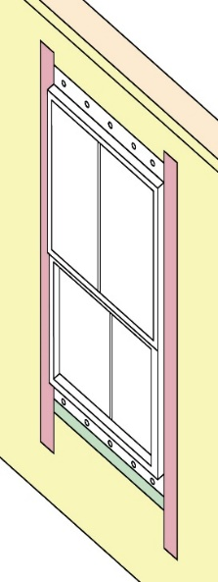  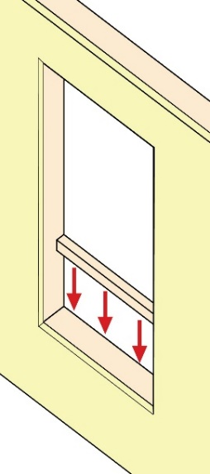  STEP 2: Install Backdam | 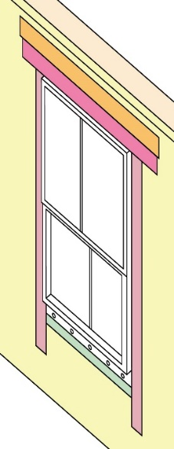  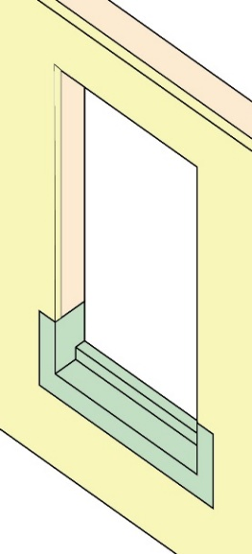  STEP 3: Install Sill Pan Flashing | 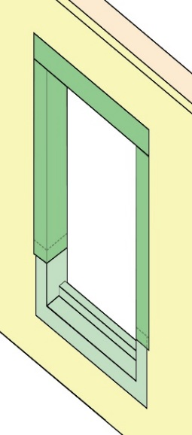  STEP 4: Install Rough  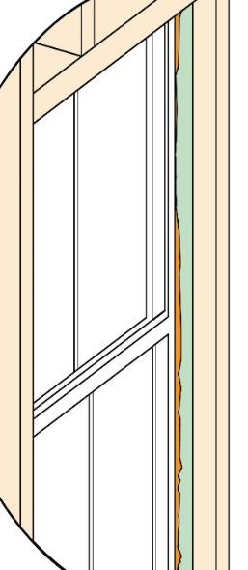  Opening Jamb and Head Flashing
STEP 5: Install Window | STEP 6: Install External Jamb Flashing | STEP 7: Install External Head Flashing & Termination Tape | STEP 8: Install air barrier sealant around window gap on inside
Figure 3.6.3.1(2): Standard Installation Method for Integral Flange Window Installation on Walls with an FPIS WRB System

3.6.3.2 Window Buck Installation Method. A window buck or rough frame extension and flashing shall be provided in accordance with Figure 3.6.3.2. The fenestration unit shall be supported by and anchored to the window buck in accordance with the fenestration manufacturer’s installation instructions for anchorage and support.

User Note: The window buck installation method is typically employed for fenestration installations not complying with the standard installation method of Section 3.6.3.1. The wood buck is similar to that used in masonry and concrete construction. In this method, the FPIS can be installed before or after fenestration installation and the extension of the window buck is sized to match the thickness of the FPIS. A buck may also be constructed using blocking in a picture frame method fastened around the perimeter of the rough opening; in this arrangement the rough opening dimensions do not need to accommodate the thickness of materials used to form a window buck inserted into the rough opening.
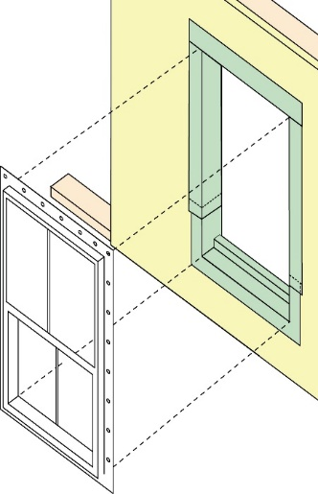  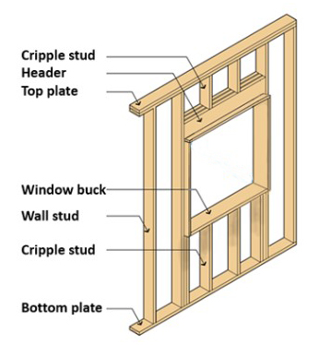  STEP 1: Install Window Buck Rough Opening Extension | 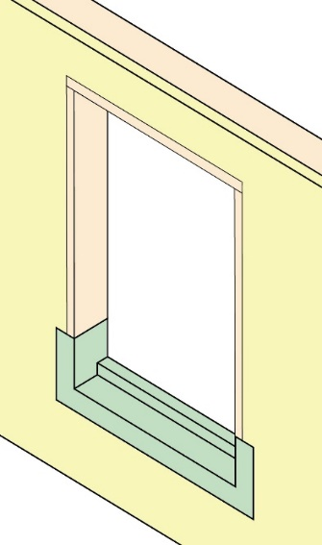  STEP 2: Install Back Dam and  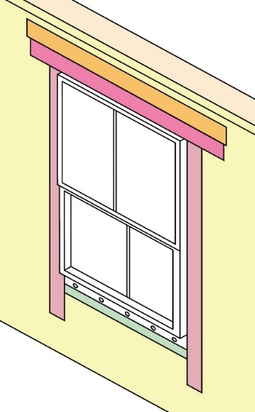  Sill Pan Flashing | 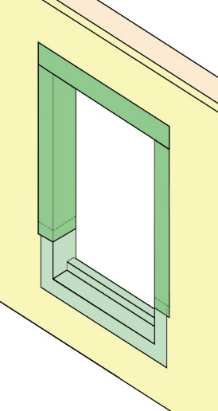  STEP 3: Install Rough Opening Jamb  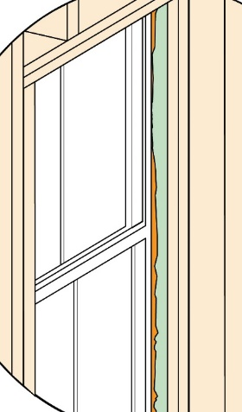  and Head Flashing
STEP 4: Install Window | STEP 5: Install External Jamb and Head Flashing & Termination Tape | STEP 6: Install air barrier sealant around window gap on inside
Figure 3.6.3.2: Window Buck Installation Method

3.6.3.3 Non-Finned Windows. Windows without fins, such as block frame windows, shall be installed in accordance with Figure 3.6.3.3. The window frame shall be of sufficient depth to overlap rough opening framing to provide adequate bearing support for shims and to accommodate any fenestration frame and hinge anchorages to the rough opening framing as required by the fenestration manufacturer’s installation instructions. Where these conditions cannot be satisfied, a window buck and flashing shall be installed in a manner consistent with Figure 3.6.3.2 or a design in accordance with Section 3.6.2.

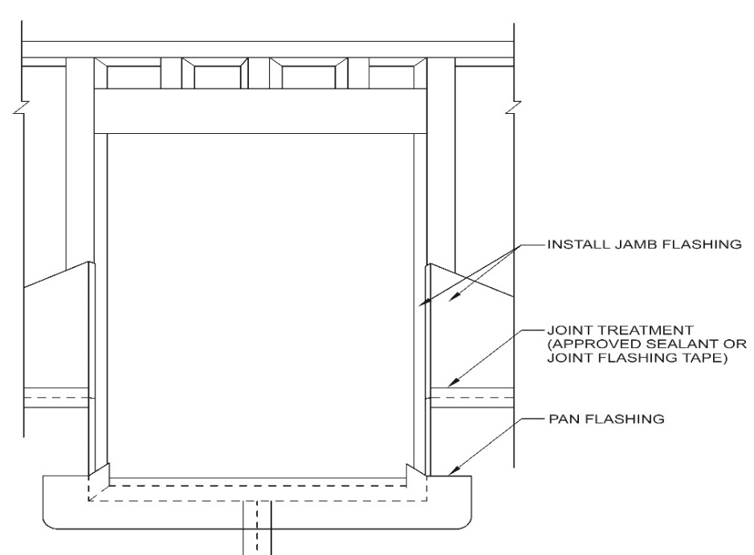
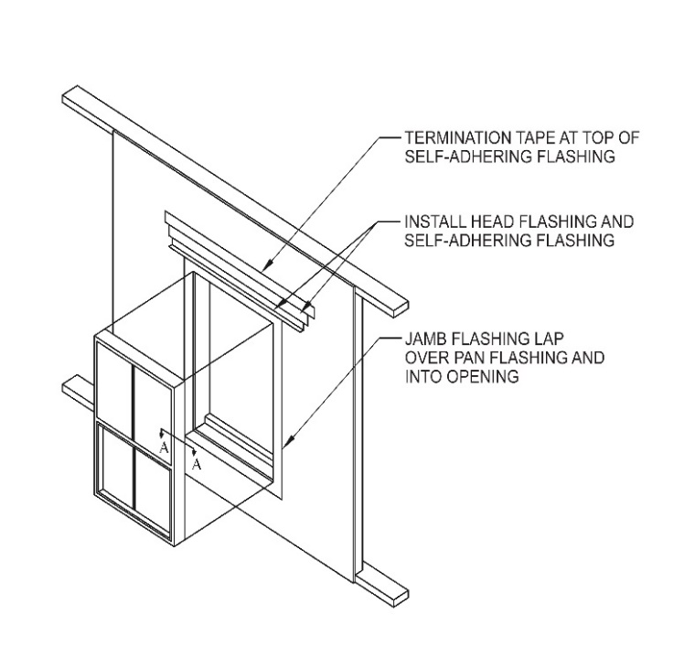 | 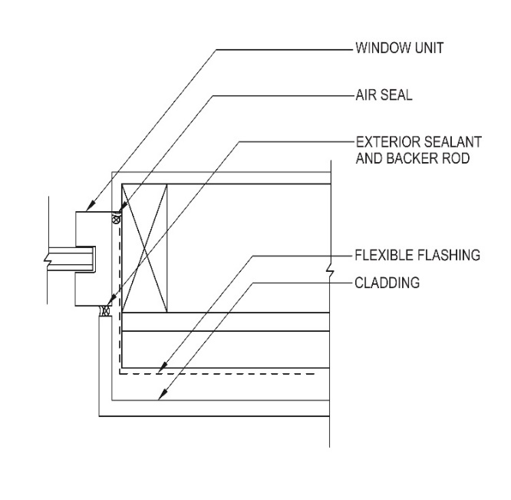
Figure 3.6.3.3: Installation of Block Frame (Non-Finned) Window
in Wall with FPIS WRB System
User Note: For block frame windows and in general, rough opening sill flashing or sill pans should be sloped to the exterior to maximize drainage.

3.6.3.4 Window Replacements and Additions. Full frame window replacements and addition of new windows to existing walls with FPIS WRB systems shall comply with the same detailing and installation requirements as indicated in Sections 3.6.3.1 through 3.6.3.3 for new construction.

3.6.3.5 Doors in Walls with FPIS WRB System

3.6.3.5.1 Doors with Perimeter Mounting Flanges (Nailing Fins). Doors with perimeter mounting flanges shall be installed with flashing, which shall be applied so as to integrate the flanges on the door unit with the FPIS WRB system. Doors with perimeter mounting flanges shall be installed in similar fashion to that required for installation of flanged windows in accordance with Section 3.6.3.1. Where fasteners for perimeter mounting flanges are applied through FPIS or other sheathing materials lacking nail-holding capacity equivalent to that of wood framing, the flange fastener length shall be specified to maintain required penetration into framing. In addition, the door frame shall be of sufficient depth to overlap rough opening framing to provide adequate bearing support for shims and to accommodate any fenestration frame or hinge anchorages to the rough opening framing as required by the door manufacturer’s installation instructions. Where these conditions cannot be satisfied, a rough opening extension buck as required by Section 3.6.3.2 shall be provided or a design providing adequate fenestration support. In all cases, door thresholds shall be fully supported on structural support materials.

3.6.3.5.2 Non-Finned Doors (Block Frame). Block frame doors with an integral or separately applied brick molding or similar water-tight architectural perimeter trim shall be installed in similar fashion to that required for the installation in non-finned (block frame) windows in Section 3.6.3.3. The door frame must be of sufficient depth to overlap rough opening framing to provide adequate bearing support for shims and to accommodate any fenestration frame and hinge anchorages to the rough opening framing as required by the door manufacturer’s installation instructions. Where these conditions cannot be satisfied, a rough opening extension buck as required by Section 3.6.3.2 shall be provided or a design providing adequate fenestration support. In all cases, door thresholds shall be fully supported on structural support materials.

3.6.3.5.3.4.3 Door Replacements and Additions. Door frame replacements and addition of new doors to existing walls with FPIS WRB systems shall comply with the same detailing and installation requirements as indicated in Sections 3.6.3.5.1 through 3.6.3.5.2 for new construction.

3.6.4 Qualification, Quality Assurance and Labeling Requirements. The FPIS material properties, quality assurance, and labeling shall comply with Chapter 1.

Chapter 4 - Connections Through FPIS

4.1 General. Cladding and other building component connections through FPIS shall comply with this section and shall be capable of resisting all applicable structural design loads in accordance with the locally applicable building code.

4.2 Specification Requirements. Cladding and other building component connections through FPIS shall be specified in accordance with one of the following:
1. Connection designs using design values determined in accordance with Section 4.2.1;
2. For cladding connections only, prescriptive solutions complying with Section 4.2.2; or,
3. Design values determined by testing and performance criteria complying with Mandatory Appendix C.

4.2.1 Performance Specification. Where applicable, the calculation procedures in this section shall be used by a registered design professional to determine the lateral (shear) and withdrawal design values for connections through FPIS. The lateral design value calculation procedures provided herein are applicable to FPIS having a maximum 4-inch thickness and a minimum 15 psi compressive strength in accordance with ASTM C578 or ASTM C1289. Other limitations as provided in Sections 4.2.1.1 and 4.2.1.2 shall apply. Where the limitations of the calculation procedures are not satisfied, design lateral (shear) values shall be determined in accordance with Mandatory Appendix C.

4.2.1.1 Connections Through FPIS to Wood framing. The installation and design of connections using dowel-type fasteners (i.e., nails and screws) shall comply with NDS including the additional requirements indicated in (a) and (b) below for connections including a layer of FPIS sandwiched between the connected parts.
a. Allowable withdrawal design values. Withdrawal design values for dowel-type fasteners shall be determined in accordance with NDS Section 12.2. Where dowel-type fasteners are installed through FPIS, the specified fastener length shall be sufficient to provide the design penetration into wood framing.
b. Reference lateral design values. Reference lateral (shear) design values for dowel-type fasteners shall be determined in accordance with NDS Section 12.3 with the following modifications and limitations where the connection includes a layer of FPIS sandwiched between the connected parts:
i. The reduction term, R_{d}, in accordance with NDS Table 12.3.1B shall not be less than 3.0.
ii. The yield limit equations in accordance with TR12 Table 1-1 which include a gap parameter, g, equal to the thickness of FPIS sandwiched between connected parts, shall be used in lieu of the yield limit equations in NDS Table 12.3.1A.
iii. The minimum fastener penetration in the main member (member receiving the fastener tip), including the thickness of wood structural panels attached to the main member, shall comply with NDS and shall not be less than 1 inch for screws or 1-1/4 inches for nails.
iv. The minimum specific gravity of wood materials being connected shall be 0.42.

User Note: The use of a minimum R_{d} value of 3.0 is intended to control long-term deflection and limit initial deflection to not more than 0.015 inches for dowel-type fasteners of ¼-inch diameter or less, FPIS of minimum 15psi compressive strength and maximum 4-inch thickness, wood materials of 0.42 specific gravity or greater, and the fastener penetration in the main member as indicated above (ABTG, 2015c). With application of the R_{d} value of 3.0 under these conditions of use, the resulting safety margins relative to ultimate lateral capacity are typically greater than 5.

4.2.1.2 Connections Through FPIS to Cold-formed steel framing. The installation and design of screw type connections shall comply with AISI S100 Section J4 with the additional requirements indicated in (a) and (b) below for connections including a layer of FPIS sandwiched between the connected parts. Where screw fasteners are installed through FPIS, the fastener length shall be sufficient to provide a minimum of three threads penetration through the cold-formed steel member receiving the fastener tip.
a. Tension allowable design values. Nominal tension design values for screw connections shall be determined in accordance with AISI S100 Section J4.4 and divided by a safety factor of not less than 3.0 to derive an allowable design tension value.
b. Shear allowable design values. Nominal shear strength design values for screws shall be determined in accordance with AISI S100 Section J4.3.1 and divided by a safety factor of not less than 3.0 to derive an allowable shear design value. Where the connection includes a layer of FPIS sandwiched between the connected parts, the following additional requirements and limitations shall apply:
i. For connections using #8 or #10 screws, AISI S100 Eq. J4.3.1-1 [P_{ns} = 4.2 (t₂³d)^{1/2}F_{u2} ] shall be multiplied by one of the following gap effect reduction factors, G_{r}, as applicable:
  - For #10 screw in 54 mil (0.054 in. (1.370 mm)) and 50 ksi (345 MPa) steel: G_{r} = 0.17 – 0.0048 r
  - For #10 screw in 43 mil (0.043 in. (1.09 mm)) and 33 ksi (228 MPa) steel:
G_{r} = 0.19 – 0.0066 r
  - For #8 or #10 screw in 33 mil (0.033 in. (0.838 mm)) and 33 ksi (228 MPa) steel: G_{r} = 0.16 – 0.0064 r
where,
G_{r} = Gap effect reduction factor for use with AISI S 100 Eq. J4.3.1-1
r = d_{sep}/d
d_{sep} = Separation between connected steel parts caused by thickness of FPIS, in. (mm)
d = Nominal screw diameter
= 0.164 in. (4.17 mm) for #8 screws
= 0.190 in. (4.83 mm) for #10 screws
ii. The value of r shall not exceed 21.
iii. For 0< r <2, calculated G_{r} in accordance with Item ‘i’ above does not need to be less than (1-r/2).
iv. A larger steel thickness and screw size than indicated in Item ‘i’ for the respective G_{r} equations shall be permitted provided the P_{ns} value calculated in accordance with AISI S100 Eq. 4.3.1-1 uses the screw size and steel thickness as indicated in Item ‘i’ for the respective G_{r} equations.
v. The material against the screw head shall be minimum 33 mil and 33 ksi steel, minimum 3/8-inch thick wood or wood-based material with a specific gravity of not less than 0.42, or equivalent.

User Note: The use of the gap reduction factors and a minimum safety factor of 3.0 is intended to control long-term deflection and limit short-term deflection to not more than 0.015-inches based on evaluation of test data to develop and confirm the design methodology (ABTG, 2015c). With application of the gap reduction factors to control deflection, the resulting safety factors are typically much greater than 3. The minimum15 psi limit and maximum 4-inch thickness for FPIS is associated with the test data upon which the gap reduction factor equations are based (ABTG, 2015c).

4.2.1.3 Connections Through FPIS to Concrete and Masonry. FPIS shall be secured to concrete or masonry construction in accordance with the FPIS manufacturer’s installation instructions or an approved design and shall be capable of resisting all applicable design loads in accordance with the applicable building code. Fasteners used to attach cladding, furring, or other building components through FPIS to concrete or masonry construction shall be approved for the application by testing in accordance with Mandatory Appendix C, designed to resist loads determined in accordance with the locally applicable building code and installed in accordance with the fastener manufacturer’s installation instructions.

4.2.2 Prescriptive Specification. The FPIS minimum compressive strength shall be 15 psi in accordance with ASTM C578 or ASTM C1289. Cladding connections through FPIS shall be the more stringent of:
(a) requirements in this section for support of cladding weight where attached through FPIS to wood framing (Section 4.2.2.1), cold-formed steel framing (Section 4.2.2.2), or wood structural panel sheathing (Section 4.2.2.3);
(b) the cladding manufacturer’s installation requirements; and
(c) the cladding connection requirements as prescribed in accordance with the locally applicable building code to resist applicable loads.

User Note: Prescriptive requirements for cladding connections to masonry and concrete materials are not provided in this section. Such connections generally rely on proprietary fasteners or anchors that are evaluated in accordance with Section 4.2.1.3 and other appropriate test standards for concrete connections. Refer to the concrete fastener manufacturer for connection design data or to an approved design.

4.2.2.1 Cladding Connection through FPIS to Wood Framing. Determine an appropriate cladding attachment requirement in accordance with one of the following:
a. Direct attachment of cladding through FPIS to wall framing in accordance with Figure 4.2.2.1a and Table 4.2.2.1a; or,
b. Furring attachment through FPIS to wall framing in accordance with Figure 4.2.2.1b and Table 4.2.2.1b whereby cladding is attached to the furring in accordance with the applicable building code or the cladding manufacturer’s installation instructions.

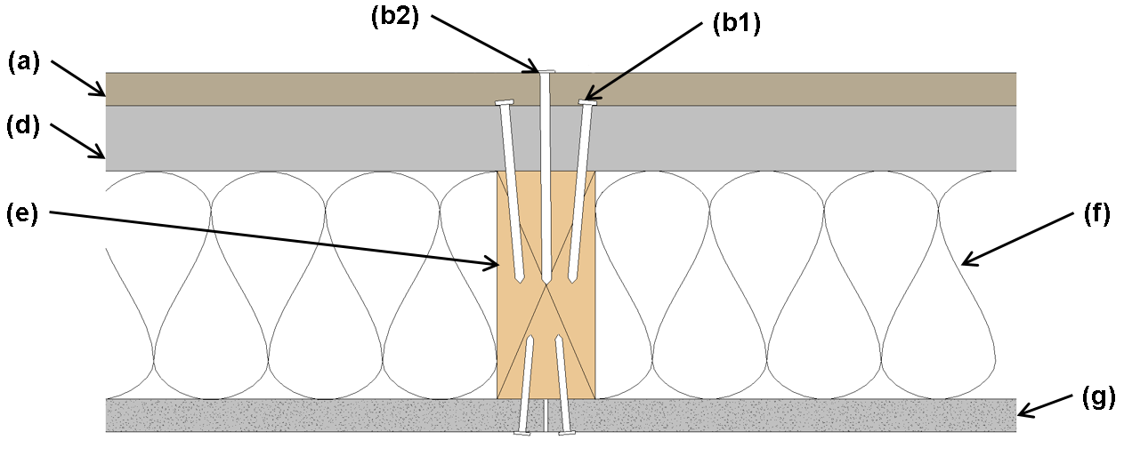
(a) Cladding
(b1) Fastener (Foam to Stud) per FPIS Manufacturer
(b2) Fastener (Cladding to Stud) per Table 4.2.2.1a
(d) FPIS
(e) Framing
(f) Cavity Insulation
(g) Wall Finish
Figure 4.2.2.1a: Plan View – Direct Cladding Connection through FPIS to Wood Stud

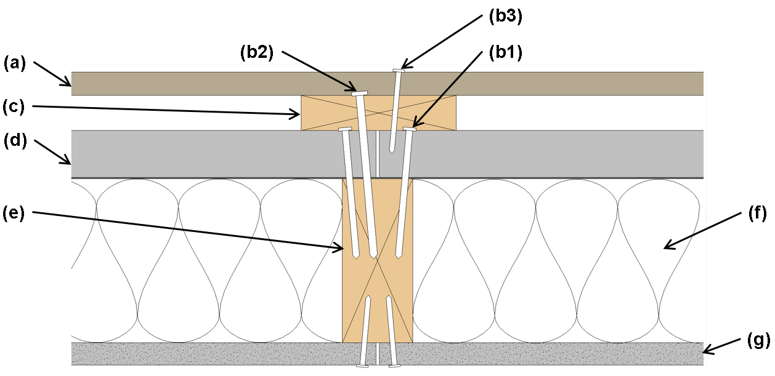 | (a) Cladding  (b1) Fastener (Foam to Stud) per FPIS Manufacturer  (b2) Fastener (Furring to Stud) per Table 4.2.2.1b  (b3) Fastener (Cladding to Furring) per Siding Manufacturer  (c) Wood Furring  (d) FPIS  (e) Framing  (f) Cavity Insulation  (g) Wall Finish
Figure 4.2.2.1b: Cladding Connection Using Wood Furring Attached Through FPIS to Wood Stud

Figure 4.2.2.1 Note: This figure is for cladding connection illustration only. Additional components or materials are generally required for code compliance depending on design conditions. These may include structural sheathing (where required for bracing), exterior gypsum sheathing (where required for exterior fire ratings), an interior vapor retarder, an air barrier, and a water-resistive barrier. FPIS may provide for some, but not all of these functions.
User Note (Tables 4.2.2.1a and b): To determine cladding weight for use of Tables 4.2.2.1a and b, add the actual weight of all materials on the exterior side of the foam sheathing. This includes, but is not limited to the cladding material, structural sheathing, furring, or other materials located exterior of the FPIS that are supported by the fastener extending through the FPIS and into the stud. Examples of cladding included in each weight category: 3 psf – vinyl siding, wood lap siding, most fiber cement siding; 11 psf – 3-coat stucco, 18 psf – medium weight adhered masonry veneer, 25 psf heavy adhered masonry veneer. Examples are not inclusive of all claddings. Refer to cladding manufacturer data for actual unit weight. For water-absorptive claddings such as stone or masonry veneer, the cladding weight should be based on a “wet” or saturated condition as defined in the manufacturer’s product data. Cladding and furring connections must be separately designed or comply with cladding manufacturer and locally applicable building code requirements where more stringent than these provisions for support of cladding weight only. Refer to commentary for supplemental guidance on designing wood furring for wind load resistance.

TABLE 4.2.2.1a: Siding Minimum Fastening Requirements for Direct Cladding Attachment
Over FPIS to Support Cladding System Weight^{1,2,3,4}
Cladding Fastener  Through FPIS  into: | Siding Fastener  Type &  Minimum Size | Siding  Fastener  Vertical  Spacing  (in.) | Maximum Thickness of FPIS (in.)
Cladding Fastener  Through FPIS  into: | Siding Fastener  Type &  Minimum Size | Siding  Fastener  Vertical  Spacing  (in.) | 16" o.c. Fastener Horizontal Spacing |  |  |  | 24" o.c. Fastener Horizontal Spacing
Cladding Fastener  Through FPIS  into: | Siding Fastener  Type &  Minimum Size | Siding  Fastener  Vertical  Spacing  (in.) | Max Cladding Weight: |  |  |  | Max Cladding Weight:
Cladding Fastener  Through FPIS  into: | Siding Fastener  Type &  Minimum Size | Siding  Fastener  Vertical  Spacing  (in.) | 3 psf | 11 psf | 18 psf | 25 psf | 3 psf | 11 psf | 18 psf | 25 psf
Wood Framing  (minimum  1¹/₄" penetration) | Nail  (0.113” shank; 0.226” head) | 6 | 2.00 | 1.45 | 0.75 | DR | 2.00 | 0.85 | DR | DR
Wood Framing  (minimum  1¹/₄" penetration) | Nail  (0.113” shank; 0.226” head) | 8 | 2.00 | 1.00 | DR | DR | 2.00 | 0.55 | DR | DR
Wood Framing  (minimum  1¹/₄" penetration) | Nail  (0.113” shank; 0.226” head) | 12 | 2.00 | 0.55 | DR | DR | 1.85 | DR | DR | DR
Wood Framing  (minimum  1¹/₄" penetration) | Nail  (0.120” shank; 0.281” head) | 6 | 3.00 | 1.70 | 0.90 | 0.55 | 3.00 | 1.05 | 0.50 | DR
Wood Framing  (minimum  1¹/₄" penetration) | Nail  (0.120” shank; 0.281” head) | 8 | 3.00 | 1.20 | 0.60 | DR | 3.00 | 0.70 | DR | DR
Wood Framing  (minimum  1¹/₄" penetration) | Nail  (0.120” shank; 0.281” head) | 12 | 3.00 | 0.70 | DR | DR | 2.15 | DR | DR | DR
Wood Framing  (minimum  1¹/₄" penetration) | Nail  (0.131” shank; 0.281” head) | 6 | 4.00 | 2.15 | 1.20 | 0.75 | 4.00 | 1.35 | 0.70 | DR
Wood Framing  (minimum  1¹/₄" penetration) | Nail  (0.131” shank; 0.281” head) | 8 | 4.00 | 1.55 | 0.80 | DR | 4.00 | 0.90 | DR | DR
Wood Framing  (minimum  1¹/₄" penetration) | Nail  (0.131” shank; 0.281” head) | 12 | 4.00 | 0.90 | DR | DR | 2.70 | 0.50 | DR | DR
Wood Framing  (minimum  1¹/₄" penetration) | 16d Nail  (0.162” shank; 0.344” head) | 6 | 4.00 | 3.55 | 2.05 | 1.40 | 4.00 | 2.25 | 1.25 | 0.80
Wood Framing  (minimum  1¹/₄" penetration) | 16d Nail  (0.162” shank; 0.344” head) | 8 | 4.00 | 2.55 | 1.45 | 0.95 | 4.00 | 1.60 | 0.85 | 0.50
Wood Framing  (minimum  1¹/₄" penetration) | 16d Nail  (0.162” shank; 0.344” head) | 12 | 4.00 | 1.60 | 0.85 | 0.50 | 4.00 | 0.95 | DR | DR
For SI: 1" = 25.4 mm; 1 pound per square foot [psf] = 0.0479 kPa
- Table values are based on wood framing of Spruce-Pine-Fir or any wood species with a specific gravity of 0.42 or greater in accordance with NDS. Required fastener minimum penetration shall be permitted to include thickness of wood structural panel sheathing materials.
- Nail fasteners shall comply with ASTM F1667, except nail length shall be permitted to exceed ASTM F1667 standard lengths. Fasteners of equivalent or greater diameter and bending strength shall be permitted.
- FPIS shall have a minimum compressive strength of 15 psi in accordance with ASTM C578 or ASTM C1289.
- DR = Design Required

TABLE 4.2.2.1b: Furring Minimum Fastening Requirements for Application Over FPIS to Support Cladding System Weight ^{1,2,3,4,5,6}
Furring  Material | Framing  Member | Fastener  Type &  Min. Size | Minimum  Penetration  into Wall  Framing (in.) | Fastener  Spacing  in Furring  (in.) | Maximum Thickness of FPIS (in.)
 |  |  |  |  | 16" o.c. Furring |  |  |  | 24" o.c. Furring
 |  |  |  |  | Siding Weight: |  |  |  | Siding Weight:
 |  |  |  |  | 3 psf | 11 psf | 18 psf | 25 psf | 3 psf | 11 psf | 18 psf | 25 psf
Min.  1x3 Wood  Furring | Min.  2x  Wood  Stud | Nail  (0.120" shank;  0.271" head) | 1¹/₄" | 8 | 3.00 | 1.85 | 1.05 | 0.65 | 3.00 | 1.20 | 0.60 | DR
 |  |  |  | 12 | 3.00 | 1.20 | 0.60 | DR | 3.00 | 0.70 | DR | DR
 |  |  |  | 16 | 3.00 | 0.80 | DR | DR | 2.30 | DR | DR | DR
Min.  1x3 Wood  Furring | Min.  2x  Wood  Stud | Nail  (0.131" shank;  0.281" head) | 1¹/₄" | 8 | 4.00 | 2.45 | 1.45 | 0.95 | 4.00 | 1.60 | 0.85 | DR
 |  |  |  | 12 | 4.00 | 1.60 | 0.85 | DR | 4.00 | 0.95 | DR | DR
 |  |  |  | 16 | 4.00 | 1.10 | DR | DR | 3.05 | 0.60 | DR | DR
Min.  1x3 Wood  Furring | Min.  2x  Wood  Stud | 16d Nail  (0.162” shank; 0.344” head) | 1¹/₄" | 8 | 4.00 | 4.00 | 2.45 | 1.60 | 4.00 | 2.75 | 1.45 | 0.85
 |  |  |  | 12 | 4.00 | 2.75 | 1.45 | 0.85 | 4.00 | 1.65 | 0.75 | DR
 |  |  |  | 16 | 4.00 | 1.90 | 0.95 | DR | 4.00 | 1.05 | DR | DR
Min.  1x3 Wood  Furring | Min.  2x  Wood  Stud | #10 wood  screw  (0.363” head) | 1" | 12 | 4.00 | 2.30 | 1.20 | 0.70 | 4.00 | 1.40 | 0.60 | DR
 |  |  |  | 16 | 4.00 | 1.65 | 0.75 | DR | 4.00 | 0.90 | DR | DR
 |  |  |  | 24 | 4.00 | 0.90 | DR | DR | 2.85 | DR | DR | DR
Min.  1x3 Wood  Furring | Min.  2x  Wood  Stud | ¼" hex lag screw | 1¹/₂" | 12 | 4.00 | 2.65 | 1.50 | 0.90 | 4.00 | 1.65 | 0.80 | DR
 |  |  |  | 16 | 4.00 | 1.95 | 0.95 | 0.50 | 4.00 | 1.10 | DR | DR
 |  |  |  | 24 | 4.00 | 1.10 | DR | DR | 3.25 | 0.50 | DR | DR
For SI: 1" = 25.4 mm; 1 pound per square foot (psf) = 0.0479 kPa
- Table values are based on wood framing and furring of Spruce-Pine-Fir or any wood species with a specific gravity of 0.42 or greater in accordance with NDS.
- Nail fasteners shall comply with ASTM F1667, except nail length shall be permitted to exceed ASTM F1667 standard lengths. Wood screws and lag screws shall comply with NDS Appendix L and ANSI/ASME B18.6.1. Other approved fasteners of equivalent or greater diameter and bending strength shall be permitted. Required fastener minimum penetration shall be permitted to include thickness of wood structural panel sheathing materials.
- A minimum 2x wood furring shall be used where the required siding fastener penetration into wood material exceeds ¾" (19.1 mm) and is not more than 1¹/₂" (38.1 mm), unless approved deformed shank siding nails or siding screws are used to provide equivalent withdrawal strength, allowing the siding connection to be made to a 1x wood furring.
- Furring shall be spaced a maximum of 24" o.c. in a vertical or horizontal orientation.
- In a vertical orientation, furring shall be located over wall studs and attached with the required fastener spacing.
- Furring strips installed in a horizontal direction shall be fastened at each stud with a number of fasteners equivalent to that required by the fastener spacing. If the required nail spacing is 12" o.c. and the studs are 24" o.c., then two (2) nails would be required at each stud (24/12=2). In no case shall fasteners be spaced more than 24" (0.6 m) apart.
- FPIS shall have a minimum compressive strength of 15 psi, in accordance with ASTM C578 or ASTM C1289.
- DR = Design Required

4.2.2.2 Cladding Attachment through FPIS to Cold-formed Steel Framing. Determine an appropriate cladding attachment requirement in accordance with one of the following:
a. Direct attachment of cladding through FPIS to wall framing in accordance with Figure 4.2.2.2a and Table 4.2.2.2a; or,
b. Furring attachment through FPIS to wall framing in accordance with Figures 4.2.2.2b(1) or (2) and Table 4.2.2.2b whereby cladding is attached to the furring in accordance with the applicable building code or the cladding manufacturer’s installation instructions.

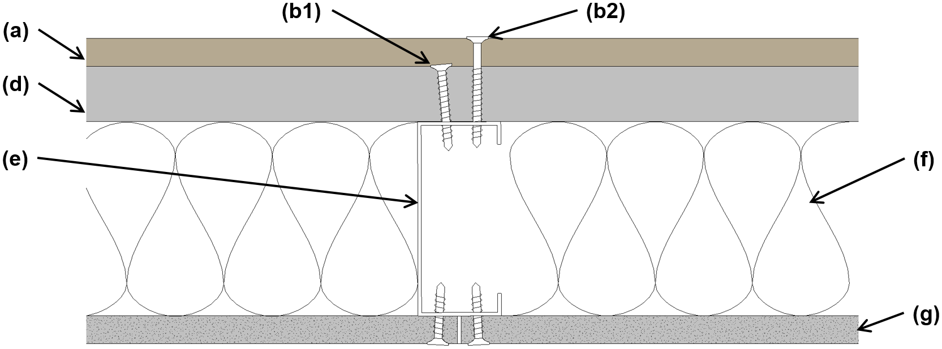 | (a) Cladding  (b1) Fastener (Foam to Stud) per FPIS Manufacturer  (b2) Fastener (Cladding to Stud) per Table 4.2.2.2a  (d) FPIS  (e) Framing  (f) Cavity Insulation  (g) Wall Finish
Figure 4.2.2.2a: Plan View – Direct Cladding Connection Through FPIS to Cold-formed Steel Stud

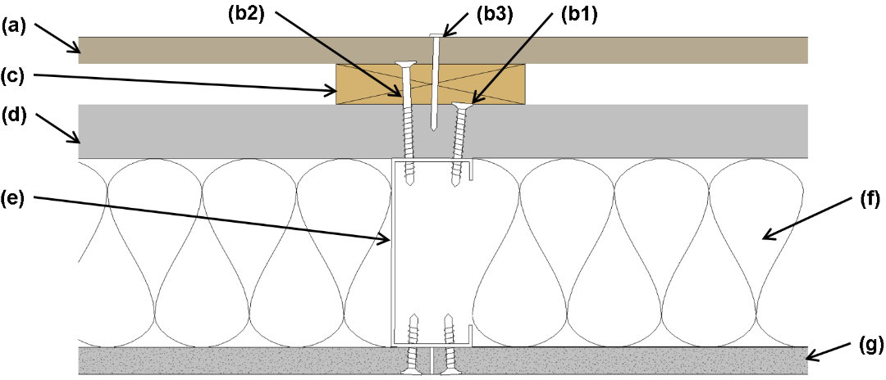 | (a) Cladding  (b1) Fastener (Foam to Stud) per FPIS Manufacturer  (b2) Fastener (Furring to Stud) per Table 4.2.2.2b  (b3) Fastener (Cladding to Furring) per Siding Manufacturer  (c) Wood Furring  (d) FPIS  (e) Framing  (f) Cavity Insulation  (g) Wall Finish

Figure 4.2.2.2b(1): Cladding Connection to Vertical Furring Attached Through FPIS to Cold-formed Steel Stud

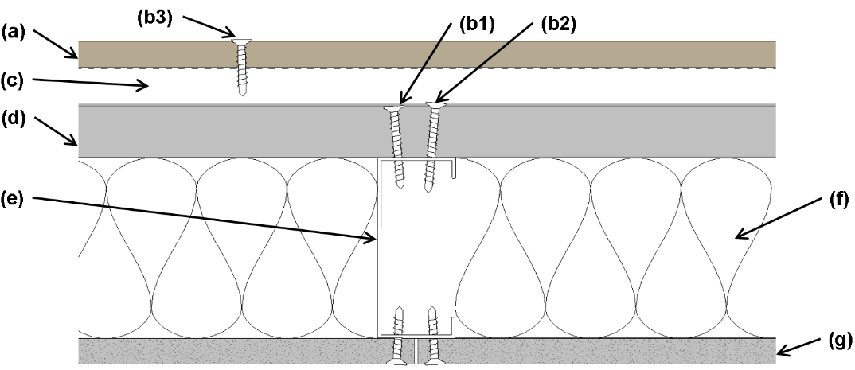
Figure 4.2.2.2b(2): Cladding Connection to Horizontal Steel Furring (Hat Channel) Perpendicular to Cold-formed Steel Studs and Connected through FPIS to Cold-formed Steed Studs.
(a) Cladding
(b1) Fastener (Foam to Stud) per FPIS manufacturer
(b2) Fastener (Hat Channel to Stud – fasten alternate or both flanges at each stud location) per Table 4.2.2.2b
(b3) Fastener (Cladding to Hat Channel) per Siding Manufacturer
(c) Hat Channel Furring (Horizontal Shown)
(d) FPIS
(e) Framing
(f) Cavity Insulation
(g) Wall Finish

User Note (Figure 4.2.2.2): This figure is for cladding attachment illustration only. Additional components or materials are generally required for code compliance depending on design conditions. These may include structural sheathing (where required for bracing), exterior gypsum sheathing (where required for exterior fire ratings), an interior vapor retarder, an air barrier, and a water-resistive barrier. FPIS may provide for some, but not all of these functions.
User Note (Tables 4.2.2.2a and b): Tables 4.2.2.2a and b address only shear capacity of fastening to support cladding weight. To determine cladding weight, add the actual weight of all materials on the exterior side of the foam sheathing. This includes, but is not limited to the cladding material, structural sheathing, furring, or other materials located exterior of the FPIS that are supported by the fastener extending through the FPIS and into the stud. Examples of cladding included in each weight category: 3 psf – vinyl siding, wood lap siding, most fiber cement siding; 11 psf – 3-coat stucco, 18 psf – medium weight adhered masonry veneer, 25 psf heavy adhered masonry veneer. Examples are not inclusive of all claddings. Refer to cladding manufacturer data for actual unit weight. For water-absorptive claddings such as stone or masonry veneer, the cladding weight should be based on a “wet” or saturated condition as defined in the manufacturer’s product data. Cladding and furring connections must be separately designed or comply with cladding manufacturer and locally applicable building code requirements where more stringent than these provisions for support of cladding weight only. Refer to commentary for supplemental guidance on designing metal furring for wind load resistance.

TABLE 4.2.2.2a: Siding Minimum Fastening Requirements for Direct Cladding Attachment
Over FPIS to Support Cladding System Weight ^{1,2,3,4}
Cladding Fastener  Through FPIS  into: | Siding Fastener  Type &  Minimum Size | Siding  Fastener  Vertical  Spacing  (in.) | Maximum Thickness of FPIS (in.)
Cladding Fastener  Through FPIS  into: | Siding Fastener  Type &  Minimum Size | Siding  Fastener  Vertical  Spacing  (in.) | 16" o.c. Fastener Horizontal Spacing |  |  |  | 24" o.c. Fastener Horizontal Spacing
Cladding Fastener  Through FPIS  into: | Siding Fastener  Type &  Minimum Size | Siding  Fastener  Vertical  Spacing  (in.) | Max Cladding Weight: |  |  |  | Max Cladding Weight:
Cladding Fastener  Through FPIS  into: | Siding Fastener  Type &  Minimum Size | Siding  Fastener  Vertical  Spacing  (in.) | 3 psf | 11 psf | 18 psf | 25 psf | 3 psf | 11 psf | 18 psf | 25 psf
Steel Framing  (minimum  penetration of steel  thickness + 3  threads) | #8 screw (0.285” head)  into 33 mil steel  or thicker | 6 | 3.00 | 2.95 | 2.20 | 1.45 | 3.00 | 2.35 | 1.25 | DR
 | #8 screw (0.285” head)  into 33 mil steel  or thicker | 8 | 3.00 | 2.55 | 1.60 | 0.60 | 3.00 | 1.80 | DR | DR
 | #8 screw (0.285” head)  into 33 mil steel  or thicker | 12 | 3.00 | 1.80 | DR | DR | 3.00 | 0.65 | DR | DR
 | #10 (0.333” head) screw  into 33 mil steel | 6 | 4.00 | 3.50 | 2.70 | 1.95 | 4.00 | 2.90 | 1.70 | 0.55
 | #10 (0.333” head) screw  into 33 mil steel | 8 | 4.00 | 3.10 | 2.05 | 1.00 | 4.00 | 2.25 | 0.70 | DR
 | #10 (0.333” head) screw  into 33 mil steel | 12 | 4.00 | 2.25 | 0.70 | DR | 3.70 | 1.05 | DR | DR
 | #10 (0.333” head) screw  into 43 mil steel  or thicker | 6 | 4.00 | 4.00 | 4.00 | 3.60 | 4.00 | 4.00 | 3.45 | 2.70
 | #10 (0.333” head) screw  into 43 mil steel  or thicker | 8 | 4.00 | 4.00 | 3.70 | 3.00 | 4.00 | 3.85 | 2.80 | 1.80
 | #10 (0.333” head) screw  into 43 mil steel  or thicker | 12 | 4.00 | 3.85 | 2.80 | 1.80 | 4.00 | 3.05 | 1.50 | DR
For SI: 1" = 25.4 mm; 1 pound per square foot [psf] = 0.0479 kPa
- Tabulated values are based on minimum 33 ksi steel for 33 mil and 43 mil steel and 50 ksi steel for 54 mil steel or thicker.
- Screws shall comply with the requirements of ASTM C1513.
- FPIS shall have a minimum compressive strength of 15 psi in accordance with ASTM C578 or ASTM C1289.
- DR = Design Required

TABLE 4.2.2.2b: Furring Minimum Fastening Requirements for Application Over FPIS Sheathing to Support Cladding System Weight ^{1,2,3,4,5}
Furring  Material | Framing  Member | Fastener  Type &  Min. Size | Minimum  Penetration  into Wall  Framing (in.) | Fastener  Spacing  in Furring  (in.) | Maximum Thickness of FPIS (in.)
 |  |  |  |  | 16" o.c. Furring |  |  |  | 24" o.c. Furring
 |  |  |  |  | Siding Weight: |  |  |  | Siding Weight:
 |  |  |  |  | 3 psf | 11 psf | 18 psf | 25 psf | 3 psf | 11 psf | 18 psf | 25 psf
Minimum  33mil  Steel Hat  Channel  or  Minimum  1x3 Wood  Furring | 33 mil  Cold-formed Steel Stud | #8 screw  (0.285" head) | Steel  thickness +3  threads | 12 | 3.00 | 1.80 | DR | DR | 3.00 | 0.65 | DR | DR
 |  |  |  | 16 | 3.00 | 1.00 | DR | DR | 2.85 | DR | DR | DR
 |  |  |  | 24 | 2.85 | DR | DR | DR | 2.20 | DR | DR | DR
 | 33 mil  Cold-formed Steel Stud | #10 screw  (0.333" head) | Steel  thickness +3  threads | 12 | 4.00 | 2.25 | 0.70 | DR | 3.70 | 1.05 | DR | DR
 |  |  |  | 16 | 3.85 | 1.45 | DR | DR | 3.40 | DR | DR | DR
 |  |  |  | 24 | 3.40 | DR | DR | DR | 2.70 | DR | DR | DR
 | 43 mil  or  thicker  Cold-formed Steel Stud | #8 screw  (0.285" head) | Steel  thickness +3  threads | 12 | 3.00 | 1.80 | DR | DR | 3.00 | 0.65 | DR | DR
 |  |  |  | 16 | 3.00 | 1.00 | DR | DR | 2.85 | DR | DR | DR
 |  |  |  | 24 | 2.85 | DR | DR | DR | 2.20 | DR | DR | DR
 | 43 mil  or  thicker  Cold-formed Steel Stud | #10 screw  (0.333" head) | Steel  thickness +3  threads | 12 | 4.00 | 3.85 | 2.80 | 1.80 | 4.00 | 3.05 | 1.50 | DR
 |  |  |  | 16 | 4.00 | 3.30 | 1.95 | 0.60 | 4.00 | 2.25 | DR | DR
 |  |  |  | 24 | 4.00 | 2.25 | DR | DR | 4.00 | 0.65 | DR | DR
For SI: 1" = 25.4 mm; 1 pound per square foot (psf) = 0.0479 kPa
- Table values are based on:
  - Wood furring of Spruce-Pine-Fir or any softwood species with a specific gravity of 0.42 or greater per NDS.
  - Minimum 33 mil steel hat channel furring of 33 ksi steel. Steel hat channel shall have a minimum ⁷/₈" (22.2 mm) depth, 1-1/4” (32 mm) web width, and ½” (12.7 mm) wide flanges with web or flanges bearing on FPIS surface.
  - Cold-formed steel framing of indicated nominal steel thickness and minimum 33 ksi steel for 33 mil and 43 mil steel and 50 ksi steel for 54 mil steel or thicker.
- Screws shall comply with the requirements of ASTM C1513.
- Furring shall be spaced a maximum of 24" o.c. in a vertical or horizontal orientation.
  - In a vertical orientation, furring shall be located over wall studs and attached with the required fastener spacing.
  - Where placed horizontally, furring shall fastened at each stud with a number of fasteners equivalent to that required by the fastener spacing. If the required fastener spacing is 12" o.c. and the studs are 24" o.c., then two (2) fasteners would be required at each stud (24/12=2). In no case shall fasteners be spaced more than 24" (0.6 m) apart.
4. FPIS shall have a minimum compressive strength of 15 psi, in accordance with ASTM C578 or ASTM C1289.
5. DR = Design Required

4.2.2.3 Lightweight Cladding Connection through FPIS to Wood Structural Panels. Direct connection of lightweight cladding (maximum 3 psf unit weight) through FPIS (maximum 2-inches thick and minimum 15 psi compressive strength) to wood structural panels (minimum 7/16-inch thickness) shall comply with Figure 4.2.2.3(a) or (b) and Table 4.2.2.3. The cladding fastener shall be of sufficient length to penetrate a minimum of ¼-inch beyond the back side of the wood structural panel sheathing. Fastener minimum size and maximum spacing shall comply with the cladding manufacturer’s installation instructions where more stringent.

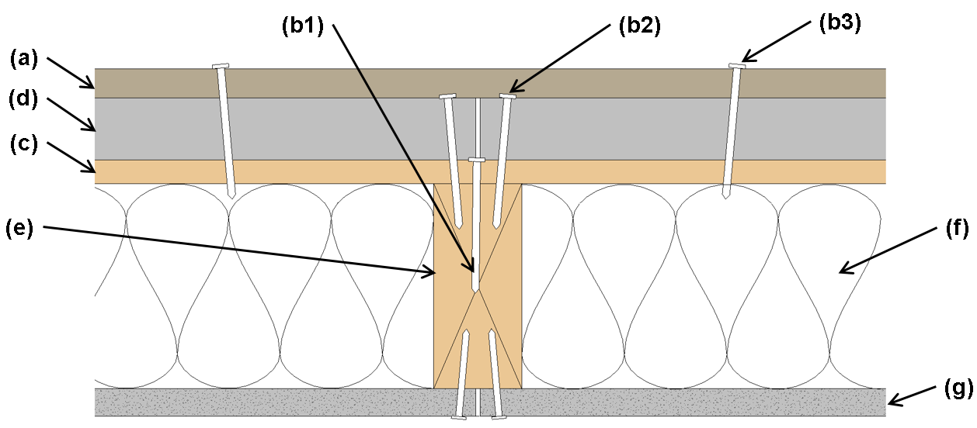
(a) Cladding
(b1) Fastener (WSP to Stud) per code
(b2) Fastener (Foam to Stud) per FPIS manufacturer
(b3) Fastener (Cladding to WSP – nail or screw) per Table 4.2.2.3
(c) WSP
(d) FPIS
(e) Framing
(f) Cavity Insulation
(g) Wall Finish
Figure 4.2.2.3a: Cladding Connection through FPIS to Wood Structural Panels (WSP) on a Wood Frame Wall

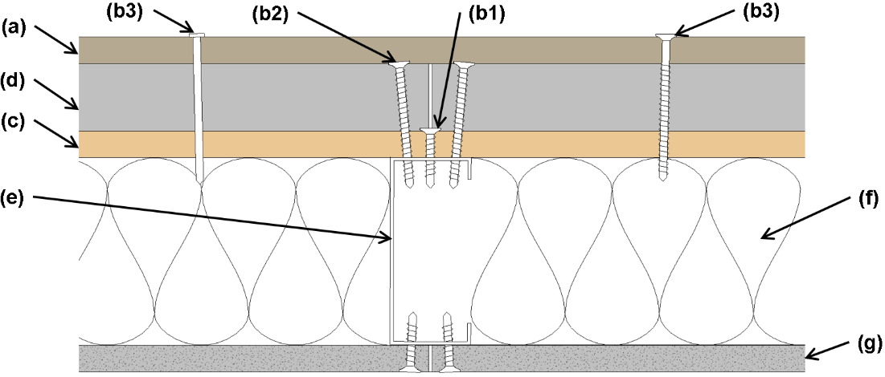
(a) Cladding
(b1) Fastener (WSP to Stud) per code
(b2) Fastener (Foam to Stud) per FPIS manufacturer
(b3) Fastener (Cladding to WSP – nail or screw) per Table 4.2.2.3
(c) WSP
(d) FPIS
(e) Framing
(f) Cavity Insulation
(g) Wall Finish
Figure 4.2.2.3b: Cladding Connection through FPIS to Wood Structural Panels (WSP) on a Cold-Formed Steel Frame Wall

Figure 4.2.2.3 Note: This figure is for cladding connection illustration only. Additional components or materials are generally required for code compliance depending on design conditions. These may include exterior gypsum sheathing (where required for exterior fire ratings), an interior vapor retarder, an air barrier, and a water-resistive barrier. FPIS may provide for some, but not all of these functions.

TABLE 4.2.2.3: Light-weight Cladding Minimum Fastening Requirements for Attachment Through Maximum 2-inch-thick FPIS to Minimum 7/16-inch-thick Wood Structural Panel ¹
Type and Size of Fastener | Horizontal Spacing of Fasteners along Siding (inches)
Roof sheathing ring shank nail (0.120” min. shank; 0.281” head) | 12” oc
Post frame ring shank nail (0.148” min. shank; 5/16” head) | 15” oc
No. 6 screw (0.138” min. shank; 0.262” head) | 12” oc
No. 8 screw (0.164” min. shank; 0.312” head) | 16” oc
For SI: 1" = 25.4 mm
- Horizontal spacing of fasteners along siding is based on a siding width (distance between horizontal rows of fasteners) of 12 inches. For other siding widths, multiply required horizontal spacing by 12/w where w is the siding width in inches.

4.3 Installation Requirements. The FPIS, cladding materials, components, and fasteners shall be installed in accordance with the respective manufacturer’s installation instructions, the locally applicable building code, or an approved design as applicable. Fasteners shall be installed to provide substantial contact between all materials without gaps and without causing excessive distortion or compression of connected materials.

4.4 Qualification, Quality Assurance, and Labeling Requirements. Fasteners used in accordance with this standard shall comply with standards applicable to the specified fastener and the locally applicable building code. Alternative fastening materials and methods evaluated in accordance with Mandatory Appendix C shall be specified consistent with standards and material properties applicable to the specific fastening materials. The FPIS material properties, quality assurance, and labeling shall comply with Chapter 1.

Chapter 5 – Reference Documents
User Note: References included in Chapter 5 are normative (mandatory) because they are referenced in the mandatory provisions of the standard. For informational references included in user notes and the commentary, refer to Commentary & User Note References at the end of the standard.
FMA/AAMA/WDMA 500-16, Standard Practice for the Installation of Mounting Flange Windows into Walls Utilizing Foam Plastic Insulating Sheathing (FPIS) with a Separate Water-Resistive Barrier (WRB)
AAMA TIR-504-20, Voluntary Laboratory Test Method to Qualify Vertical Fenestration Installation Procedures
AAMA 711-13, Voluntary Specification for Self-Adhering Flashing Used for Installation of Exterior Wall Fenestration
AAMA 714-19, Voluntary Specification for Liquid Applied Flashing Used to Create a Water-Resistive Seal around Exterior Wall Openings in Buildings
AATCC Test Method 127-1998, Water Resistance: Hydrostatic Pressure Test, American Association of Textile Chemists and Colorists
AISI S100-16, North American Specification for the Design of Cold-Formed Steel Structural Members
ANSI/ASME B18.6.1-1981 (R2016), Wood Screws (Inch Series)
ANSI/ABTG FS 100 – 2012 (R2018), Standard Requirements for Wind Pressure Resistance of Foam Plastic Insulating Sheathing Used in Exterior Wall Covering Assemblies
ASCE 7-16, Minimum Design Loads and Associated Criteria for Buildings and Other Structures
ASTM C578-19, Standard Specification for Rigid, Cellular Polystyrene Thermal Insulation
ASTM C1289-19, Standard Specification for Faced Rigid Cellular Polyisocyanurate Thermal Insulation Board
ASTM C1513-18, Standard Specification for Steel Tapping Screws for Cold-Formed Steel Framing Connections
ASTM D1761-20, Standard Test Methods for Mechanical Fasteners in Wood
ASTM D3679-17, Standard Specification for Rigid Poly(Vinyl Chloride) (PVC) Siding
ASTM E96-16, Standard Test Methods for Water Vapor Transmission of Materials
ASTM E283-19, Standard Test Method for Determining Rate of Air Leakage Through Exterior Windows, Curtain Walls, and Doors Under Specified Pressure Differences Across the Specimen
ASTM E 331-00(2016), Standard Test Method for Water Penetration of Exterior Windows, Skylights, Doors and Curtain Walls by Uniform Static Air Pressure Difference
ASTM E1677-19, Standard Specification for Air Barrier (AB) Material or System for Low-Rise Framed Building Walls
ASTM E1886-19, Standard Test Method for Performance of Exterior Windows, Curtain Walls, Doors, and Impact Protective Systems Impacted by Missile(s) and Exposed to Cyclic Pressure Differentials
ASTM E2178-13, Standard Test Method for Air Permeance of Building Materials
ASTM E2273-18, Standard Test Method for Determining Drainage Efficiency of Exterior Insulation and Finish Systems (EIFS) Clad Wall Assemblies
ASTM E2357-18, Standard Test Method for Determining Air Leakage of Air Barrier Assemblies
ASTM E2556-10(2016), Standard Specification for Vapor Permeable Flexible Sheet Water-Resistive Barriers Intended for Mechanical Attachment
ASTM E2925-19, Standard Specification for Manufactured Polymeric Drainage and Ventilation Materials Used to Provide a Rainscreen Function
ASTM F1667-18a, Standard Specification for Driven Fasteners: Nails, Spikes, and Staples
ASTM G154-16, Standard Practice for Operating Florescent Ultraviolet (UV) Lamp Apparatus for Exposure of Nonmetalic Materials
NDS, National Design Specification (NDS®) for Wood Construction, American Wood Council, Leesburg, VA, 2018
TR12, General Dowel Equations for Calculating Lateral Connection Values, American Wood Council, Leesburg, VA, 2015.

Mandatory Appendix A – Quality Assurance

A.1. General. FPIS and related accessories or components complying with specific portions or requirements of this standard for various end-use applications shall be produced under a quality assurance program administered by an approved agency. An approved quality assurance manual shall be developed in collaboration with the approved agency. The quality assurance manual shall specify quality assurance testing and process control requirements in accordance with Section 1.4 of this standard for the evaluated characteristics applicable to the intended uses of the FPIS product in accordance with this standard.

A.2. Quality Assurance Testing

A.2.1. Testing shall be conducted by an approved agency.

A.2.2. Test equipment located at the manufacturing facility or off-site shall be properly maintained, calibrated, and evaluated for precision, accuracy, and adequacy at a frequency satisfactory to the approved agency and the entity providing certification and auditing of the approved agency.

A.2.3. The frequency of critical tests as required by this standard shall be chosen by the approved agency to yield quality assurance that supports maintenance of performance as required for qualification in accordance with intended FPIS applications as addressed in this standard.

A.3. Process Control

A.3.1. Data from quality assurance verification tests required by the quality assurance program and approved quality assurance manual outlined in Section A.1 shall be evaluated prior to shipment of the material represented by the sample. The evaluation shall assess conformity to control levels selected to support maintenance of performance as required for specific qualifications in accordance with this standard.

A.3.2. When the analysis described in A.3.1 indicates that the product is below the control level, the associated portion of production shall be subject to re-examination in accordance with the acceptance procedures provided in the approved quality assurance manual (see Section A.1).

A.3.3. All pertinent records shall be maintained for a minimum of five years and be available for review by both in-house and approved agency personnel. At a minimum, such records shall include:

A.3.3.1. All inspection reports and records of test equipment calibration, whether accomplished by in-house or by approved agency personnel.

A.3.3.2. All test data, including retests and data associated with rejected production.

A.3.3.3. Details of any corrective actions taken and the disposition of any rejected production resulting from tests or inspection.

A.4. Alternate to Full-Scale Testing. Quality control testing shall be permitted to be based on correlation to material properties evaluated in this standard as a substitute for full-scale testing as required in this standard for qualification purposes.

A.5. Requalification. Where any one or more components are reformulated in a manner considered significant by the approved agency responsible for quality assurance testing, requalification in accordance with this standard shall be required for the reformulated component and its use in an assembly, if applicable.

MANDATORY APPENDIX B – Standard Practice for Evaluation of Water-Resistive Barrier Application of FPIS

B.1 General

B.1.1. Purpose. This appendix includes detailed requirements for qualification.

B.1.2. Requirements. Where intended to be used as a WRB system, FPIS, joint treatments, and flashing components shall be evaluated in accordance with Sections B.2 and B.3.

B.1.3. Sampling. FPIS products and components used to conduct evaluations for qualification in accordance with Sections B.2 and B.3 shall be representative of and sampled from normal production. Sample selection shall be approved by the evaluation agency.

B.2. Evaluation of Materials for a FPIS WRB System

B.2.1. FPIS. The FPIS, including facers, if any, shall comply with Sections B.2.1.1 and B.2.1.2.

B.2.1.1. Durability (Weathering). Three specimens (8 inches x 8 inches (203 mm x 203 mm) each) of the FPIS, including facer (if used), shall be prepared from product sampled in accordance with Section B.1.3. The sample shall be of the minimum thickness and compressive strength intended for use for each FPIS variation considered for qualification under this standard as an FPIS WRB system. The specimens shall be subject to the durability pre-conditioning sequence shown in Table B1 and shall show no visible delamination or blistering of the external layer.

B.2.1.2. Water Resistance (small specimen, hydrostatic). Following durability pre-conditioning in accordance with Section B.2.1.1, the weathered specimens shall be tested in accordance with AATCC Test Method 127 with a hydrostatic head of 21.6 inches (55 cm) sustained for 5 hours. None of the specimens shall exhibit water leakage on the underside.
User Note: For the purposes of Section B.2.1.2, the definition of water leakage is defined as more than 3 drops of water over 5 hours of testing and explained in the non-mandatory appendix of ASTM E 2556.

B.2.1.3. Allowance for Combined Evaluation. Where joint sealing treatments are used and tested in accordance with Section B.2.2, the prepared specimens with joints shall be permitted to also qualify the FPIS as required by Section B.2.1 provided the surface area exposed to water resistance testing in accordance with Section B.2.1.2 spans the complete joint treatment and at least 2.4 inches (61 mm) in width of the wetted area is the exposed surface of the FPIS extending beyond the joint treatment. Both edges of the joint sealant shall be exposed to water resistance testing.

B.2.2. FPIS WRB System Interface Detailing Methods and Materials. Flashing products, joint sealing treatments, and joint methods used as interfacing components of a continuous FPIS WRB system shall be assessed in accordance with Section B.3 and Table B2.
TABLE B1
Durability Pre-Conditioning Sequence
Weathering Condition | Procedure
Ultraviolet Light Exposure | Option A: Expose specimens to light from ultraviolet sun lamps with bulbs producing UV characteristics of 5.0 W/m²/nm irradiance at a wavelength of 315 to 400 nm at 1 meter. The exposure condition shall cause a uniform and sustained specimen temperature between 135ºF to 140ºF for 210 hours (10 hours per day for 21 days). Ultraviolet light exposure shall be directed to those surfaces exposed to sunlight after typical installation.  Option B: Expose specimens to fluorescent UVA-340 lamps in a fluorescent UV condensation apparatus operated in accordance with Practice G154, Cycle 1. The samples shall be exposed for a duration of 2 weeks (336 h). UV radiation exposure shall be directed on the sample surfaces that will be exposed to sunlight in normal applications.
Accelerated Aging | Following the ultraviolet light exposure, subject specimens to 25 cycles of drying and wetting as follows:  - Oven dry specimens at 120ºF (49 C) for three hours, with all surfaces exposed  - Immerse specimens in room temperature tap water for three hours, with all surfaces submerged  - Remove specimens from immersion, blot dry, and then air-dry for 18 hours at 75ºF+/-5ºF (23.8 C +/- 2.8C) with all surfaces exposed.

User Note: For U/V exposure, Option A is based on current provisions in ICC-ES AC 71 and ICC-ES AC 38. Option B is based on criteria in ASTM E2556. Both of these U/V exposures are recognized as acceptable criteria for evaluation of durability of water-resistive barriers and, thus, are provided as options. For accelerated aging, the criteria are based on ICC-ES AC 71 and focus on wetting and drying cycles under controlled temperature conditions; requirements in ASTM E2556 and AC38 are essentially the same. For the purpose of considering dimensional stability under varying temperature and humidity conditions, the FPIS material standards, ASTM C578 and ASTM C1289, referenced in Chapter 1 are used. In addition to these durability requirements under controlled laboratory conditions, manufacturers also may conduct field exposure studies of specimens or full assemblies to further evaluate durability performance and dimensional stability under long-term exposure to actual conditions of use.

TABLE B2
Qualification Requirements for Interface Detailing Methods and Materials
Method | Requirement
Self-Adhering Flashing | Comply with AAMA 711, including an assessment of compatibility with the FPIS product(s) and other substrates intended for qualification in accordance with this standard; compatibility shall be determined in accordance with Section 6.4 of AAMA 711.
Liquid Applied Flashing | Comply with AAMA 714, including the assessment of compatibility with the FPIS product(s) and other substrates intended for qualification in accordance with this standard; compatibility shall be determined in accordance with Section 7.1 of AAMA 714.
FPIS joint sealing treatments and penetration flashing treatments | Section B.2.3 or B.2.4, and B.3 of this standard.
FPIS joint sealing methods | Qualification shall be in accordance with Section B.3 of this standard.

B.2.3. FPIS WRB System Joint Sealing Treatments. Three specimens of each joint sealing treatment considered for qualification shall be prepared and evaluated in accordance with Sections B.2.3.1 and B.2.3.2. Each specimen shall have two minimum 3 inch x 6 inch pieces of the FPIS product joined together with the specified joint sealing treatment along the minimum 6-inch adjacent edges of the two pieces separated by a 1/8-inch uniform gap width. The joint sealing treatment shall be cured, if required, in accordance with the manufacturer’s specifications, but not more than 14 days at room temperature.

B.2.3.1. Durability (Weathering). The specimens shall be subjected to the durability pre-conditioning sequence of Table B1 and the joint sealing treatment shall show no visible delamination, peeling, or blistering.

B.2.3.2. Water Resistance (small specimen, hydrostatic). Following durability pre-conditioning in accordance with Section B.2.3.1, the weathered specimens shall be tested and evaluated for water resistance in accordance with Section B.2.1.2 with the hydrostatic head applied to the joint sealing treatment and interface with the FPIS product.
User Note: Joint sealing treatments for sheathing-type WRB systems, such as those using FPIS, typically rely on a construction joint tape formulated to work in such applications (e.g., complying with the weathering and water resistance requirements stated above in Section B.2.3). For interfaces with window heads (head flashing), the use of self-adhering flashing complying with Table B2 is often used in lieu of construction joint tape and may also be used as a joint sealing treatment as recognized in Section B.2.4. Refer to the commentary for additional information.

B.2.4. Alternative FPIS WRB System Joint Sealing Treatment Qualification. Self-adhering and liquid applied joint sealing treatments qualified in accordance Table B2 shall be permitted as an alternative to Section B.2.3. The qualification requirements of Section B.3 also shall apply to the specific joint sealing treatment.

B.3. Evaluation of FPIS WRB System

B.3.1. Test Method. The FPIS WRB system shall be tested in accordance with ASTM E 331.

B.3.2. Number of Specimens. One wall assembly specimen shall be prepared in accordance with Section B.3.3.1 or B.3.3.2 for each combination of FPIS WRB system components and installation conditions to be evaluated.

B3.3 Specimen Construction Options

B.3.3.1 Specimen Construction in Accordance with ASTM E 331. The wall assembly construction shall comply with Section 8 of ASTM E 331 and with the following conditions:
a. Test assemblies shall be at least 8 feet by 8 feet in size.
b. The FPIS WRB System, including joint treatments or methods, shall be installed in accordance with the manufacturer’s proposed installation instructions for the components and assembly being evaluated.
c. Test assemblies shall include at least one vertical joint and, where not otherwise prohibited by the manufacturer’s installation instructions, at least one horizontal joint, both installed following practices represented in the manufacturer’s proposed installation instructions.
d. An opening penetration, minimum 2 feet by 4 feet in size, shall be centrally located in the test assembly and include a water-resistant material in the opening representing a window blank to which flashing materials are applied to seal the interface or protect against water intrusion in a manner consistent with materials and practices represented in the FPIS manufacturer’s proposed installation instructions. Where an actual window unit is used in the test in lieu of a window blank, the window unit (excluding the interface with the wall) shall be permitted to be masked.
e. A minimum 2-foot perimeter of exposed wall surface shall be maintained around the perimeter of the opening penetration required by Item d.
An example test wall assembly is shown in Figure B.3.3.1.
User Note: The above test wall assembly construction requirements are consistent with ICC-ES AC 71 and ASTM E331 and are intended to be representative of typical conditions of use. This standard is not intended to identify leakage paths through fenestration products as those considerations are addressed in fenestration product standards such as NAFS (AAMA/WDMA/CSA, 2017). Thus, this standard requires that a window blank be used or that an actual window unit, if used, be masked such that water penetration may only occur through the flashing interface with the WRB or through the WRB assembly itself.

B.3.3.2 Specimen Construction in Accordance with ASTM E2357. The wall assembly construction shall comply with the Specimen 2 configuration provided in Annex 1 and 2 of ASTM E 2357 and with the following conditions:
- Test assembly dimensions shall be a minimum of 8 feet x 8 feet in size.
- The FPIS WRB System, including joint treatments or methods, shall be installed in accordance with the manufacturer’s proposed installation instructions for the components and assembly being evaluated.
- Test assemblies shall include at least one vertical joint and, where not otherwise prohibited by the manufacturer’s installation instructions, at least one horizontal joint, both installed following practices represented in the manufacturer’s proposed installation instructions. See Figure B.3.3.2 for joint placement.
- An opening penetration, minimum 2 feet by 4 feet in size, shall be located in the test assembly as shown in Figure B3.3.2 and include a water-resistant material in the opening representing a window blank to which flashing materials are applied to seal the interface or protect against water intrusion in a manner consistent with materials and practices represented in the FPIS manufacturer’s proposed installation instructions. Where an actual window unit is used in the test in lieu of a window blank, the window unit (excluding the interface with the wall) shall be permitted to be masked.

User Note: The above test wall assembly construction requirements are consistent with the construction requirements of air barrier assemblies in ASTM E2357. The intent is that specimen 2 of ASTM E2357 can also be used in the ASTM E331 test.

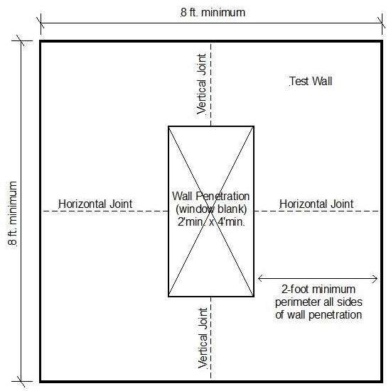
Figure B.3.3.1 Illustration of wall test assembly complying with the minimum requirements of Section B.3.3.1

Figure B.3.3.2. Illustration of wall test assembly complying with Section B.3.3.2
(Reprinted, with permission, from ASTM E2357−18 Standard Test Method for Determining Air Leakage Rate of Air Barrier Assemblies, copyright ASTM International,100 Barr Harbor Drive, West Conshohocken, PA 19428. A copy of the complete standard may be obtained from ASTM International, www.astm.org.)

B.3.4. Test Approach. To assess compliance with Section 3.2.2 of the standard, the test approach shall comply with Section B.3.4.1 or Section B.3.4.2. The test criteria for the selected test approach shall comply with the relevant criteria in Section B.3.5.

B.3.4.1. Specimens Tested without Cladding (exposed WRB test approach). Where cladding is not installed over the FPIS WRB system, the wall assembly specimen test result shall be applicable to the WRB system irrespective of the type of cladding used in end use. No interior finish or air-leakage sealing on the interior side of the assembly shall be provided (e.g., open stud cavities and no air-leakage sealing on the interior side of fenestration frames). Flashing and installation details for penetrations through the WRB surface shall be consistent with the FPIS WRB system manufacturer’s installation instructions.
User Note: The requirement not to provide interior finish or air-sealing on the interior side of the assembly is due to indexing of the pressure differential used in ASTM E331 testing of an exposed WRB layer to a condition where the pressure loading is not potentially shared by other air-movement-resistant layers of a multi-layered assembly as would occur in an actual building exposed to real wind flows and aerodynamic effects. Such test methods cannot replicate these pressure equalization conditions and thus must be indexed to a static pressure condition which is consistently applied to all test configurations for meaningful and consistent results.

B.3.4.2. Specimens Tested with Cladding (concealed WRB test approach). Where cladding is installed over the FPIS WRB system, the wall assembly specimen test result shall be applicable only to the WRB system as used together with the specific type of cladding and its installation method. Where intended to be used with an interior air barrier, the wall assembly construction shall be permitted to include a translucent interior surface (representative of an interior finish) with air-sealing of penetrating elements to framing or the translucent interior surface to replicate a continuous air-barrier on the interior side of the assembly. Flashing and installation details for penetrations and air-leakage sealing, if included in the test specimen, shall be consistent with the FPIS WRB system manufacturer’s installation instructions.

B.3.5. Criteria. Specimens shall be constructed in accordance Sections B.3.2 through B.3.4 and tested in accordance with ASTM E331 for a minimum total test duration of 120 minutes at the standard water spray rate of 5 gal/hr-ft² (3.4 L/min-m²) using a minimum test pressure differential of 6.24 psf. No water leakage shall be observed at the completion of the test.

User Note: Water leakage is defined by water penetrating the FPIS WRB system and/or the interface with fenestration and other penetrations included in the test wall assembly. Water leakage directly through a fenestration element to its interior face shall not be considered a failure of the FPIS WRB system and interfacing (flashing) details. Therefore, steps shall be taken to eliminate the fenestration element from contributing to leakage (refer to Section B.3.3). Significant air leakage can also alter the pressure control of the test and must be avoided for this reason. Water penetrating to pan flashing, if included, and drained to the exterior shall not be considered water leakage.

Mandatory Appendix C - Standard Practice for Evaluation of Building Component Shear Connections through FPIS

C.1 General. Connection assemblies shall be tested for shear resistance and slip (stiffness) in accordance with this section. A minimum of 3 specimens shall be constructed in accordance with Section C.2 for each configuration of materials and tested in accordance with ASTM D1761 and Section C.4. A minimum of 3 additional identical specimens shall be constructed in accordance with Section C.2 and tested for long-term creep effects in accordance with Section C.5. The test set-up in each case shall comply with Section C.3. Shear allowable design values shall be determined from test results in accordance with Section C.6. The results shall be applicable to the fasteners of the same type with a minimum bending yield strength and ductility as tested.

C.2 Specimen construction. The specimen as shown in Figures C.1 and C.2 shall consist of a minimum 12”x16” portion of wall with framing, FPIS, and a siding or furring material as applicable. Fasteners connecting the siding or furring to the 12”x16” wall portion (into framing members or structural sheathing) shall be located a minimum of 4-inches from the edges of the specimen and installed using appropriate tools and techniques for the type of fastener (e.g., clutched screw gun, hammer, etc.). Other building components, connection configurations, and specimen sizes shall be tested in similar manner without restraint of applicable failure modes. Connections shall be absent of voids between the connected parts and tightened without damaging or compressing materials.

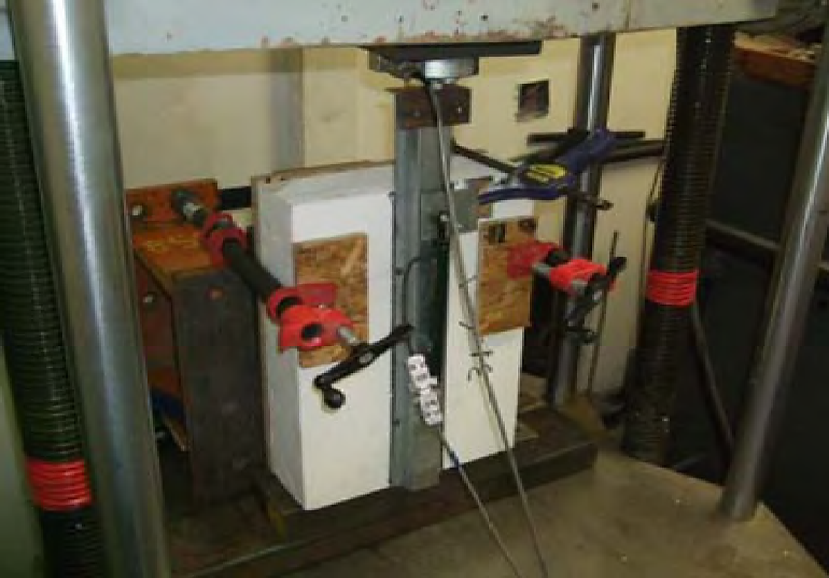
Figure C.1: Typical short-term shear test set-up

User Note: Figure C.1 is an image of a test being conducted using a universal testing machine. The load is applied at the top of a metal furring in this case. Clamps are used to maintain a vertical position of the test specimen. The applied load and downward deflection of the furring are measured by a load cell and deflectometer. In this test, the specimen has 4-inch thickness of FPIS and furring attachments are to a wood structural panel sheathing substrate.

Figure C.2: Typical long-term shear load (creep) test rack set-up

User Note: Figure C.2 is an image of a long-term shear load test rack supporting two test specimens. In this case the test specimens are 1x4 wood furring attached through 2-inch-thick FPIS to a wood framing or sheathing substrate. Weights are attached to an extension of the wood furring to provide a sustained and constant loading and dial gauges are used to periodically record deflection (creep) of the furring relative to the substrate material.

C.3 Test set-up and Conditions. The test set up shall apply shear load to the connection configuration in a manner that does not alter the behavior of the connection from that which would occur in end use. One suitable test set-up is shown in Figures C.1 and C.2. The test specimen body (frame) shall be restrained from rotating (due to the eccentricity of load path through the specimen) without interfering with the behavior of the furring or siding connection to the specimen body. The ambient temperature conditions during testing shall be recorded.
User Note: It is recommended that ambient temperature conditions during the short-term test procedure (Section C.4) and long-term (Section C.5) be maintained at room temperature (approximately 70°F) to correspond with conditions upon which the provisions of Chapter 4 of the standard were based (ABTG, 2015c). However, additional tests may be considered for either test procedure to ascertain the effects of varying temperature and humidity conditions. For example, additional specimens for long term testing could be exposed to outdoor conditions including temperatures greater and lesser than 70°F. While such tests are less “controlled” and subject to greater variability in results, they can provide additional information regarding naturally varying temperature and humidity effects on observed displacement or creep (Baker, 2014).

C.4 Test procedure (short term loading). A universal testing machine or other suitable testing equipment shall be used to apply the force to the attached material (see Figure C.1). Load and displacement data shall be recorded for displacements up to 3 inches or until failure occurs. A displacement rate of not more than 0.2 inches per minute shall be used.

C.5 Test procedure (long term loading). For long term loading tests (see Figure C.2), specimens shall be similarly restrained in a test rack and weights shall be suspended from the attached component as shown in Figure C.2. The amount of constant weight (shear force) applied to one of the three specimens shall be determined as the number of fasteners sharing shear load multiplied by the allowable single fastener design value determine in accordance with Section C.6 based on tests in accordance with Section C.4. The other two identical test specimens shall be constructed and tested with an amount of weight 25% greater and 25% less than that used for the first specimen. The test duration shall be a minimum of 3-months or until such a time that continuing displacement ceases to occur and equilibrium is established. A dial gauge shall monitor movement over the duration of the test and readings shall be taken at least weekly.

C.6 Criteria for shear allowable design values. The test load value for a single fastener at 0.015-inch displacement shall be determined by dividing the average applied load at 0.015-inch displacement (based on tests per Section C.4) by the number of fasteners securing the siding or furring to the test specimen body. The shear allowable design value shall be the lesser of the single faster average test load at 0.015-inch displacement or the single fastener minimum peak load divided by a safety factor of 5. In addition, the shear allowable design value shall not be greater than the load per fastener for which total long term deflection by testing per Section C.5 does not exceed 1/8-inch and the deflection contribution during the final month of testing does not exceed 1/32-inch.

C.7 Material Properties. Properties of materials used to construct specimens in accordance with Section C.2 shall be documented for the following:
a. Bending yield strength of fasteners
b. Specific gravity of wood framing and furring and moisture content at time of testing
c. Base steel thickness and yield strength of steel framing and furring
d. Compressive resistance of FPIS material

C.8 Reporting Requirements. The accredited third-party test agency report shall include the following information:
a. Description and photos of tested assemblies and test apparatus.
b. Description of test methodology and material sampling procedure.
c. Description of installation methods and all materials used to fabricate test specimens including manufacturer, type, size, and relevant material characteristics and standards.
d. Bending yield strength of fasteners.
e. Specific gravity and moisture content of wood materials used to fabricate the test assemblies.
f. Base steel thickness and tensile yield strength of steel materials used to fabricate the test assemblies.
g. Compressive resistance of FPIS material used to fabricate test assemblies.
h. Load-deflection plots for each test specimen and description of failure mode.
i. Design values determined from load-deflection data in accordance with C.6.
j. Documentation of temperature conditions during tests.

COMMENTARY
(Non-mandatory Information)

Commentary Chapter 1 – General
Section 1.1 addresses the purpose of the FS200.1 standard to establish minimum requirements for applications of foam plastic insulating sheathing (FPIS) on above-grade exterior walls. Chapter 1 focuses on general requirements that apply to the entire standard. Chapter 2 provides definitions. Chapters 3 and 4 provide requirements for various FPIS applications on above-grade exterior walls. Within these chapters, topical sections are organized to support the information needs of various audiences, such as code-officials, designers, builders, installers, and manufacturers. For example,

- general requirements typically apply to all users;
- specification requirements apply to code authorities, specifiers, designers, and builders and typically include performance and prescriptive options for compliance;
- installation requirements apply to installers and builders; and,
- qualification, quality assurance, and labeling requirements apply to manufacturers and approved agencies as required for certain applications and properties of FPIS.

Section 1.2 addresses the scope of the standard. FS 200.1 applies only to FPIS materials that comply with the ASTM standards listed in Section 1.2.1 and Table 1 of the standard. Other scoping matters addressed in Section 1.2 include:

- This standard is intended to supplement and be coordinated with the locally applicable building and energy conservation codes (e.g., see Section 1.2.2). In the U.S., locally applicable building and energy conservation codes are typically based on model codes such as the International Building Code (IBC), the International Residential Code (IRC), and the International Energy Conservation Code (IECC). The user must also be cognizant of and comply with any local amendments to these model codes as a result of the local review and adoption process.
- Section 1.2.8 specifically excludes exterior insulation finish systems (EIFS), structural insulated panels (SIP), and insulating concrete forms (ICF) to avoid conflicts with existing standards and model code requirements that already address these types of above-grade wall or cladding systems that use foam plastics.
- Section 1.2.9 is intended to allow FPIS manufacturers to use alternative means and methods to demonstrate code compliance in accordance with the locally applicable building code provisions. Documentation of code compliance for approval by a local authority having jurisdiction is typically provided through code evaluation reports provided by accredited approved agencies or approved sources providing code evaluation services. For FPIS applications where Section 1.2.9 is used as the basis for demonstrating code compliance in lieu of this standard, compliance with the labeling (Section 1.3) and quality assurance (Section 1.4) requirements of this standard is not necessary.

The provisions in the locally applicable building code govern all matters relating to building construction. The building designer, builder, code official, and owner are responsible for using this standard in a coordinated fashion with the locally applicable codes. In general, coordination of this standard with a locally applicable code falls into three conditions of use:

- Where a code compliance topic is excluded from the scope of this standard, the user must rely exclusively on the locally applicable code for compliance.
- Where a code compliance topic is included in the scope of this standard and also in the locally applicable code, the user must ensure compliance with the locally applicable code provisions and can use this standard to supplement the code with additional code compliant design or prescriptive solutions provided this standard is adopted by the locally applicable code or is otherwise approved for use by the local authority having jurisdiction.
- Where a provision of this standard is not included in the locally applicable code, such provision can be used provided the standard is recognized in the locally applicable code or its use is approved by the local authority having jurisdiction.

For FPIS manufacturers, use of this standard for FPIS product qualification testing, labeling, and quality assurance falls into two conditions:

- Where this standard is not adopted in a locally applicable building code or a particular code compliance topic is not addressed in the scope of this standard, the manufacturer must rely exclusively on the locally applicable code to demonstrate or establish compliance.
- Where this standard becomes adopted by a locally applicable building code, there are two choices for demonstrating compliance for any given code compliance topic addressed in this standard:
  - Rely on the locally applicable code provisions to establish compliance in accordance with Section 1.2.9, or
  - Rely on the provisions of this standard to establish code compliance, including Sections 1.3 and 1.4 as applicable to certain compliance topics addressed in Chapters 3 and 4 for above-grade wall applications of FPIS.

Table C1 is provided as a reference to facilitate use of this standard in coordination with current model building code provisions at the time of this writing. It provides a general map of code compliance topics that are addressed in current model codes, FS-200.1, or both. A more detailed discussion for the each of the topics listed in Table C1 follows the table.

TABLE C1
FS200.1 and Model Building Code Coordination
FPIS Application and Code Compliance Topics | 2021 IBC | 2021 IRC | 2021  IECC | FS-200.1
FPIS R-value for Energy Code Compliance
(Minimum R-value requirements for FPIS continuous insulation on above-grade walls are established in the locally applicable energy code and are not addressed in FS200.1 except in relation to water vapor control per Section 3.4)

Section 1.2.5 - Fire Performance, Safety and Protective Requirements
(e.g., surface burning characteristics, exterior flame spread, fire-resistance rating, use of thermal barriers and ignition barriers, etc.)

Section 1.3 – FPIS Labeling
(Labeling is required in model codes and in FS200.1; refer to discussion that follows for additional information)

Section 1.4 – FPIS Quality Assurance
(Quality assurance is required in model code reference standards for FPIS such as ASTM C578, ASTM C1289, and ANSI/ABTG FS100; refer to discussion that follows for additional information).

Section 3.1.1 - Wind Resistance
(The model codes and FS200.1 rely on the FS100 standard where wind resistance of FPIS is required, i.e., when used as the sole exterior sheathing material over open stud framing)

Section 3.1.2 - Wall Bracing
(FPIS by itself is not a wall bracing material, and must be integrated with wall bracing materials required by code)

Section 3.1.3 - Cladding
(FPIS by itself is not a cladding material, but must be integrated with wall cladding materials by cladding connections through FPIS to support cladding weight and secure the FPIS and cladding against outward-acting negative wind pressure)

Section 3.2 - Water-Resistive Barrier
(Applicable only where a FPIS product is intended to be used as a water-resistive barrier system and is not otherwise approved in accordance with Section 1.2.9)

Section 3.3 - Air Barrier System
(Applicable only where a FPIS product is intended to be used as an air barrier material or assembly and is not otherwise approved in accordance with Section 1.2.9)

Section 3.4 - Water Vapor Control for Frame Wall Assemblies
(FS200.1 coordinates with and expands upon limited code prescriptive provisions for use of FPIS continuous insulation and water vapor retarders to control water vapor movement)

Section 3.5 – Water Vapor Control for Reservoir Claddings
(FS200.1 coordinates with and clarifies limited code prescriptive provisions for use of FPIS continuous insulation as a multi-functional backing material for reservoir claddings such as PC stucco and adhered masonry veneers.
Section 3.6 – Fenestration Installation in Walls with FPIS
(FS200.1 includes specific testing, design, and prescriptive installation requirements for water and wind resistance of fenestration installations in walls with FPIS)

Chapter 4 – Connections through FPIS
(FS200.1 includes design provisions and prescriptive solutions that are consistent with and expand upon the limited prescriptive solutions included in model codes)

The following is a summary of how various users of the standard, including FPIS manufacturers, can coordinate use the FS200.1 standard with a locally applicable code with regard to the code compliance topics or applications listed in Table C1. This summary assumes the FS200.1 standard is adopted in the locally applicable building code. As mentioned above, where the FS200.1 standard is not adopted in the locally applicable building code it may be used by way of an approved design or an approved use as permitted by the local authority having jurisdiction.

FPIS R-value for Energy Code Compliance: Minimum R-values for FPIS used as continuous insulation (most common) or cavity insulation for energy code compliance are not addressed in FS200.1. Consult the locally applicable energy code for building envelope thermal insulation requirements, including above-grade walls. However, FS200.1 and also recent model building codes (especially the 2021 editions of the IRC and IBC) do provide minimum continuous insulation R-values in relation to control of water vapor movement in above-grade walls, depending on climate and other factors. Refer to Sections 3.4 and 3.5 of FS200.1 for additional information. These provisions are important to ensure coordinated compliance with the locally applicable building code’s water vapor retarder requirements and the locally applicable energy code’s insulation requirements. For additional information, wall calculator tools, guides, and resources to assist in coordinating energy code compliance and building code water vapor and moisture control requirements, refer to https://www.continuousinsulation.org .

Section 1.2.5 - Fire Performance, Safety and Protective Requirements: Section 1.2.5 excludes this topic from the scope of SF200.1. All users must comply with fire performance, safety, and protective provisions in the locally applicable code for use of foam plastics, such as FPIS. For U.S. model codes, these requirements are included primarily in Section R316 of the IRC and Chapter 26 of the IBC. Consult the FPIS manufacturer for code compliance data. For additional information, refer to https://www.continuousinsulation.org/applications/fire-performance .

Section 1.3 – FPIS Labeling; Section 1.4 – FPIS Quality Assurance: These sections of FS200.1 are primarily applicable to FPIS manufacturers and third-party approved agencies providing product evaluation and quality assurance services. As indicated in Table C1, U.S. model building codes require labeling of FPIS products. For example, the IECC requires FPIS products to be “rated” and labeled in accordance with the Federal Trade Commission’s R-value Rule (CFR Title 16, Part 460). FPIS material standards, ASTM C578 and ASTM C1289, have material qualification and inspection requirements and these standards are referenced in the IRC and IBC. These standard’s also serve as a “gateway” for use of an FPIS product in accordance with any application for above-grade walls addressed in FS200.1 (see Section 1.2.1 and Table 1). In addition, the IBC and IRC model codes reference the ANSI/ABTG FS100 standard (formerly ANSI/SBCA FS100) for above-grade wall applications where FPIS wind pressure resistance is required. The FS100 standard includes quality assurance provisions consistent with those in Section 1.4 and Mandatory Appendix A of FS200.1. In the above cases, the FS200.1 standard poses no new labeling or quality assurance requirements.

Sections 1.3 and 1.4 of FS200.1, including related mandatory appendices for quality assurance and qualification testing, only apply for certain code compliance topics as referenced in Section 1.3.3 of the standard. As with current model codes, compliance with ASTM C578 or ASTM C1289 is required for all above-grade wall applications of FPIS addressed in FS200.1. Furthermore, Sections 1.3 and 1.4 only apply where the FS200.1 standard is adopted by a locally applicable building code and the FPIS manufacturer elects to demonstrate compliance with the FS200.1 standard by use of these provisions and not in accordance with Section 1.2.9 of FS200.1. As mentioned, Section 1.2.9 permits FPIS manufacturers to demonstrate code compliance in accordance with the locally applicable building code. This may include compliance with “deemed-to-comply” lists including particular FPIS products or types recognized in the code for certain applications, following prescriptive or design provisions addressed in the code, or using data from an accredited and approved agency for a code evaluation report demonstrating equivalency to the code. Thus, the FS200.1 standard’s processes for labeling and quality assurance are not mandated provided code compliance is demonstrated in accordance with Section 1.2.9.

Section 3.1.1 - Wind Resistance: This property of an FPIS product, including its attachment to a structure where not relying on furring or cladding connections for wind resistant attachment (see commentary Section 3.1.3 and on Chapter 4), relies on the ANSI/ABTG FS100 standard which also is a code-reference standard. Thus, as shown in Table C1, the FS200.1 standard and current model building codes (including several prior editions) have identical requirements. As indicated in Section 3.1.1, wind resistance of an FPIS product is only required where FPIS is intended to be applied as the sole exterior sheathing material on exterior walls of open stud framing. For use of FPIS as over- or under-sheathing on frame walls with a separate exterior structural sheathing material or on any solid wall construction (like concrete or masonry construction), compliance with FS100 is not required by code or by the FS200.1 standard.

As indicated in Section 1.3.3 of FS200.1, an approved agency listing or report is required to demonstrate compliance with FS100 for applicable uses and it also contains quality assurance provisions consistent with Section 1.4 and Mandatory Appendix A of FS200.1. Thus, Sections 1.3, 1.4, and 3.1.3 of the FS200.1 standard are no different than current model building code requirements in relation to wind pressure resistance of FPIS products. In addition, Section 1.2.9 of FS200.1 and also Section 1.5 of FS100 permit wind resistance to be demonstrated, where intended to be installed as the sole exterior sheathing over open-stud framing, by alternative means of demonstrating equivalency to the locally applicable code requirements for wind resistance.

Section 3.1.2 - Wall Bracing: This section of FS200.1 simply establishes that FPIS shall be integrated with wall bracing materials and methods complying with the locally applicable building and energy codes. There are no requirements in FS200.1 for labeling or quality assurance of FPIS in relation to this code compliance topic. This section merely recognizes that conventional FPIS products are not structural wall bracing materials. For guidance on integrating FPIS with code-compliant wall bracing, refer to the IRC Wall Bracing Guide at https://www.continuousinsulation.org/applications/structural .

For FPIS products that are offered as structural composite bracing panels (e.g., laminated to a structural panel material), qualification as a bracing material must rely on code evaluation and approval separate from the scope of the FS200.1 standard. Also, where integrated with wall bracing materials as under-sheathing, the underlying FPIS layer affects the shear capacity of connections through FPIS of the overlying structural bracing panel (if used for bracing). All of these wall bracing matters are not addressed in FS200.1. Consequently, the user is responsible to ensure that FPIS is integrated with a code compliant bracing method on above-grade walls in accordance with the locally applicable building code’s prescriptive wall bracing or design provisions.

In addition, compliance with the locally applicable energy code also is required in Section 3.1.3 with regard to integrating FPIS with wall bracing on frame walls. For example, U.S. model code editions prior the 2021 IRC (Chapter 11) and 2021 IECC permit thinner foam sheathing to be used over intermittent structural panel braces (generally located at building corners and so many feet on center along exterior wall lines) as a means to maintain a uniform wall thickness. However, in the 2021 IRC (Chapter 11) and 2021 IECC, this allowance was removed to ensure continuity of insulation and thermal performance of above-grade wall assemblies. This concern also relates to the need to have sufficient exterior continuous insulation R-value to maintain uniform control of water vapor as required by the 2021 IRC and IBC as well as Section 3.4 of the FS200.1 standard (which expands upon limited prescriptive code provisions). The amount of continuous insulation required for a moisture-controlled above-grade wall assembly depends on climate, the amount and type of cavity insulation, and the interior vapor retarder type (e.g., class or perm rating) specified for code compliance. It is particularly important that moisture-sensitive wall bracing panels (including wood structural panels or gypsum panels) be protected with an appropriate amount of FPIS continuous insulation on the exterior (and not necessarily just the minimum that may be required or allowed for energy code compliance).

Section 3.1.3 – Cladding: There are no requirements in FS200.1 for labeling or quality assurance of FPIS in relation to this general code compliance topic. But, the cladding requirements of Section 3.1.3 establish three important code compliance requirements for cladding installed over FPIS. First, the cladding installation must comply Chapter 4 of the FS200.1 standard or limited prescriptive provisions in the recent editions of model codes for fastening to support the cladding weight (refer to commentary for Chapter 4 for additional information). Second, the cladding installation must comply with the locally applicable building code and the cladding manufacturer’s installation instructions for wind pressure resistance. Generally, fasteners for cladding attachment through FPIS must comply with the more stringent requirement of Chapter 4, the building code, or the cladding manufacturer’s installation instruction. In many cases, the resulting requirement is simply that fasteners be specified with a length sufficient to accommodate the thickness of FPIS and maintain the required minimum penetration into wood framing materials, including wood sheathing if present, for negative wind pressure withdrawal or pull-off resistance. Third, and finally, an exception is provided for cases where vinyl siding wind pressure ratings must be adjusted to provide sufficient negative wind-pressure restraint (withdrawal resistance) to the siding and FPIS combined. This only applies where FPIS is the sole exterior sheathing material on a frame wall and its fastening is not designed or qualified in accordance with FS100 to resist, independent of cladding attachments, the full design negative wind pressure required by code (see commentary for Section 3.1.1). These requirements are all consistent with IRC and IBC provisions.

Section 3.2 - Water-Resistive Barrier: Where FPIS is not intended to be used as a WRB system or where Section 1.2.9 is used as the basis for demonstrating equivalency in accordance with the locally applicable building code, compliance with Section 3.2 and the labeling and quality assurance requirements of Section 1.3 and 1.4 is not required. However, approval for use is subject to the local authority having jurisdiction. Where a locally applicable building code has adopted the FS200.1 standard as a means of compliance and specification, the FPIS WRB system manufacturer can demonstrate code compliance by following the requirements of Sections 3.2.4 (which references qualification testing requirements and criteria in Mandatory Appendix B), Section 1.3, and Section 1.4. In this later case, code approval is not subject to the discretion of the local authority having jurisdiction, and product labeling (or a listing report) becomes the basis for specification by users and enforcement by code officials. Even so, the ability to follow a code equivalency basis for FPIS WRB system approval remains available in accordance Section 1.2.9. For additional information, refer to commentary on Section 3.2 and also https://www.continuousinsulation.org/applications/WRB .

Section 3.3 - Air Barrier System: The air barrier material and assembly requirements and test criteria in Section 3.3 of FS200.1 are identical to those found in the IECC. Also, included in Section 3.3 is an exception to allow FPIS use as an air barrier material where listed as a deemed-to-comply air barrier material in the IECC. Consequently, these model energy code provisions may be used to demonstrate FPIS air barrier material or assembly compliance in accordance with Section 1.2.9 of FS200.1 and the locally applicable energy code (if consistent with the IECC or ASHRAE 90.1 standard). The FS200.1 standard also provides a means for demonstrating compliance through labeling or a listing report of the FPIS product in accordance with Section 1.3. This serves as a means for product specification and enforcement. The nature of quality assurance needed in accordance with Section 1.4 for air barrier properties is at the discretion of the manufacturer and a third-party quality assurance provider (for example some FPIS products may clearly qualify as an air barrier with a need for re-qualification only in the event of a product reformulation significantly affecting air permeability of the product). For more information, refer to commentary on Section 3.3 and also https://www.continuousinsulation.org/applications/air-barrier .

Section 3.4 - Water Vapor Control for Frame Wall Assemblies: The FPIS design and prescriptive construction provisions in Section 3.4 of the FS200.1 standard are consist with and serve as the basis for a limited selection of prescriptive solutions found in Section R702.7 of the 2021 IRC and Section 1404.3 of the 2021 IBC for water vapor control and specification of water vapor retarders. For additional information refer to commentary on Section 3.4 and https://www.continuousinsulation.org/topical-library/water-vapor-control .

For most FPIS applications on above-grade walls to control water vapor in accordance with Section 3.4, there are no requirements for labeling or quality assurance of FPIS other than that required by the ASTM material standards listed in Table 1 and Section 1.2.1 of the standard. However, Section 1.3.3 does require that the water vapor permeance at the declared thickness of an FPIS product be addressed in labeling or a listing report and this also invokes quality assurance in accordance with Section 1.4. But, this requirement is only applicable where the water vapor permeance of FPIS is required to be 1 perm or less for the “no interior vapor retarder” application of FPIS in accordance with Section 3.4 (i.e., see footnote f of Table 3.4.2.1 and footnote c of Tables 3.4.2.2(A) and (B)).

Even so, Section 1.2.9 of the standard permits code compliance to be demonstrated through equivalency to the locally applicable building code as an alternative to compliance with Sections 3.4, 1.3, and 1.4. However, because the “no interior vapor retarder” application of FPIS to control water vapor in above-grade wall assemblies is not specifically addressed in current model codes (up to and including the 2021 editions of the IRC and IBC), this provision in FS200.1 provides a rational means to establish code equivalency. An equivalent solution can also be rationalized by way of an approved engineering analysis of hygrothermal performance as permitted by FS200.1 and also permitted by the locally applicable building code (subject to approval of the design by the local authority having jurisdiction).

Section 3.5 – Water Vapor Control for Reservoir Claddings: Section 3.5 addresses the application of FPIS behind a reservoir cladding, like Portland cement stucco or adhered masonry veneer, as a means to help control inward water vapor movement. These provisions are consistent with those found in the 2021 editions of the IRC and IBC, but specifically focus on the application of FPIS. For this application of FPIS on above-grade walls, the primary requirement for labeling or quality assurance of FPIS relates to conformance to the ASTM material standards listed in Table 1 and Section 1.2.1 (same as required in current model codes). However, where FPIS is used a drainage material (e.g., backside is grooved and placed over a separate WRB layer), Section 1.3.3 requires labeling or a listing report demonstrating compliance with the 90% drainage efficiency criteria using one of the two test methods mentioned in Section 3.5.2.3. This too is consistent with provisions in the 2021 IBC and IRC. Furthermore, Section 1.2.9 of FS200.1 may be used to demonstrate compliance in accordance with these recent model codes where adopted as the locally applicable building code in lieu of complying with the qualification, quality assurance, and labeling requirements of FS200.1.

Section 3.6 – Fenestration Installation in Walls with FPIS: Section 3.6 provides performance-based (design or testing) and prescriptive installation details for installation of fenestration on above-grade walls with FPIS continuous insulation on the exterior. The primary source for fenestration installation instructions is the fenestration manufacture and this is a requirement found in model codes. However, where the fenestration manufacturer’s installation instructions lack applicable solutions for walls with FPIS, the provisions of Section 3.6 provide a basis for equivalent, code-compliant solutions. For use of the prescriptive installation details in Section 3.6.3, the user needs to ensure conformity with the limitations of use. One of these limitations for installation of flanged fenestration directly over FPIS is that the FPIS product type specified must have a minimum compressive resistance of 15psi in accordance with the ASTM standards listed in Table 1 in Section 1.2.1. Section 1.3.3 does require a listing report (including installation details) for the case where performance-based testing in accordance with Section 3.6.2.1(2) is used to justify an installation procedure, including those which do not comply with the prescriptive installation procedures of Section 3.6.3. For more information, refer to commentary on Section 3.6.

Chapter 4 – Connections through FPIS: Chapter 4 of FS200.1 provides engineering design procedures (based on model code referenced design standards) for evaluating the shear capacity of cladding and building component connections through a layer of FPIS. For these design procedures the FPIS material must have a minimum compressive resistance of 15 psi based on the ASTM standards listed in Table 1 in Section 1.2.1. These design procedures are the basis of prescriptive cladding and furring connection requirements also found in Chapter 4 and also are the basis of identical prescriptive requirements for cladding and furring attachment through FPIS found in recent editions of the IBC (Section 2603) and IRC (Section R703). The key difference in FS200.1 from the model codes is that the design procedures are made available for use to design cladding, furring, and building component (e.g., structural ledger) connections through FPIS sheathing to the underlying structure.

Also included in Chapter 4 (and Mandatory Appendix C) is the ability to test connections through FPIS to justify a solution that falls outside of the use conditions for the design procedures or prescriptive solutions in Chapter 4. The test method and criteria in Mandatory Appendix C are consistent with test methods and criteria used to develop the design procedures and prescriptive cladding attachment solutions. Where testing is used to demonstrate compliance, Section 1.3.3 of the standard requires a listing report including installation instructions consistent with the manner in which the assembly was tested. There are no other labeling or quality assurance requirements required by Chapter 4 of the FS200.1 standard.

Commentary Chapter 2 – Definitions
No commentary.

Commentary Chapter 3 – FPIS for Use in Above Grade Walls

C3.1 General

The general section links Chapter 3 back to the general requirements addressed in Chapter 1 and then addresses additional general requirements related specifically to above-grade wall applications of FPIS. These include wind resistance requirements (Section 3.1.1), coordination with wall bracing required by the locally applicable building code (3.1.2), and coordination with building code requirements for installation of cladding (3.1.3).

Section 3.1.1 references the ANSI/ABTG FS100 standard (formerly ANSI/SBCA FS100) for qualifying the wind pressure resistance properties of an FPIS product of a given type and thickness, including facers if present. The FS100 standard is also referenced in the IRC and IBC model codes for the same purpose. It also includes quality assurance requirements which are consistent with those included in Mandatory Appendix A of FS200.1 (refer to commentary on Mandatory Appendix A). The FS100 standard is primarily intended for use by FPIS manufacturers and their third-party approved agencies as a means to provide users with design wind pressure values for specifying FPIS products in accordance with the locally applicable code for applications where FPIS wind resistance is required. The FS100 standard is available at https://www.appliedbuildingtech.com/standards .

It is important to note that the need for wind pressure resistance of FPIS and compliance with the FS100 standard only applies for above-grade wall applications of FPIS where it is the sole exterior sheathing material installed over open stud framing. Where FPIS is installed directly over solid wall surfaces, like concrete or masonry walls, or is installed as over- or under-sheathing (e.g., installed to either side of an exterior structural sheathing panel), the FPIS product is not required to resist wind pressure and is not required to comply with the FS100 standard.

Finally, the FS100 standard can also be used to qualify fastening methods of FPIS such that the FPIS is not reliant on cladding or furring attachments to resist wind pressure suction (withdrawal) forces. This practice may have relevance were cladding materials and their attachment are not based on the full design wind load and use pressure-equalized wind loads as a basis for code compliance. The primary example is vinyl siding and this is addressed further in commentary on Section 3.1.3.

Section 3.1.2 addresses the need to integrate FPIS with wall bracing materials and methods as governed by the locally applicable building code and energy code. Where exterior structural panels are used for bracing, FPIS is commonly used as over-sheathing. If used as under-sheathing it alters the bracing capacity (structural panel attachment shear capacity) and the impact on bracing capacity must be properly qualified in accordance with the alternative means and methods provisions of the locally applicable building code (e.g., a code evaluation or engineered design using an approved agency or approved source). There also are proprietary composite bracing panels whereby FPIS is laminated in the factory to the interior or exterior side of a structural panel material creating an insulated structural sheathing panel. Use of these materials must comply with the manufacturer’s approved installation instructions and design data. In addition, FPIS may be used with wood let-in, metal strap or other forms of angled braces as permitted by the locally applicable building code or by engineered design. For example, metal strap X-braces are commonly used for bracing of cold-formed steel commercial buildings. In these cases, FPIS is installed over open stud framing and would need to comply with the FS100 standard for wind pressure resistance unless a separate wind resistant sheathing material is used such as gypsum sheathing (see commentary on Section 3.1.1).

FPIS integration with wall bracing also must comply with the locally applicable energy code. For example, some older U.S. model energy code editions may allow for reduced R-value and thickness of FPIS when installed over intermittent structural bracing panels (e.g., brace panels located at building corners and every so many feet on center along an exterior wall line as required by the code). However, such reduction in thickness of FPIS over intermittent structural panels must also consider water vapor control requirements addressed in Section 3.4 of FS200.1 (and more recent editions of U.S. model codes). Again, full-thickness FPIS panels that are installed between the intermittent bracing panels and over open stud framing must comply with the FS100 standard for wind pressure resistance (see commentary on Section 3.1.1).

For additional information regarding the integration of FPIS with wall bracing, refer to IRC Wall Bracing: A Guide for Builders, Designers, and Plan Reviewers (ABTG, 2018) available at https://www.continuousinsulation.org/applications/structural .

Section 3.1.3 addresses cladding installation over FPIS. Cladding connections through FPIS must comply with Chapter 4 of FS200.1 which ensures the connection is able to support the cladding weight (transferred through the cladding or furring connection and FPIS to the structural framing by shear). These connection provisions are consistent with and expand upon provisions found in recent editions of the IRC (see Section R703) and IBC (see Section 2603). For wind pressure resistance, the cladding attachment (e.g., fastening schedule) also must comply with the locally applicable building code and cladding manufacturers installation requirements. Typically, this simply requires that fasteners have additional length equivalent to the FPIS thickness such that the fastener embedment in framing is not reduced and the required withdrawal (wind suction pressure) resistance is maintained.

Vinyl siding installed over foam sheathing is addressed in Section 3.1.3 as a special case in regard to cladding and exterior wall covering assembly wind load resistance. Where foam sheathing is installed as over- or under-sheathing there are no special considerations for installation of vinyl siding over foam sheathing. However, an exception addresses the case where vinyl siding is installed over FPIS as the sole exterior sheathing layer and the FPIS is not separately attached to resist the full design wind load (e.g., it relies at least in part on the vinyl siding connection for withdrawal resistance). For this case, the adjusted minimum wind load design pressure ratings for vinyl siding in Table 3.1.3 are applicable. These increased wind load design pressure ratings are required because vinyl siding wind pressure ratings are based on the use of a reduced wind load due to pressure equalization whereby the wall assembly (including sheathing layers) behind the vinyl siding resists the full wind load and are relatively rigid and air impermeable. Thus, the air-permeable vinyl siding experiences only a fraction of the total wind pressure differential across the wall assembly. Refer to ASTM D3679 Annex 1, ASCE 7 commentary C30.1.5, and Cope et al.(2012) for additional explanation. In this very specific context of use with FPIS, vinyl siding and its attachments cannot be used as a means for permanent securement of the FPIS unless the vinyl siding wind pressure rating is specified in accordance with Table 3.1.3. If the foam sheathing is used as over-sheathing or under-sheathing, or it and its fastening method complies with the FS100 standard (see commentary on Section 3.1.1), then this exception and Table 3.1.3 do not apply and vinyl siding can be specified as usual (not with increased wind load design pressure ratings per Table 3.1.3 to enable securement of the underlying FPIS). A user note in the standard explains the derivation of the adjusted wind load design pressure ratings in Table 3.1.3.

Other siding materials are typically designed to conservatively resist the full design wind load and, therefore, are capable of being used for permanent securement of FPIS in all conditions of use. The primary consideration is use of longer fasteners to ensure the siding fastener penetration into a structural substrate and suction wind load (negative pressure) withdrawal resistance is maintained. In addition, siding attachment must comply with Chapter 4 to ensure support of cladding weight (which tends to become increasingly important for thicker applications of FPIS and heavier cladding systems that rely on connections to the structure for gravity load support).

C3.2 Water-Resistive Barrier

A water-resistive barrier (WRB) is a critical moisture control layer to protect the building envelope and the building from water damage. FPIS materials have been and often are used as continuous insulation and as a means to control water vapor (refer to Section 3.4) with a separate WRB material layer provided to manage bulk water. Section 3.2 provides a means to also use FPIS as a WRB system such that a separate WRB becomes unnecessary or can be used for redundancy. For additional information on water-resistive barriers and use of FPIS as a WRB system, refer to https://www.continuousinsulation.org/applications/WRB .

Section 3.2.2 provides specification requirements aimed at builders and designers. For FPIS WRB systems, specification is rather simple. It relies on labeling or an approved agency listing report in accordance with Section 3.2.4 together with coordinated installation instructions as required by Section 3.2.3. This provides a simple means for prescriptive specification. It also provides a simple means for compliance verification by code authorities without requiring their case-by-case review and approval for use. Alternatively, in accordance with Section 1.2.9, a manufacturer can elect to not comply with Section 3.2 and instead obtain a code evaluation or research report as a means to demonstrate code compliance to specifiers and gain approval for use at the discretion of the local code authority. This approach has been the common practice for FPIS WRB systems. Where FS200.1 is not recognized in a locally adopted building code, this latter approach is the only means available for specification and code approval.

Section 3.2.3 establishes the requirement that the FPIS WRB system manufacturer’s installation instructions are the basis for compliant installation. It also ties these instructions to the qualification/testing requirements of Section 3.2.4. While FPIS WRB systems share common traits (e.g., tape joints, water-resistant foam sheathing, installation practices, etc.), the specific materials and components used generally have different formulations and characteristics that must be qualified in each case in accordance with Mandatory Appendix B (or by alternative means and methods in accordance with Section 1.2.9). Following the FPIS WRB system manufacturer’s instructions and material specifications is necessary to achieve the intended performance.

Section 3.2.4 refers to qualification, quality assurance, and labeling requirements provided in Chapter 1. In addition, Mandatory Appendix B is referenced for qualification testing requirements and criteria (see later commentary on Mandatory Appendix B). It should be noted, again, that Chapter 1 of FS200.1 permits the use of alternative code compliance methods in accordance with the alternative means and methods clause of the locally applicable building code; refer to Section 1.2.9.

While the National Building Code of Canada specifically recognizes the use of FPIS as a sheathing-type WRB system (e.g., refer to 2015 NBC Part 9, Section 9.27.3.4 “Insulating Sheathing in lieu of Sheathing Membrane”), U.S. model building codes have remained essentially silent on this matter, and generically reference “other approved materials”. Consequently, the alternative means and methods provisions of U.S. model codes have been relied upon to gain approval for use of FPIS WRB systems. For FPIS WRB systems and many other WRB materials not specifically recognized in the code, this has been the common means of demonstrating code compliance. It involves use of an approved agency (for testing), acceptance criteria such as ICC-ES AC71 (ICC-ES, 2011a), and a code evaluation or research report issued by one of several accredited code evaluation services for local code authority approval on a case-by-case basis. Section 1.2.9 of the FS200.1 standard permits this process to continue as an alternative to Section 3.2. The FPIS WRB system qualification requirements in Mandatory Appendix B are consistent with the performance intent of U.S. model codes and acceptance criteria such as ICC-ES AC71. A listing of FPIS WRB systems with code evaluation research reports following this alternative means and methods approach for code compliance can be accessed through https://www.continuousinsulation.org/applications/WRB.

C3.3 Air Barrier

Effective use of a continuous air barrier as part of a building envelope is necessary for compliance with U.S. model energy conservation codes. It also is important for control of water vapor movement (moist air movement) and efficient design of HVAC systems to control the indoor environment of a building. Where FPIS continuous insulation layer is used on the exterior side of an assembly as an air barrier or in addition to a separate exterior air barrier material, it can further improve water vapor control by controlling temperature within the assembly, keeping it warm and above dew point and help avoid high internal humidity within the assembly (refer to Section 3.4).

The provisions of Section 3.3 for use of FPIS as an air barrier material or part of an air barrier assembly are consistent with requirements in the International Energy Conservation Code (ICC, 2021c) and the ASHRAE 90.1-2019 standard (ASHRAE, 2019). In general, these standards require an air barrier to be provided in all construction enclosing conditioned spaces but do not designate the location for such air barriers. Thus, they may be located to the interior side, within, or on the exterior side of assemblies. Regardless of their location, they must be detailed for continuity between building envelope assemblies (e.g., roof, walls, floors, and foundation). Alternatively, an assembly itself may be qualified as an air barrier assembly and the inter-connection of assemblies must then be detailed to maintain continuity of the air barrier. For more information on air barriers and a listing of code-compliant FPIS air barrier materials, refer to https://www.continuousinsulation.org/applications/air-barrier .

FPIS materials qualified in accordance with Section 3.3.4 can be used as an air barrier material or as part of an air barrier assembly. When used for this purpose, FPIS is typically placed on the exterior side of an assembly as continuous insulation. But, it can also serve as an air barrier and added insulation on the interior side of walls, such as behind bathtubs (particularly when located adjacent to exterior walls) or on walls separating conditioned space from a non-conditioned space (like a vented attic space adjacent to a bonus room). When also used as a water-resistive barrier with sealed joints (refer to Section 3.2), use of FPIS as an air barrier is essentially completed with the inclusion of details for continuity of air resistance at the terminal perimeter of the FPIS continuous insulation and also at all penetrations, such as fenestration and service openings.

In Canada, additional qualification requirements for air barriers apply. These requirements are addressed in CAN/UL S-741 (2016) and CAN/UL S-742 (2016) and, at the time of this writing, the requirements of these standards meet or exceed the air barrier material property requirements of Section 3.3 of FS200.1 and U.S. model energy codes and standards.

C3.4 Water Vapor Control for Frame Wall Assemblies

The water vapor control provisions in Section 3.4 are consistent with and expand on recently updated water vapor retarder provisions in the 2021 IBC (Section 1404.3) and IRC (Section R702.7) that include a limited set of prescriptive solutions. These code provisions and those in Section 3.4 of this standard are derived primarily from the following research reports and guidance documents and references included therein:

- Assessment of Hygrothermal Performance and Design Guidance for Modern Light-Frame Wall Assemblies,” Advances in Hygrothermal Performance of Building Envelopes: Materials, Systems and Simulations, ASTM STP1599 (Crandell, 2017) https://www.astm.org/DIGITAL_LIBRARY/STP/PAGES/STP159920160097.htm
- Assessment of Water Vapor Control Methods for Modern Insulated Light-Frame Wall Assemblies, ABTG Research Report No. 1410-03 (ABTG, 2015b) https://www.appliedbuildingtech.com/rr/1410-03
- Model Moisture Control Guidelines for Light-Frame Walls: A Building Code Supplement for Builders, Designers, and Building Officials, ABTG Research Report No. 1701-01 (ABTG, 2017) https://www.appliedbuildingtech.com/rr/1701-01
- Durability by Design: A Professional’s Guide to Durable Home Design, 2nd Edition (HUD, 2015) https://www.huduser.gov/portal/publications/reports/Guide-Durability-by-Design.html

Wall calculators for wood frame and cold-formed steel frame wall assemblies are available on the web to implement the water vapor control provisions of Section 3.4. They also provide a means to coordinate and check compliance with various model energy codes and standards. Refer to: https://www.continuousinsulation.org/calculators.

Finally, it is important to note that while Section 3.4.4 refers to Chapter 1 for FPIS material properties, quality assurance, and labeling requirements, the only relevant requirement is to comply with the ASTM material standards listed in Table 1 of Section 1.2.1 and to label the FPIS product in accordance with those standards as consistent with current industry practice and regulations. The case where an additional labeling or listing report is required is where FPIS is used on a wall with “no interior vapor retarder” as indicated in Section 1.3.3; refer to the discussion on this matter in the commentary on Chapter 1.

For more information on use of FPIS continuous insulation as a means to effectively control water vapor for durable and energy efficient assemblies, refer to: https://www.continuousinsulation.org/applications/water-vapor-control .

C3.5 Water Vapor Control for Reservoir Claddings

Reservoir claddings present a unique risk of undesirable moisture accumulation in wall assemblies whereby water absorbed by a reservoir cladding during rain events is driven inward under high vapor pressure differentials caused by solar radiation following rain events. To mitigate this problem, model building codes such as the 2021 IBC and IRC have begun to require a ventilated air space or drainage space behind conventional Portland cement stucco and adhered masonry veneer in moist climate regions. The provisions in Section 3.5 are consistent with those newer model code provisions, but focus particularly on use of FPIS for this application. Model code requirements for anchored brick veneer have traditionally required an air-space (typically 1-inch thick) and weeps which provide for drainage to expel bulk water. It also provides some amount of venting to promote air exchange which serves to intercept and remove water vapor being inwardly driven into the wall assembly.

An effective or redundant strategy to mitigate inward vapor drives is to block the inward movement of moisture by using a low permeance material layer behind a reservoir cladding. FPIS continuous insulation can be used for this purpose as most products at installed thickness or with use of low-perm facer materials are not vapor permeable (i.e., they typically have vapor permeance of less than 5 perms per ASTM E96, Procedure A, dry cup). The specification requirements in Section 3.5.2 feature this use of FPIS. In colder climate zones, this practice requires coordination with the requirements of Section 3.4 to effectively control outward vapor flows that occur during winter months. This use of FPIS to block inward water vapor flows does not eliminate the requirement to provide for bulk water drainage (e.g., a WRB and drainage plain with weeps to ensure a pathway for liquid water to be expelled). For example, Section 3.5.2.3 provides a prescriptive (3/16-inch drainage space) and performance-based (test standard) means to demonstrate adequate drainage where required in moist or marine climate regions. Such drainage may be provided by properly qualified drainage WRB materials, drainage mats, or grooved FPIS installed over a WRB material. Or, it can be provided to the outside of an FPIS WRB system complying with Section 3.2 and located between the FPIS WRB system and the reservoir cladding by use of furring or a drainage material.

Section 3.5.4 refers to Chapter 1 for FPIS material properties, quality assurance, and labeling. Only compliance with the ASTM standards listed in Table 1 is required which is an existing regulatory requirement for code-compliant FPIS materials. However, where FPIS is used as a means for drainage (e.g., grooved) over a separate WRB material layer, compliance with the appropriate ASTM test standards and 90% drainage efficiency criterion of Section 3.5.2.3, Item 2, is required and this would invoke labeling and quality assurance requirements in Chapter 1 (only if an alternative means of demonstrating compliance per Section 1.2.9 is not used).

C3.6 Fenestration Installation in Walls with FPIS

The installation of fenestration (i.e., windows and doors) in any wall assembly creates the need to provide for proper methods of interfacing wall and fenestration materials to ensure continuity of water and weather resistance. It is also important to ensure proper support and anchorage for the fenestration product to transfer design loads, such as wind load, to the wall structure. Where FPIS is used as the WRB system, the water-resistance of its installation and its interface (flashing) with fenestration is addressed in the FPIS WRB system qualification requirements of Section 3.2.4, specifically the testing and performance requirements of Mandatory Appendix B.

For integration of fenestration products installed in walls with FPIS, the specifications in Section 3.6.2 provide several means and resources to determine appropriate flashing and also structural anchorage and support of fenestration installed in walls with FPIS. Section 3.6.3 requires that fenestration be installed in accordance with a method or procedure justified in accordance with Section 3.6.2. Alternatively, Section 3.6.3 provides prescriptive installation procedures that may be followed where applicable (i.e., satisfying the indicated requirements and limitations as applicable). These prescriptive solutions are focused on fenestration types commonly used for “punched openings” (e.g., flanged fenestration and block-frame fenestration).

The prescriptive installation methods in Section 3.6.3 and the means of determining other compliant solutions in Section 3.6.2, such as the AAMA 504 performance-based testing method, are consistent with recent research and testing which conducted a wide-ranging evaluation of the water-resistance, structural, and durability performance of common windows types installed in walls with FPIS continuous insulation of various types and thicknesses using a variety of FPIS-manufacturer specified flashing materials (ABTG, 2021). This research also documented standard installation methods developed by field experience (i.e., accepted practice) over the course of 50 years since FPIS products first began to enter the construction market as an energy-saving technology. In addition, it evaluated changes in building codes over time in relation to water-management of wall systems, window installation, WRBs, and other relevant factors. Installation standards such as CAN/CSA A440.4 (CSA, 2018), fenestration industry standards, and other guides (e.g., DOE, 2017) were also considered. For further study, the ABTG research report is available at: https://www.appliedbuildingtech.com/rr/2104-01 .

Although not a requirement of U.S. model building codes at the time of this writing, a drained sill pan and rough-opening flashing is featured as a best practice for all prescriptive installation methods and details in Section 3.6.3. This provides additional protection or redundancy against water intrusion (Lacasse and Armstrong, 2011; Lacasse and Armstrong, 2013). This best practice recommendation recognizes that water leakage paths occur in new or existing fenestration products and installations for a variety of reasons (Morrison Hershfield Limited, 1996; City of Woodbury, 2011; Crandell and Kenney, 1995; RDH Building Engineering Limited, 2002a and 2002b).

The use of a drained sill pan requires that the bottom flange of the window remain unsealed or, at most, have bedding sealant placed intermittently to provide a drainage path from the sill pan to the WRB. While this unsealed window sill flange is intended to allow for drainage from the sill pan, it also can result in upward and inward movement of water into the sill pan under extreme wind-driven rain events with significant coincidental positive (inward) wind pressure on the windward side of buildings. The primary means to mitigate this opposing consequence is achieved by careful air sealing of the rough opening gap on the interior side of the window frame (Lacasse and Armstrong, 2013). This air sealing will cause the rough opening air gap to pressure equalize such that water is drained from and not driven into the window’s rough opening gap and sill pan. Therefore, interior air sealing of the fenestration rough opening gap is an integral part of using a drainage pan to protect against water intrusion. Air sealing is also a requirement of model energy codes for a continuous air barrier.

While use of drainage pans may be considered a best practice and are featured in all of the prescriptive details of this standard, use of fully-sealed (flashed) window flanges (without a drainage pan) have been known to provide very good water resistance. In any installation (with or without a sill pan), care should be taken in flashing installation and fenestration product manufacturing, handling, and installation to minimize the potential for incidental water leakage. In all cases, it is advisable to conduct a “water hose” spray test on completed fenestration and WRB installations to help detect and repair any observed leaks prior to enclosing the interior and exterior side of the wall with finishes.

Whether using the fenestration manufacturer’s instructions, a tested solution per AAMA 504, a designed solution, or a prescriptive installation procedure, or a combination of these methods from Section 3.6, sheathing joints in a FPIS WRB system must be sealed with durable adhesive joint tape or other joint treatment specified and applied in accordance with the FPIS WRB system manufacturer’s installation instructions per Section 3.2. Joint sealing treatments often include tapes that are typically 3-4 in. wide. Flexible self-adhering flashing is also used as a joint sealing treatment and for joints interfacing with components penetrating walls, such as fenestration. Flexible self-adhering flashing is typically 4-9 in. wide. Other flashing materials include mechanical flashing and liquid-applied flashing. Appropriate installation conditions for joint tapes, flexible self-adhering flashings, and liquid-applied flashing include adherence to the specified temperature range for application, cleanliness of surfaces, and rolling or pressing onto substrates being joined together in a water-tight fashion. Some substrates also may require a primer as specified by the flashing manufacturer.

For additional resources and guidance, refer to: https://www.continuousinsulation.org/applications/window-installation

Commentary Chapter 4 – Connections through FPIS

The technical basis of the cladding and other building component connection design, testing, and installation requirements in Chapter 4 is documented in the following report:

ABTG (2015c). Attachment of Exterior Wall Coverings Through Foam Plastic Insulating Sheathing (FPIS) to Wood or Steel Wall Framing, ABTG Research Report No. 1503-02, https://www.appliedbuildingtech.com/rr/1503-02

The provisions in Chapter 4 are consistent with the basis for limited prescriptive requirements in the 2015 through 2021 editions of the IRC and IBC (which were derived from the test data and engineering calculation procedures described in the above report).

The engineering procedures of Section 4.2.1 provide for calculation of solutions beyond the limited prescriptive solutions included in the codes and in Section 4.2.2 of FS200.1 for cladding and furring connections through FPIS materials. For example, other load-bearing building components, such as deck or roof ledgers, can also be designed for adequate structural support capacity and stiffness when fastened to the structure through a layer of FPIS by use of the engineering provisions of Section 4.2.1 (or testing in accordance with Mandatory Appendix C).

The prescriptive cladding attachment tables in Chapter 4 are based on connections for adequate gravity load support to cladding. Resistance to fastener pull-out or withdrawal caused by outward (negative) design wind pressures is addressed by fastening requirements in the locally applicable building code or the cladding manufacturer’s installation instructions. Alternatively, fastener withdrawal resistance can be determined in accordance with code-accepted design methods or standards. The more stringent fastening schedule for cladding gravity load support per Chapter 4 and wind pressure resistance per the locally applicable code must be used.

For furring materials and their attachment to a structure, prescriptive wind pressure resistance requirements are typically not available in the locally applicable building code and design values for some wood furring materials may not be available (e.g., 1x4 finish graded wood). Therefore, Tables C.4(1) and (2) are provided below to supplement the furring connection requirements through FPIS as addressed in Chapter 4, Section 4.2.2. The tabulated allowable wind pressure resistance must be equal to or greater than the components and cladding allowable stress design (ASD) negative (suction) pressure wind load required by the locally applicable building code. Because these tables are only representative of an appropriate furring design for wind pressure resistance, the applicability for a specific use should be verified for suitability prior to use. The tabulated design values are based on analysis of furring bending, fastener withdrawal (for the stated minimum penetration into wood material with a minimum 0.42 specific gravity), and fastener head pull through.
TABLE C.4(1): Furring Minimum Fastening Requirements for Application Over FPIS to Resist Allowable Stress Wind Pressure ¹
Furring  Material | Framing  Member | Fastener  Type &  Minimum Size | Minimum  Penetration  into Wall  Framing (in.) | Fastener  Spacing  in Furring  (in.) | Allowable Wind  Pressure Resistance of Furring Attachment (psf)
 |  |  |  |  | 16" o.c. Furring | 24" o.c. Furring
Minimum  1x3 Wood  Furring | Minimum  2x  Wood  Stud | Nail  (0.120" shank;  0.271" head) | 1¹/₄" | 8 | 42.6 | 28.4
 |  |  |  | 12 | 28.4 | 18.9
 |  |  |  | 16 | 21.3 | 14.2
Minimum  1x3 Wood  Furring | Minimum  2x  Wood  Stud | Nail  (0.131" shank;  0.281" head) | 1¹/₄" | 8 | 46.5 | 31.0
 |  |  |  | 12 | 31.0 | 20.7
 |  |  |  | 16 | 23.3 | 15.5
Minimum  1x3 Wood  Furring | Minimum  2x  Wood  Stud | 0.162" diameter  nail | 1¹/₄" | 8 | 57.5 | 38.3
 |  |  |  | 12 | 38.3 | 25.6
 |  |  |  | 16 | 28.8 | 19.2
Minimum  1x3 Wood  Furring | Minimum  2x  Wood  Stud | #10 wood  screw | 1" | 12 | 107.3 | 71.6
 |  |  |  | 16 | 79.0 | 52.7
 |  |  |  | 24 | 35.1 | 23.4
Minimum  1x3 Wood  Furring | Minimum  2x  Wood  Stud | ¼" lag screw | 1¹/₂" | 12 | 140.4 | 93.6
 |  |  |  | 16 | 79.0 | 52.7
 |  |  |  | 24 | 35.1 | 23.4
For SI: 1" = 25.4 mm; 1 pound per square foot (psf) = 0.0479 kPa

TABLE C.4(2): Furring Minimum Fastening Requirements for Application Over FPIS to Resist Allowable Stress Wind Pressure ¹
Furring  Material | Framing  Member | Fastener  Type &  Minimum Size | Minimum  Penetration  into Wall  Framing (in.) | Fastener  Spacing  in Furring  (in.) | Allowable Wind  Pressure Resistance of Furring Attachment (psf)
 |  |  |  |  | 16" o.c. Furring | 24" o.c. Furring
Minimum  33mil  Steel Hat  Channel  or  Minimum  1x3 Wood  Furring | 33 mil  Cold-formed Steel Stud | #8 screw  (0.285" head) | Steel  thickness +3  threads | 12 | 52.9 | 35.3
 |  |  |  | 16 | 39.7 | 26.5
 |  |  |  | 24 | 26.5 | 17.6
 | 33 mil  Cold-formed Steel Stud | #10 screw  (0.333" head) | Steel  thickness +3  threads | 12 | 62.9 | 41.9
 |  |  |  | 16 | 47.1 | 31.4
 |  |  |  | 24 | 31.4 | 21.0
 | 43 mil  or  thicker  Cold-formed Steel Stud | #8 screw  (0.285" head) | Steel  thickness +3  threads | 12 | 69.0 | 46.0
 |  |  |  | 16 | 51.8 | 34.5
 |  |  |  | 24 | 34.5 | 23.0
 | 43 mil  or  thicker  Cold-formed Steel Stud | #10 screw  (0.333" head) | Steel  thickness +3  threads | 12 | 81.9 | 54.6
 |  |  |  | 16 | 61.5 | 41.0
 |  |  |  | 24 | 35.1 | 23.4
For SI: 1" = 25.4 mm; 1 pound per square foot (psf) = 0.0479 kPa

Section 4.3 provides installation requirements. It is important that fasteners comply with the specifications in Section 4.2 and appropriate fastener standards are referenced therein. It is also important that fasteners are installed to avoid any gaps between material layers and to avoid over-tightening resulting in distortion of materials.

Section 4.4 addresses qualification, quality assurance, and labeling requirements in accordance with Chapter 1. However, the only provision in Chapter 1 of importance for the FPIS material is compliance with the ASTM standards in Table 1. Consequently, the specifier must specify the appropriate FPIS material type and compression resistance. For example, the design procedures of Section 4.2.1 and the prescriptive cladding fastening provisions of Section 4.2.2 are based on use of FPIS with minimum 15 psi compression resistance.

Where a FPIS material with less than 15 psi compressive resistance is used (or if some advantage for higher compressive resistance is sought), testing in accordance with Mandatory Appendix C must be conducted. In this case, the manufacturer (or a designer) would engage an approved agency (e.g., test lab) to determine appropriate alternative solutions to be included in a listing report (required by Section 1.3.1). Manufacturer installation instructions are required to be consistent with the materials and details used in conducting tests in accordance with Mandatory Appendix C. Such an approach also may be used for qualification of proprietary fasteners or attachment techniques. Typically joint slip caused by deflection and creep governs the acceptable shear (lateral) resistance performance of fastener installed through a layer of FPIS. Mandatory Appendix C provides an appropriate test methodology and criteria to evaluate such connections. Conventional engineering analysis techniques and assumptions do not necessary provide accurate basis to determine shear resistance of fasteners installed through a layer of FPIS unless confirmed by or calibrated to relevant test data (as was done for the design procedures in Section 4.2.1 which are the basis for the prescriptive solutions in Section 4.2.2.).

Commentary for Mandatory Appendix A
The quality assurance requirements of Mandatory Appendix A are based on and are consistent with those also included in ANSI/ABTG FS100 standard (formerly ANSI/SBCA FS100). The quality assurance provisions include many features similar to that of ASTM D7033 (ASTM, 2014) which deals with similar subject matter for wood structural panel sheathing products.

Commentary for Mandatory Appendix B
C-B.1 General. The technical provisions (i.e., testing and performance criteria) of Mandatory Appendix B are consistent with existing ICC-ES AC 71 (ICC-ES, 2011a) testing and evaluation criteria with the following key differences:

1. Self-adhering and liquid applied flashing applications are recognized for integrated use with FPIS WRB systems when appropriately qualified (See Sections B2.2 and B2.4)
2. Two methods for U/V durability pre-conditioning are provided which address methods typically used for water-resistive barrier materials and components intended for limited exposure during construction (See Section B.2.1.1 and Table B1).
3. Full-scale wall assembly testing per ASTM E 331 is improved by:
a. Addressing test specimen construction requirements including common interfaces with wall components (See Section B3.3), including allowance to use a specimen configuration in accordance with ASTM E 2357.
b. Providing direction for two test approaches, with or without cladding installed (See Section B3.4).
4. Strengthened quality assurance, labelling, and installation instruction requirements for components and accessories of a qualified FPIS WRB system (See Sections 3.2.4, 1.3, and 1.4 in the standard)

The test criteria (test pressure, duration, and water spray rate) used in Section B3.5 are not changed from that used in ICC-ES AC71 (ICC-ES, 2011a). As discussed later, these test criteria are among the most severe for currently recognized WRB materials and systems (ABTG, 2015a).

C-B.2 Evaluation of Materials in a FPIS WRB System. Section B.2 addresses evaluation of material properties including durability and water-resistance performance based on small-specimen material testing. Section B.3 addresses performance of full-scale wall assemblies using materials qualified in accordance with Section B.2 which compose a FPIS WRB system.

C-B.2.1 FPIS. The durability or weathering pre-conditioning requirements (B.2.1.1) are intended to address a concealed WRB application with limited exposure during construction as typical for all WRB systems. The concealed WRB serves as a second plane of protection against water intrusion and is located behind an exterior wall covering or finish. Therefore, its water resistance property (B.2.1.2) must be maintained after durability preconditioning (B.2.1.1). The material water resistance property is evaluated using AATCC Test Method 127. This method places a hydrostatic head of 21.6 inches on the WRB material (and also the joint sealing treatment per Section B.2.3) after durability preconditioning. This hydrostatic head is equivalent to a driving pressure of 112 psf (5,360 Pa).

C-B.2.2 FPIS WRB System Interface Detailing Methods and Materials. This section provides direction on use and qualification of various joint and interface detailing methods used as accessories or components to a complete FPIS WRB system. The methods and materials included in Table B2 are commonly used.

C-B.2.3 FPIS Joint Sealing Treatments. Joint sealing treatments used with FPIS WRB systems, commonly a manufacturer-specified joint sealing tape, must comply with the same durability pre-conditioning (B.2.3.1) and water-resistance (B.2.3.2) requirements as applied to the FPIS WRB material (Section B.2.1). They must also be subject to ASTM E 331 full assembly tests in accordance with Section B.3.

The practice of using joint-sealing treatments on sheathing-type WRBs has performed successfully when properly qualified materials are used and installed with an appropriate level of care. It is an approach similar to the successful use of sealed joints for low-slope roof membranes which have a much more severe application than a concealed WRB. It has also been used to supplement reliance on minimally lapped joints of mechanically attached membrane-type WRBs; thus, increasing water resistance of the installed assembly (Weston, Pascual, Herrin, 2002). For any WRB system, the use of sealed joints (e.g., self-adhered flashing) at fenestration jamb and head flashing is a recommended, and often necessary, practice to achieve a desired level of water intrusion resistance (Lstiburek, 2015; Lstiburek, 2013; DOE, 2012). Where self-adhering flashing is used in addition to bedding sealants applied between the WRB surface and the flange of a fenestration product, a redundant level of protection is provided. The use of pan flashing at window sills and door thresholds provides a third level of redundancy and is highly recommended (see Commentary on Section 3.6).

C-B.2.4 Alternative Joint Sealing Treatment Qualification. This section recognizes that self-adhering and liquid applied joint sealing treatments as included in Table B2 are separately qualified by AAMA standards mentioned in Table B2 for these flashing products. The only additional need is to confirm substrate compatibility as also required in Table B2 for these products. Thus, the testing requirements of B.2.3 are considered satisfied by compliance with Table B2.

C-B.3 Evaluation of FPIS WRB System. Section B.3 of the standard evaluates full-scale wall assembly water-resistance using the ASTM E331 test method. Materials qualified in accordance with Section B.2 are installed on the test wall specimen and tested as a system to determine acceptable performance. As shown in Table C1, standards for various WRB materials and applications vary substantially. In a few cases, like mechanically attached membrane WRBs (e.g., No. 15 felt, Grade D paper, and various types of building wraps), full scale testing of the installation method is not required (refer to ASTM E 2556 and ICC-ES AC 38 listed in Table C1). Various sources indicate potential performance problems and variations in the absence of appropriate water penetration assembly testing or material testing requirements (Dorin, 2005; Hall and Hoigard, 2005; Lstiburek, 2012). Consequently, FPIS WRB systems have been subject to stringent assembly qualification test criteria (refer to ICC-ES AC 71 in Table C1). In all cases represented in Table C1 for various types of WRBs, the test criteria are not correlated to geographic or climatic variations in risk of water intrusion (i.e., variation in wind-driven rain hazard) because an appropriate wind-drive rain and coincidental wind pressure map is not available for the U.S.

In Canada, fenestration units must comply with an additional supplement to the NAFS standard (AAMA/WDMA/CSA, 2017). The Canadian supplement is known as CAN/CSA A440S1 (CAN/CSA, 2009). It is not currently adopted in the U.S. CAN/CSA A440S1 requires fenestration qualification and specification for water resistance to be addressed in a risk-consistent fashion whereby the water resistance test pressure is separately reported on the fenestration label and is used to specify fenestration based on climate-specific wind-driven rain design pressures. This Canadian approach uses a more precise and risk-consistent wind-driven rain design pressure which is based on analysis of wind speeds or pressure coincidental with a threshold rainfall rate (Cornick and Lacasse, 2004). A similar analysis of wind-driven rain design pressures is not available for the U.S. However, a driving rain index (Grim, 1982) and an annual wind-driven rainfall climatology (Underwood, 1999) are available for a rough assessment of wind-driven rain hazard as it varies across the U.S. While these sources can provide useful guidance for the relative severity of wind-driven rain climate, they are not necessarily suitable for establishing test criteria for qualifying or specifying WRB systems or fenestration products in the U.S. Therefore, Mandatory Appendix B maintains existing relatively stringent test criteria for the evaluation of water resistance of FPIS WRB systems.

FPIS WRB systems in accordance with this standard and as shown in Table C1 (refer to ICC-ES AC 71) are required to be tested to the highest pressure differential of 6.24 psf and longest duration of 2 hours in comparison to criteria applied to other common WRB materials and methods. For comparison to the benchmarked performance of traditional felt paper WRBs with shingle-lapped joints (e.g., the code-recognized material and installation method), refer to Table C2 which shows performance much lower than required for FPIS WRB systems in this standard.

TABLE C1
Assessment of WRB Water Penetration Test Requirements
Evaluation Reference | Water Penetration Assembly Test Requirements
ASTM E 331 | “6.2.4 Water-Spray System – The water-spray system shall deliver water uniformly against the exterior surface of the test specimen at a minimum rate of 3.4 L/m2 (5.0 U.S. gal/ft²-h).”  “10.1 The test-pressure difference or differences at which water penetration is to be determined, unless otherwise specified, shall be 137 Pa (2.86 lbf/ft²).”  “11.5 Apply the air-pressure difference…along with the specified rate of water spray, for 15 min.”
ASTM E 2570 | “8.5.4 ASTM E331…at a minimum pressure difference of 137 kPa (2.86 psf) for a period of 15 minutes”  NOTE: The ASTM E331 test occurs after durability testing by applying transverse load (8.5.1), racking displacement (8.5.2), and water/radiant heat cycling (8.5.3)
ASTM E 547 | “10.1 The test pressure difference or differences at which water penetration is to be determined, unless otherwise specified, shall be 137 Pa (2.86 lbf/ft²).”  “10.3.2 In no case shall the total time of pressure application be less than 15 min.”  “6.2.4.1 the water-spray…at a minimum rate of 3.4 L/m² (5.0 U.S. gal/ft²-h)”
AAMA/WDMA/CSA 101/I.S.2/A440 (NAFS) | Minimum water penetration test pressure = 2.9 psf (up to 8 psf depending on class)  NOTE: Unlike WRB systems, windows are not covered by cladding in end use.
AAMA 504 | “8.4 The completed mockup shall next be tested for water penetration resistance in accordance with ASTM E331 at a minimum test pressure of 150 Pa (3.0 psf) for 60 minutes.”
ICC-ES AC 71 | “3.4.1.3 The test assemblies shall be tested at a minimum differential pressure of 6.24 psf (0.297 kN/m²).”  “3.4.1.4 The test assemblies shall be subjected to a minimum test exposure duration of 2 hours.”
ICC-ES AC 38 | No water penetration assembly test.
ASTM E 2556 | No water penetration assembly test.  “1.2 This specification is limited to the evaluation of materials and does not address installed performance. Although the fastening practices…may affect the installed function of these materials, they are not included in this specification.”
Source: (ABTG, 2015a)
TABLE C2
WRB Benchmark Test Data
Product | Test Condition | Performance | Reference
No. 15 Asphalt Felt (ASTM D4869, Type I) installed over wood structural panels, 2 reps | ASTM E331, 2.86psf with 5gal/hr/ft² water spray | No water penetration observed at 15 min. | PEI, 2013
No. 15 Asphalt Felt (ASTM D226) installed over wood structural panels, 3 reps | ASTM E331, 2.86psf with 5gal/hr/ft² water spray | Water penetration observed at 5 – 8 min. (all specimens) | RADCO, 2014
No. 15 Asphalt Felt (ASTM D226, Type I) installed over wood structural panels, 1 rep | ASTM E331, 2.86psf with 5gal/hr/ft² water spray | Water penetration observed at 7 min. | NTA, 2012
No. 15 Asphalt Felt (ASTM D226, Type I) installed over open cavity directly to wood studs | ASTM E331, 2.86psf with 5gal/hr/ft² water spray | Water penetration observed at 0.05 min. (3 seconds) | NTA, 2013a
House Wrap over open cavity directly to wood studs | ASTM E331, 2.86psf with 5gal/hr/ft² water spray | Water penetration observed at 0.1 min. (6 seconds) | NTA, 2013b
Source: (ABTG, 2015a)

C-B.3.3 Specimen Construction. The wall assembly construction for testing and qualifying the performance of an FPIS WRB system provides two options. The first (Section B.3.3.1) is based on guidance provided ICC-ES AC 71 and also Section 8 of the ASTM E 331 test method. The second option (Section B.3.3.2) allows the same wall specimen construction as specified in ASTM E2357. This allows the same wall specimen to be used for evaluation of air resistance and water resistance. Both options include a fenestration penetration and FPIS WRB system joints. These provisions are intended to ensure that the tested assembly is representative of actual conditions of use for a robust and generally applicable qualification of the FPIS WRB system.

Also, when including fenestration in a test assembly, some special considerations are necessary. For example, fenestration water-resistance tests for products sold in the U.S. are typically conducted at a somewhat arbitrary pressure differential equal to 15% of the labeled structural design wind pressure rating of the fenestration product per the NAFS standard (Butt, 2005). However, this does not necessarily ensure that a given product used for WRB testing purposes will not leak due to normal variances in product manufacturing and performance. The tests conducted for this standard are not intended to re-evaluate the fenestration product itself which is the scope of the NAFS standard. Consequently, water penetrating the fenestration unit does not constitute a failure of the WRB system and its interface with the fenestration unit. Therefore, fenestration components are required to be masked to prevent their potential for water leakage from negating or obscuring the intended test of the FPIS WRB system and its interface with fenestration. As an alternative to using a “masked” window unit, the standard allows use of a window “blank” which does not have the operable or glazing parts of an actual window but provides for an interface as would be required for an actual window or door unit.

C-B.3.4 Test Approach. Two test approaches are provided in this section. Section B.3.4.1 provides a means of testing without cladding such that the qualification test result is generally applicable for use of the FPIS WRB system with any cladding material and cladding installation method. This has been common practice for WRB qualification testing. But, this exposes the WRB layer directly to a very severe water spray rate from ASTM E 331 test methodology. Water spray rates could (or should) be adjusted accordingly to account for the absence of cladding which would deflect most of the water spray in actual end use. However, such an adjustment of water spray rate is not made in this standard to ensure leak detection and in view of the test pressure differential being the primary determinant of performance. The lack of cladding also affects to some degree the pressure differential experienced by the WRB layer in actual dynamic wind flow conditions because the pressure load is not shared by the cladding layer (by way of pressure equalization effects on multi-layered assemblies which alters the portion of the overall wall wind loading experienced by any given material layer in an assembly). However, such pressure equalization effects cannot be duplicated reliably with simple cyclic (temporally dynamic) or static uniform pressure loading. The pressure loading must also be spatially varying as in real wind flow to realistically replicate pressure equalizing effects as shown in Cope et al. (2012)).

The second test approach in Section B.3.4.2 includes cladding installed over the WRB, but this limits the qualification result to the specific cladding type and cladding installation method used in the test. This test approach includes cladding fastener penetrations through the WRB layer but with the added protection of the cladding. Thus, most of the water spray is deflected away from the concealed WRB surface.

C-B.3.5 Criteria. Section B.3.5 provides the test method and criteria (e.g., ASTM E 331 test pressure) for qualification purposes. It is important to note that existing code-approved FPIS WRB systems have typically been qualified for use with a water test pressure differential of 6.24 psf using an “exposed” WRB test assembly condition (see Section B.3.4.1). Thus, existing code-approved FPIS WRB systems should be considered as complying with the test criteria and intent of this standard.

Commentary for Mandatory Appendix C

Mandatory Appendix C provides a test method for qualification of alternative means and methods of making cladding or structural component connections through a layer of FPIS for support of cladding weight or other gravity loads. Support of outward acting loads, such as wind or seismic forces, must be evaluated by accepted design practice or test methods or otherwise comply with provisions in the locally applicable building code. The test procedure and criteria used in Mandatory Appendix C are consistent with the basis for provisions in Chapter 4 and also in the IBC and IRC (ICC 2018a; ICC 2018b). For additional information on the test methodology and criteria of Mandatory Appendix C, including test report references, refer to ABTG (2015c).

COMMENTARY & USER NOTE REFERENCES
(Non-Mandatory Information)

AAMA/WDMA/CSA 101/I.S.2/A440-17 (NAFS), North American Fenestration Standards/Specifications for Windows, Doors and Skylights, American Architectural Manufacturers Association, Schaumburg, IL
ABTG (2015a). Water-Resistive Barriers: Assuring Consistent Assembly Water-Penetration Resistance, ABTG Research Report No. 1504-03, http://www.appliedbuildingtech.com/rr/1504-03
ABTG (2015b). Assessment of Water Vapor Control Methods for Modern Insulated Light-Frame Wall Assemblies, ABTG Research Report No. 1410-03, Applied Building Technology Group LLC, Madison, WI (https://www.appliedbuildingtech.com/rr/1410-03)
ABTG (2015c). Attachment of Exterior Wall Coverings Through Foam Plastic Insulating Sheathing (FPIS) to Wood or Steel Wall Framing, ABTG Research Report No. 1503-02, http://www.appliedbuildingtech.com/rr/1503-02
ABTG (2017). Model Moisture Control Guidelines for Light-Frame Walls: A Building Code Supplement for Builders, Designers, and Building Officials, ABTG Research Report No. 1701-01, Applied Building Technology Group LLC, Madison, WI (https://www.appliedbuildingtech.com/rr/1701-01)
ABTG (2018). IRC Wall Bracing: A Guide for Builders, Designers, and Plan Reviewers, ABTG Research Report No. 1601-01, Applied Building Technology Group LLC, Madison, WI (http://www.appliedbuildingtech.com/rr/1601-01 )
ABTG (2021). Installation and Performance of Flanged Fenestration Units Mounted on Walls with Foam Plastic Insulating Sheathing, ABTG Research Report No 2104-01, Applied Building Technology Group LLC, Madison, WI (https://www.appliedbuildingtech.com/rr/2104-01 )
ASHRAE 90.1-2019, Energy Standard for Buildings Except Low-Rise Residential Buildings, www.ashrae.org
ASHRAE 160-2016, Criteria for Moisture-Control Design Analysis in Buildings, www.ashrae.org
ASHRAE (2017). Handbook of Fundamentals, www.ashrae.org
ASTM C390-08(2019), Standard Practice for Sampling and Acceptance of Thermal Insulation Lots, ASTM International, www.astm.org
ASTM C755-20, Standard Practice for Selection of Water Vapor Retarders for Thermal Insulation, ASTM International, www.astm.org
ASTM D226-17, Standard Specification for Asphalt-Saturated Organic Felt Used in Roofing and Waterproofing, ASTM International, www.astm.org
ASTM D4869-16a, Standard Specification for Asphalt-Saturated Organic Felt Underlayment Used in Steep Slope Roofing, ASTM International, www.astm.org
ASTM D7033-14, Standard Practice for Establishing Design Capacities for Oriented Strand Board (OSB) Wood-Based Structural-Use Panels, ASTM International, www.astm.org
ASTM E547-00(2016), Standard Test Method for Water Penetration of Exterior Windows, Skylights, Doors, and Curtain Walls by Cyclic Static Air Pressure Difference, ASTM International, www.astm.org
ASTM E2570-07(2019), Standard Test Methods for Evaluating Water-Resistive Barrier (WRB) Coatings used under Exterior Insulation and Finish Systems (EIFS) or EIFS with Drainage, ASTM International, www.astm.org
Baker, P. (2014). Initial and Long-term Movement of Cladding Installed over Rigid Insulation, Prepared for U.S. Department of Energy, Building America Program, by Building Science Corporation, September 2014.
Butt, T.K. (2005). Water Resistance and Vapor Permeance of Weather Resistive Barriers, Journal of ASTM International, Vol. 2, No. 10, www.astm.org
CAN/CSA A440S1-09, Canadian Supplement to AAMA/WDMA/CSA 101/I.S.2/A440-08 (NAFS), www.csagroup.org
CAN/CSA A440.4-18, Window, Door, and Skylight Installation, National Standard of Canada, www.csagroup.org
CAN/ULC S741-08(2016), Standard for Air Barrier Materials – Specification, Standards Council of Canada, www.scc.ca
CAN/ULC S742-11(2016), Standard for Air Barrier Assemblies – Specification, Standards Council of Canada, www.scc.ca
City of Woodbury, Building Inspection Division (2011). Stucco in New Residential Construction, Woodbury, MN
Cope, A.D., Crandell, J.H., Johnston, D., Kochkin, V., Liu, Z., Stevig, L., and Reinhold, T.A. (2012). Wind Loads on Components of Multi-Layer Wall Systems with Air-permeable Exterior Cladding, ATC/SEI Hurricane Andrew Conference, Miami, FL. http://disastersafety.org/wp-content/uploads/ATC-Wind-Loads_IBHS.pdf
Cornick, S.M. and Lacasse, M.A. (2004). A Review of climate loads relevant to assessing the watertightness performance of walls, windows and wall-window interfaces. NRCC-47645. National Research Council Canada (also published in Journal of ASTM International, v. 2, no. 10, Nov/Dec. 2005, pp. 1-16)
Crandell, J.H., “Assessment of Hygrothermal Performance and Design Guidance for Modern Light-Frame Wall Assemblies,” Advances in Hygrothermal Performance of Building Envelopes: Materials, Systems and Simulations, ASTM STP1599, P. Mukhopadhyaya and D. Fisler, Eds., ASTM International, West Conshohocken, PA, 2017, pp. 362-394, http://dx.doi.org/10.1520/STP159920160097
Crandell. J.C. and Kenney, T. (1995). Investigation of Moisture Damage in Single-Family Detached Houses Sided with Exterior Insulation Finish Systems in Wilmington NC, NAHB Research Center, Inc., Upper Marlboro, MD
DOE (2012). Guidance on Taped Insulating Sheathing Drainage Planes: Final Report. Prepared for Building America, Building Technologies Program, U.S. Department of Energy by Building Science Corporation, Somerville, MA, www.buildingscience.com
DOE (2017). Construction Guide, Next Generation High Performance Walls, Part 2: 2x4 Walls with 1”-1.5” Exterior Insulative Sheathing, prepared by Home Innovation Research Labs for U.S. Department of Energy, Building America Program, https://www1.eere.energy.gov/buildings/publications/pdfs/building_america/
Dorin, L. (2005). The Importance of Integrating Flashing and the Water Resistive Barrier in the Exterior Wall Systems of Residential Buildings. Journal of the ASTM International, Vol. 3, No. 5, ASTM International, West Conshohocken, PA
DrJ Engineering, LLC (2013). Attachment of Windows with Integral Flanges Through Foam Plastic Insulating Sheathing to Wood Framing, Research Report DRR No. 1304-01, http://www.drjcertification.org/ter/2013/aug/1304-01/attachment-windows-integral-flanges-through-foam-plastic-insulating-sheathing
FTC R-value Rule, Code of Federal Regulations, Title 16, Part 460, Labeling and Advertising of Home Insulation
Grimm, C.T. (1982). “A Driving Rain Index for Masonry Walls”, ASTM STP 778, www.astm.org
Hall, G.D. and Hoigard, K.R., “Water-Resistive Barriers: How do they compare?” Interface, November 2005
HUD (2015). Durability by Design (2nd Edition): A Professional’s Guide to Durable Home Design, prepared for the U.S. Department of Housing and Urban Development, Washington, DC ( www.huduser.org ) by Newport Partners LLC and ARES Consulting
ICC (2021a). International Building Code, International Code Council, Inc., www.iccsafe.org
ICC (2021b). International Residential Code, International Code Council, Inc., www.iccsafe.org
ICC (2021c). International Energy Conservation Code, International Code Council, Inc., www.iccsafe.org
ICC-ES (2011a). Acceptance Criteria for Foam Plastic Sheathing Panels Used as Water-Resistive Barriers, AC71, ICC Evaluation Service, www.icc-es.org
ICC-ES (2011b). Acceptance Criteria for Water-Resistive Barriers, AC38, ICC Evaluation Service, www.icc-es.org
Lacasse, M.A. and Armstrong, M.M. (2011). Window Sill Details for Effective Drainage of Water, Construction Technology Update No. 76, National Research Council Canada, www.nrc-cnrc.gc.ca/irc
Lacasse, M.A. and Armstrong, M.M. (2013). Window Installation Details for Effective Sealing Practice, Construction Technology Update No. 80, National Research Council Canada, www.nrc-cnrc.gc.ca/irc
Lstiburek, J., “Leaks & Holes”, ASHRAE Journal, December 2012.
Lstiburek, J.W. (2013). “Stuck on You”, ASHRAE Journal, February 2013.
Lstiburek, J.W. (2015). “Windows Can Be a Pain”, ASHRAE Journal, April 2015.
Morrison Hershfield Limited (1996). Survey of Building Envelope Failures in the Coastal Climate of British Columbia, Canada Mortgage and Housing Corporation
National Building Code of Canada 2015 (NBC), National Research Council Canada, http://www.nrc-cnrc.gc.ca/eng/publications/codes_centre/2015_national_building_code.html
NTA (2012). ASTM E331, Water Penetration by Uniform Static Air Pressure Difference: Wall Assembly Consisting of …Shingle Underlayment Attached with Staples to 7/16-in. OSB…” Test Report: COV011712-31, NTA, Inc. Nappanee, IN
NTA (2013a). ASTM E331…Wall Assembly Consisting of a Building Felt Attached with…staples to 2x4 Stud Grade SPF Framing. Test Report: COV0090913-19, NTA, Inc., Nappanee, IN
NTA (2013b). ASTM E331…Wall Assembly Consisting of…House Wrap Attached with…Staples to 2x4 Stud Grade SPF Framing. Test Report: COV090413-71, NTA, Inc., Nappanee, IN
PEI (2013). Evaluation of 0.078” Green Thermo Sheath to ASTM E331 Water Penetration Testing for Use as a Water-Resistive Barrier, Report No. 2013-1485, Progressive Engineering, Inc., Goshen, IN
RADCO (2014). Water Penetration Tests per ASTM E331 on #15 Asphalt Saturated Felt, RADCO, Inc. Long Beach, CA
RDH Building Engineering Limited (2002a). Water Penetration Resistance of Windows: Study of Manufacturing, Building Design, Installation and Maintenance Factors, Vancouver, B.C. (report sponsored by Canada Mortgage and Housing Corporation, Homeowner Protection Office, and British Columbia Housing Management Commission)
RDH Building Engineering Limited (2002b). Water Penetration Resistance of Windows: Study of Codes, Standards, Testing and Certification, Vancouver, B.C. (report sponsored by Canada Mortgage and Housing Corporation, Homeowner Protection Office, and British Columbia Housing Management Commission)
Underwood, S.J. (1999). A Multi-Scale Climatology of Wind-Driven Rain for the Contiguous United States 1971-1995. PhD Dissertation, University of Georgia, Athens, GA.
Weston, T.A., Pascual, X., and Herrin, J. (2002). Performance Testing of Window Installation and Flashing Details. Proceedings of the Thirteenth Symposium on Improving Building Systems in Hot and Humid Climates, Houston, TX, May 20-22, 2002.

Recent ICC code development action, as of September 2021, for Section 1403.2 of the 2024 IBC has included FPIS WRB systems as a code-recognized WRB method.

